Consumer Perception Survey (CPS)

For Youth and Families

May 19-23, 2025

[Counties/providers may tailor this flyer as needed.]

Tell us what you think about the services you are receiving at this program.

Complete a voluntary and confidential survey.

Choose how you want to participate:

- Secure online survey link for this program:

YOUTH
https://uclahs.fyi/CPS2025Youth
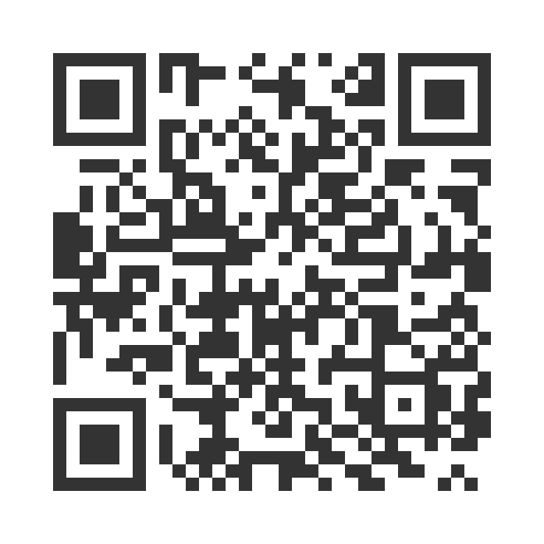
FAMILIES OF YOUTH
https://uclahs.fyi/CPS2025Family
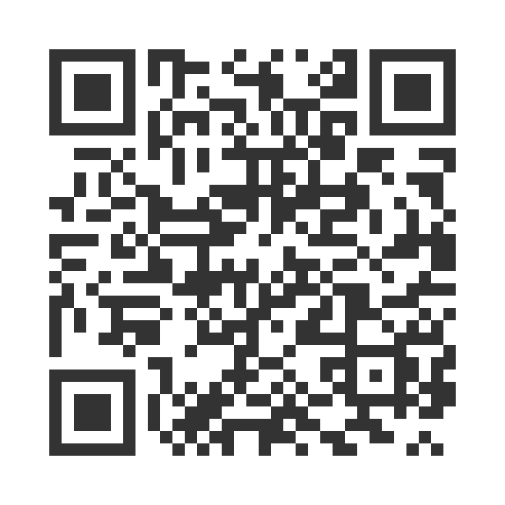

- Paper survey form (ask program staff for a form)
Ask program staff if you have questions or would like assistance with the survey!

Thank you for participating in this important survey!

