**Consumer Perception Survey (CPS)**

消費者認知問卷調查

**For Older Adults** 年長者

May 20-24, 2024

[Counties/providers may tailor this flyer as needed.]

Tell us what you think about the services you are receiving at this program. 請告訴我們您對您在此計劃中所獲得的服務的看法

Complete a voluntary, anonymous and confidential survey. Choose how you want to participate: 請完成自願、匿名和保密的問卷調查. 請選擇您想參與的方式：

**Secure online survey link for this program:**

使用本計劃的安全網路線上調查：

**OLDER ADULT**年長者

<https://uclahs.fyi/Older>

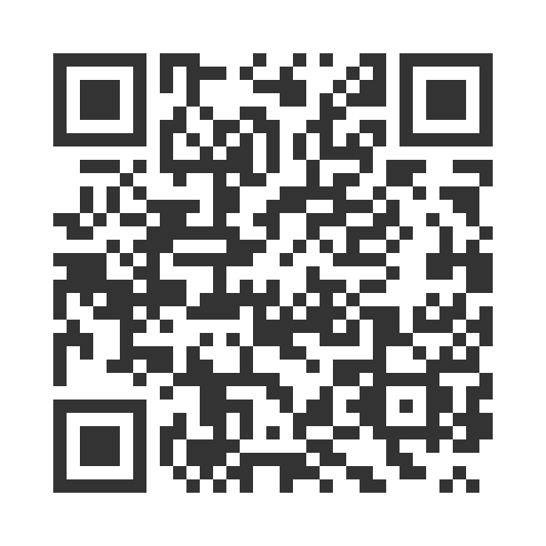

**OLDER ADULT (+QOL)** 年長者 及

<https://uclahs.fyi/OlderQOL>

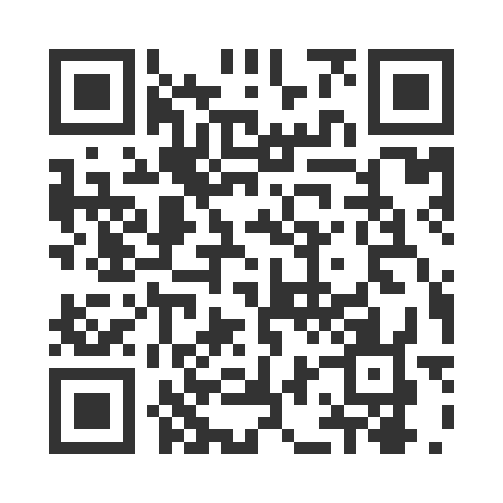

* Paper survey form (ask program staff for a form)

使用紙本問卷調查表（請向工作人員索取問卷表格）

Ask program staff if you have questions or would like assistance with the survey! 如果您有任何問題或填寫問卷調查需要幫助，請詢問工作人員

*Thank you for participating in this important survey!*

感謝您參與這項重要的問卷調查