Consumer Perception Survey (CPS)
消費者認知問卷調查

For Adults 成年人
May 20-24, 2024
[Counties/providers may tailor this flyer as needed.]
Tell us what you think about the services you are receiving at this program. 請告訴我們您對您在此計劃中所獲得的服務的看法
Complete a voluntary, anonymous and confidential survey.
Choose how you want to participate: 請完成自願、匿名和保密的問卷調查. 請選擇您想參與的方式：

Secure online survey link for this program:
使用本計劃的安全網路線上調查：

ADULT成年人
https://uclahs.fyi/Adult
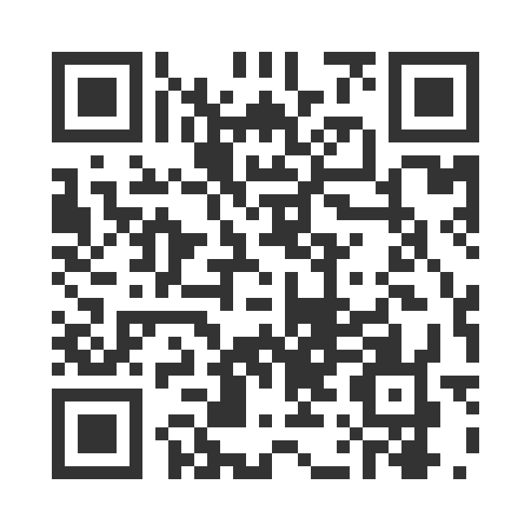

Paper survey form (ask program staff for a form)
使用紙本問卷調查表（請向工作人員索取問卷表格）
Ask program staff if you have questions or would like assistance with the survey! 如果您有任何問題或填寫問卷調查需要幫助，請詢問工作人員

Thank you for participating in this important survey!
感謝您參與這項重要的問卷調查

