

2026 Annual Medical and Health Exercise
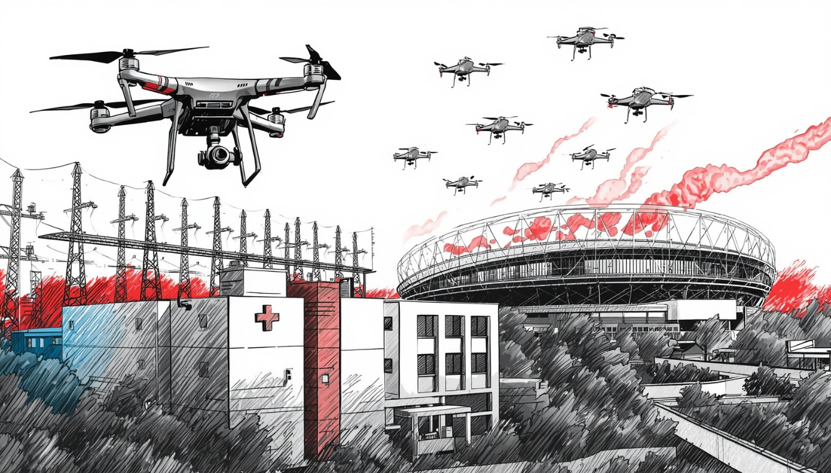
Critical Infrastructure: Targeted Violence and Power Outage Exercise

  - Situation Manual (SitMan)
  - Thursday, November 19, 2026

Welcome to the Los Angeles County Healthcare Coalition’s (HCC) annual Medical and Health Exercise (AMHE). The 2026 AMHE will include components the U.S. Administration for Strategic Preparedness and Response (ASPR), Hospital Preparedness Program (HPP), Medical Response and Surge Exercise (MRSE).

MRSE requirements include conducting an operations-based exercise designed to examine and evaluate the ability of the HCC to support a patient surge equivalent to 10% of its licensed bed capacity.

Power outage was identified as the number three threat on the overall Los Angeles County Medical and Health Hazard Vulnerability Analysis (HVA).

The 2026 exercise will focus on testing patient surge, mass-casualty incident (MCI), power outage, and other pertinent plans and processes related to power outages.
This Situation Manual (SitMan) provides exercise participants with all the necessary tools for their roles in the exercise. Some exercise material is intended for the exclusive use of exercise planners, facilitators, and evaluators, but players may view other materials that are necessary to their performance. All exercise participants may view the Situation Manual.

TABLE OF CONTENTS
TABLE OF CONTENTS 3
Exercise Overview 4
General Information 6
Participant Roles and Responsibilities 12
Exercise Structure 13
Exercise Guidelines 13
Calculating the Scale of the Surge 14
Exercise Assumptions and Artificialities 22
Appendix A: Exercise Schedule A
Appendix B: Exercise Participants B
Appendix C: Relevant Plans C
Appendix D: Acronyms D
Appendix E: Detail on Los Angeles County Emergency Medical Services Agency’s Emergency Power Status Reporting Protocols E

CUSTOMIZING THIS DOCUMENT
Throughout this document, there are opportunities for customization by organization/facility planners. This document serves as a template guidance document. This document may be modified to reflect the unique characteristics of your organization/facility. Bracketed text (e.g., [your jurisdiction]) is provided to aid with location-specific tailoring. These should be removed or modified as appropriate prior to finalizing this document. Exercise planners can insert their customized language and then remove the highlight and brackets. After tailoring the document to your jurisdiction/organization/facility, be sure to update the Table of Contents by right clicking on them and selecting “update field”.

Exercise Overview
Exercise Name | Annual Medical and Health Exercise
Exercise Date | Thursday, November 19, 2026
Scope | The Annual Medical and Health Exercise is an operations-based exercise for Healthcare Coalition (HCC) members.  Command center activation is encouraged.  We will utilize the actual live ReddiNet system during the exercise.  The exercise will begin at 8:00 a.m. and end at 12:00 p.m.
ASPR Core Capabilities | Capability 1. Foundation for Health Care and Medical Readiness  Capability 2. Health Care and Medical Response Coordination  Capability 3. Continuity of Health Care Service Delivery  Capability 4. Medical Surge
FEMA Mission Areas | FEMA National Preparedness Goal: Five Mission Areas (Prevention, Protection, Mitigation, Response, and Recovery)
FEMA Core Capabilities | - Planning  - Operational Coordination  - Operational Communication  - Public Health, Healthcare, and Emergency Medical Services
PHEP Capabilities | Capability 3: Emergency Operations Coordination  - Function 1: Conduct preliminary assessment to determine the need for activation of public health emergency operations  - Function 2: Activate public health emergency operations  - Function 3: Develop and maintain an incident response strategy  - Function 4: Manage and sustain the public health response  - Function 5: Demobilize and evaluate public health emergency operations
Goals and Objectives | The 2026 exercise will focus on testing patient surge, mass-casualty incident (MCI), power outage, and other pertinent plans and processes related to power outages.  In addition, the HCC is required to meet the surge requirements set forth in the Medical Response and Surge Exercise (MRSE).
Threat/Hazard | Patient Surge, Mass Casualty Incident (MCI), Power Outage
Scenario | Pre-Exercise: 2028 Summer Olympics are underway. Local law enforcement has issued a “Be on the Lookout” (BOLO) alert to the community requesting anyone observing suspicious Unmanned Aircraft System (UAS) - drone activity to report it to authorities. There has been an increase in threats to critical infrastructure sectors in the Los Angeles area. Specifically, to power plants, sports stadiums, and the medical and health sector. The BOLO is to remain in place for the duration of the Olympic Games.  Day of Exercise: An Unmanned Aircraft System (UAS) drone attack at Olympic event near your facility. Many victims with mild to moderate injuries self-dispatch to nearby clinics and hospitals. The Fire Department arrives on scene and initiates an MCI with the Medical Alert Center (MAC) and activates a FOAC. Victims are transported by ground ambulance resulting in a patient surge to emergency departments.  This is immediately followed by a targeted UAS strike at a local electric sub-station forcing your facility on back-up generator or resulting in total power loss.  All facilities activate Surge Plan and/or Emergency Operations Plan.
Sponsor | Los Angeles County Emergency Medical Services (EMS) Agency, Hospital Preparedness Program
Participating Organizations | - Amateur Radio Emergency Services  - Ambulatory Surgery Centers  - Clinics  - Dialysis Centers  - Home Health and Hospice  - Hospitals  - Long Term Care Facilities  - Los Angeles County Department of Mental Health  - Los Angeles County Emergency Medical Services Agency  - Los Angeles County Fire Department  - Los Angeles County Office of Emergency Management  - Provider Agencies (Private)  - Public Health (Long Beach, Pasadena, Los Angeles County)  - Urgent Care Centers
Point of Contact | Darren Verrette  Disaster Program Manager  Los Angeles County Emergency Medical Services Agency  10100 Pioneer Blvd.  Santa Fe Springs, CA 90670

General Information

Exercise Objectives and Capabilities
The Annual Medical and Health Exercise (AMHE) will also meet requirements of ASPR’s Medical Response and Surge Exercise (MRSE).
The MRSE includes six (6) required objectives for the Health Care Coalition. The Core Capabilities are from the U.S. Administration for Strategic Preparedness and Response, Health Care Preparedness and Response Capabilities guide. Health Care Preparedness and Response Capabilities (phe.gov)

Health Care Coalition Objectives:
Exercise Objective | Core Capability
Assess HCC’s capacity to support a large-scale, community-wide medical surge incident | Capability 4. Medical Surge
Evaluate a multitude of coalition preparedness and response documents and plans, including specialty surge annexes, transfer agreements, coordination plans with other state HCCs, and other relevant plans. | Capability 1. Foundation for Health Care and Medical Readiness
Evaluate coalition members’ ability to communicate and coordinate quickly to find and match available staffed beds, transportation, supplies and equipment, and personnel during a large-scale surge incident | Capability 2. Health Care and Medical Response Coordination
Assist HCCs and their members with improvement planning based on MRSE outcomes | Capability 1. Foundation for Health Care and Medical Readiness
Serve as a data source for performance measure reporting required by the HPP Cooperative Agreement | Capability 1. Foundation for Health Care and Medical Readiness
Provide flexible exercise which could be customized to meet the needs and/or exercise requirements of HCCs | Capability 1. Foundation for Health Care and Medical Readiness

Exercise Objectives by Sector
Amateur Radio Emergency Services (ARES) Objectives:
Exercise Objective | Core Capability
Maintain continuous voice/digital communication with 911 hospitals and Medical Alert Center (MAC) with less than 5 minutes of downtime | Capability 2. Health Care and Medical Response Coordination
Establish grid-independent network with 95% transmission rate for HAvBED and resource requests | Capability 2. Health Care and Medical Response Coordination
Update color-coded hospital service level poll status every 30 minutes without commercial power | Capability 2. Health Care and Medical Response Coordination

Ambulatory Surgery Center (ASC) Sector Objectives:
Exercise Objective | Core Capability
Share real-time information with Medical Health Operational Area Coordinator (MHOAC)/HCC every 30 to 60 minutes | Capability 2. Health Care and Medical Response Coordination
Activate Incident Command System (ICS) within Emergency Operations Plan (EOP) timeframe, notify staff, document resource needs | Capability 2. Health Care and Medical Response Coordination
Identify and prioritize essential functions within first 60 minutes | Capability 3. Continuity of Health Care Service Delivery

Clinic Sector Objectives:
Exercise Objective | Core Capability
Communicate with partners and Medical Coordination Center (MCC); update status and test redundant communications within 30 minutes | Capability 2. Health Care and Medical Response Coordination
Activate ICS within 15 minutes, complete Hospital Incident Command System (HICS) forms, and notify staff. | Capability 2. Health Care and Medical Response Coordination
Assess emergency power sources within first 60 minutes | Capability 2. Health Care and Medical Response Coordination

Dialysis Sector Objectives:
Exercise Objective | Core Capability
Evaluate surge capabilities within 60 minutes | Capability 2. Health Care and Medical Response Coordination
Activate communication plan within 15 minutes; respond to MCC per timelines | Capability 2. Health Care and Medical Response Coordination
Prioritize dialysis operations, assess generator, coordinate transfers within 60 minutes | Capability 3. Continuity of Health Care Service Delivery

Emergency Medical Services (EMS) Agency Objectives:
Exercise Objective | Core Capability
Activate the Medical Coordination Center (MCC) and establish communications | Capability 1. Foundation for Health Care and Medical Readiness & Capability 2. Health Care and Medical Response Coordination
Share situation status with all healthcare sectors, MHOAC partners, and MCC staff throughout the exercise | Capability 2. Health Care and Medical Response Coordination
Evaluate the MCC’s ability to support a surge in patients | Capability 3. Continuity of Health Care Service Delivery & Capability 4. Medical Surge
Coordination of Resources | Capability 2. Health Care and Medical Response Coordination

Fire Department Objectives:
Exercise Objective | Core Capability
Activate alerts within 15 minutes | Capability 2. Health Care and Medical Response Coordination
Activate MCI within 10 minutes; coordinate with MAC | Capability 4. Medical Surge
Activate FOAC within 15 minutes; identify staging areas | Capability 2. Health Care and Medical Response Coordination

Home Health Hospice (HHH) Sector Objectives:
Exercise Objective | Core Capability
Activate communication plan within 15 minutes; maintain communications with MCC | Capability 2. Health Care and Medical Response Coordination
Evaluate shelter-in-place safety within 60 minutes | Capability 2. Health Care and Medical Response Coordination
Identify and coordinate resources; submit RR to MCC | Capability 2. Health Care and Medical Response Coordination
Prioritize electricity-dependent patients within 60 minutes | Capability 3. Continuity of Health Care Service Delivery & Capability

Hospital Sector Objectives:
Exercise Objective | Core Capability
Establish communication systems and submit RR within 60 minutes | Capability 1. Foundation for Health Care and Medical Readiness
Document information sharing procedures within 30 minutes | Capability 1. Foundation for Health Care and Medical Readiness
Activate Hospital Command Center within EOP timeframe | Capability 2. Health Care and Medical Response Coordination
Develop IAP within first operational period | Capability 2. Health Care and Medical Response Coordination
Identify essential functions within 60 minutes | Capability 3. Continuity of Health Care Service Delivery
Activate downtime procedures and maintain continuity | Capability 3. Continuity of Health Care Service Delivery
Activate surge response plan within operational period | Capability 4. Medical Surge

Long-Term Care (LTC) Sector Objectives:
Exercise Objective | Core Capability
Activate EOP within 15 minutes | Capability 2. Health Care and Medical Response Coordination
Activate communication plan and submit reports within 60 minutes | Capability 2. Health Care and Medical Response Coordination
Assess surge impact and implement shelter procedures | Capability 4. Medical Surge
Initiate Nursing Home ICS (NHICS) within first operational period | Capability 3. Continuity of Health Care Service Delivery
Facilitate behavioral health support within 60 minutes | Capability 3. Continuity of Health Care Service Delivery
Activate LTC Mutual Aid Prpogram (MAP) and submit reports within 2 hours | Capability 3. Continuity of Health Care Service Delivery

Provider Agency Objectives:
Exercise Objective | Core Capability
Activate alerts within 15 minutes | Capability 2. Health Care and Medical Response Coordination
Initiate surge plan within 10 minutes | Capability 4. Medical Surge
Implement FOAC for mutual aid back up providers | Capability 2. Health Care and Medical Response Coordination
Submit MHOAC RR within 60 minutes | Capability 1. Foundation for Health Care and Medical Readiness

Public Health Objectives:
Exercise Objective | Core Capability
Exercise MHOAC Plan Communication / Coordination with MHOAC partners | PHEP Core Capability: 3
Exercise MHOAC Plan Resource Request | PHEP Core Capability: 3
Exercise Flash Report preparation and submission to MHOAC (EMS Agency) | PHEP Core Capability: 3

Urgent Care Sector Objectives:
Exercise Objective | Core Capability
Activate communication plan within 15 minutes; maintain MCC communications | Capability 2. Health Care and Medical Response Coordination
Modify operations to support surge within 60 minutes | Capability 3. Continuity of Health Care Service Delivery & Capability 4. Medical Surge
Assess continuity under power outage within 60 minutes | Capability 3. Continuity of Health Care Service Delivery
Table 1. Exercise Objectives and Associated Capabilities

Participant Roles and Responsibilities
The term participant encompasses many groups of people, not just those playing in the exercise. Groups of participants involved in the exercise, and their respective roles and responsibilities, are as follows:
- Players. Players are personnel who have an active role in discussing or performing their regular roles and responsibilities during the exercise. Players discuss or initiate actions in response to the simulated emergency.
- Controllers. Each participating facility will assign an Exercise Controller to participate in the Participant Webinar scheduled for September 8, 2026. The Exercise Controller is the Lead Controller at the facility and is responsible for planning, managing exercise play, setup, and operation of the exercise at their respective facility. Lead Controllers direct the pace of the exercise in accordance with the Master Scenario Event List (MSEL) developed by the EMS Agency.
The Controller provides key inputs to players and may, in addition, prompt or initiate certain player actions to ensure continuity of the exercise. They also issue exercise materials to players as required, monitor the exercise timeline, and if manageable supervise the safety of all exercise participants. Controllers are not players in the exercise. The Lead Controller are to read the EEG and the Controller Evaluator Handbook prior to the exercise.
- Simulators. Simulators are control staff personnel who deliver scenario messages representing actions, activities, and conversations of an individual, agency, or organization that is not participating in the exercise. They most often operate out of the Simulation Cell (SimCell), but they may occasionally have face-to-face contact with players. Simulators function semi-independently under the supervision of SimCell controllers, enacting roles (e.g., media reporters or next of kin) in accordance with instructions provided in the Master Scenario Events List (MSEL). All simulators are ultimately accountable to the Lead Controller.
- Evaluators. Each participating facility will assign at least one person to the Evaluator position. Evaluators evaluate and provide feedback on a designated functional area of the exercise. A Controller can also be tasked with an Evaluator assignment if manageable. It is recommended to assign the position of Evaluator to someone else in the facility who is not a player. It is also recommended that the Evaluator participate in the Participant Webinar scheduled for September 8, 2026. Evaluators observe and document performance against established capability targets and critical tasks, in accordance with the Exercise Evaluation Guides (EEGs) developed by the EMS Agency. Evaluators are to read the EEG and the Controller Evaluator Handbook prior to the exercise.
- Observers. Observers visit or view selected segments of the exercise. Observers do not play in the exercise, nor do they perform any control or evaluation functions. Observers view the exercise from a designated observation area and must remain within the observation area during the exercise. Very Important Persons (VIPs) are also observers, but they frequently are grouped separately.

Exercise Structure
This exercise will be a facilitated exercise. Players will participate in the following three (3) modules:
- Module 1: Heightened Security
- Module 2: Mass Casualty Incident (MCI) Initiation
- Module 3: Power Outage
Each module begins with an update that summarizes key events occurring within that period. After the updates, participants review the situation and engage in a plenary group discussion of appropriate [focus area] issues.

Exercise Guidelines
- This exercise will be held in an open, no-fault environment wherein capabilities, plans, systems, and processes will be evaluated. Varying viewpoints, even disagreements, are expected.
- Respond to the scenario using your knowledge of current plans and capabilities (i.e., you may use only existing assets) and insights derived from your training.
- Decisions are not precedent setting and may not reflect your jurisdiction’s/ organization’s final position on a given issue. This exercise is an opportunity to discuss and present multiple options and possible solutions.
- Problem-solving efforts should be the focus. Areas of opportunities can help improve [focus area] and result in action items.
- The assumption is that the exercise scenario is plausible, and events occur as they are presented. All players will receive information at the same time.
Data Elements and Information Sharing
The exercise will test patient surge, power outage, and other pertinent plans and processes related to power outages.
Medical and Health facilities participating in the exercise will communicate with the Medical Alert Center (MAC) or the Medical Coordination Center (MCC) to maintain situational awareness, share information, assess resource availability, and support the identification and sharing of resources. Communication with the MAC or MCC should follow the normal communication procedures according to the EMS Agency’s Communication Plan available at https://file.lacounty.gov/SDSInter/dhs/206683_Communication.pdf unless informed of alternative channels.
The following sectors are encouraged to participate in the exercise:
- Ambulatory Surgery Centers
- Clinics
- Dialysis
- Home Health & Hospice
- Hospitals
- Long Term Care
- Provider Agencies
- Urgent Care

Calculating the Scale of the Surge
HCC is required to surge to 10% of its licensed bed capacity. Los Angeles County has 21,591 licensed beds (21,591 multiplied by 10% = 2,159.1 surge patients). The HCC must surge to a minimum of 2,160 patients to meet surge requirements.

Patient Distribution Plan
HCC includes 69 Acute Care Hospitals that are 911-receiving Emergency Departments and 9 Acute Care Hospitals that do not have an Emergency Department.

The planning team selected a scenario to address top level threats identified in the regional Hazard Vulnerability Analysis (HVA), to meet ASPR grant requirements, and to foster preparedness for the 2028 Summer Olympics.

The scenario begins with pre-exercise messaging (2-3 days before exercise) to heighten the security posture due to threats to the following critical infrastructure sectors in the Los Angeles area:

- Commercial Facilities Sector (Sports Arena / Stadiums)
- Energy Sector (Power Plants / Electric Sub-stations)
- Healthcare and Public Health Sector

On the day of the exercise, exercise play is initiated by a drone attack at an Olympic sport competition with a subsequent mass-causality incident (MCI) resulting in a patient surge to emergency departments and clinics. At 9:00am the scenario progresses to drone strikes at power sub-stations resulting in widespread power outages.

Mass-Casualty Incident (MCI) and Patient Surge
AS mentioned above, drone attacks will occur at a stadium or sports venue hosting an Olympic competition “near” your facility. The attacks are intended to cause an MCI and subsequent patient surge to emergency department and/or clinic to meet surge requirements.

- Trauma Centers will receive a total of 75 surge patients, 45 walk-in and 30 by EMS (MCI). 20% of the total number of surge patients will require admission. (15 patients will require admission.)

- 9-1-1 receiving hospitals (not including Trauma Centers or Catalina Island Health) will receive a total of 40 surge patients, 25 walk-in and 15 by EMS (MCI). 20% of the total number of surge patients will require admission. (8 patients will require admission.)

- Catalina Island Health will receive a total of 20 surge patients, 10 walk-in and 10 by BLS. 20% of the total number of surge patients will require admission and half of those requiring admission will require higher level of care transfer and evacuation from Catalina Island to the mainland. (4 patients will require admission and 2 of the 4 will require higher level of care transfer and evacuation from Catalina Island to the mainland.)

- Hospitals without Emergency Departments will receive a total of 5 surge patients by walking into the facility.

- Clinics participating in the exercise will receive 5 to 10 surge patients by walking into the clinic.

Power Outage
At 9:00am, a subsequent targeted UAS strike at a local electric sub-station has forced your facility on your back-up power source or total power loss. Each participating facility can determine if they are on back-up power or complete power failure. Additionally, the power to the area around your hospital is down (ATM’s, homes, schools, stores, streetlights, etc.). At 9:00am the lead controller must announce to players that the power is out, and the facility is on back-up power source, or the facility has no power. If able, you can simulate power outage by turning off the lights or use some other creative method to simulate power failure.

Not all facilities use back-up generators that require fuel, some facilities use other back-up power sources such as power banks that store energy in batteries. In this document the phrase “Back-up Power Source” refers to both back-up generators and power banks.

Power failure provides the opportunity to evaluate many areas. Here are some suggested areas to consider: (This is not an exhaustive list nor is it required to test these areas):
- Assessment of power needs
- Back-up communications / ARES
- Back-up power system failure
- Business continuity plan
- Cancel procedures / surgeries
- Cash needs for purchases
- Charging stations for phones and laptops
- Connecting portable power banks / extension cords
- Downtime procedures
- Electric fuel fleet charging needs
- Elevators down / Med-Sled use
- Emergency fuel for response vehicles
- Emergency supplies (flashlights / batteries)
- Evacuation / relocation
- Fuel for back-up generators (How to acquire / MOU)
- HVAC system failure (Emergency cooling or warming)
- Identify vendors that provide back-up power (How to acquire / MOU)
- Identify which essential systems that are not on back-up power
- IT network down
- Medical gas failure
- Quick connect capability
- Robotic systems that require charging
- Secure parking ingress / egress
- Supporting the Community
- Utility failure (water, etc.)

Hospitals, skilled nursing facilities, and ambulatory surgery centers are all required to have back-up power sources in addition to other parameters such as time parameters, temperature requirements in patient care areas, and refueling parameters.

Other sectors in the HCC may or may not have back-up power sources. If your facility does not have back-up power, we encourage you to participate in the exercise. In addition to the power failure recommendations above, facilities can evaluate external communications via ReddiNet, continuity planning, incident management team (IMT) notification & activation, and/or activation of your Incident Command Center.

Exercise Conduct
The MAC will initiate a ReddiNet MCI poll titled, “2026 AMHE MCI”. All Hospitals with an Emergency Department (9-1-1 receiving) will receive surge patients by EMS via the ReddiNet MCI Module. At least 20% of the surge patients arriving to the emergency department must meet admission criteria and be admitted to the hospital. Each 9-1-1 receiving facility must update the MCI victim list in ReddiNet for all patients in the emergency department related to the incident.

In addition, hospitals, clinics, and urgent care facilities are encouraged to simulate receiving walk-in (self-transport) patients based upon the Patient Allocation Chart.

At 9:00 a.m., all facility controllers and exercise directors will announce to the players in their facility that the power is out and inform staff (players) if the facility is on or off back-up power. Facility controllers will begin the exercise activities they developed for their facility.

Healthcare Facility Emergency Power Resilience Playbook
In 2023, the EMS Agency developed the Healthcare Facility Emergency Power Resilience Playbook as a resource to help safeguard emergency power in hospitals and skilled nursing facilities (SNF) located in Los Angeles County.

The playbook includes protocols intended to accelerate emergency power-threat reporting to expedite response to a facility facing a threat during an outage. An expedited response may include the potential deployment of temporary government generators and the initiation of evacuation support protocols.

The LA County EMS Agency is the point of alignment between the playbook’s emergency power reporting protocols and CDPH requirements. The playbook introduces the Emergency Power System Assessment and benchmarking worksheets for Hospitals and SNF. It is recommended that Hospitals and SNFs conduct assessments to assess the status of their emergency power (link to assessments Appendix B for Hospitals and Appendix C for SNFs).

For the exercise, hospitals and SNF’s will test the power status reporting protocol. To support the reporting protocol, ReddiNet added a generator “pill” next to each facility name on the ReddiNet diversion status screen. Based on the facility’s risk status (Tier 1 or Tier 2) and the answers provided, the generator pill will change color to green, yellow, orange, or red to reflect the current risk level. Hospitals and SNFs will report their generator status during the power outage exercise by clicking the “pill” and answering the series of questions within the specified time frame. If your facility is in DRC Region-8 and you are testing back-up power failure, then answer the questions according to your assumed status for the exercise. If you are not in DRC Region-8, then answer the questions to reflect a green or yellow risk level.

PLEASE NOTE: During the exercise when you update the “pill”, be sure to enter “Drill, Drill, Drill” or “This is an Exercise” or “2026 AMHE” in the comments section to distinguish between an actual incident versus exercise activity. Following the conclusion of the exercise be sure to return your facility’s generator status to “Off Generator”.

EMS Agency and Emergency Power Coordination
The L.A. County EMS Agency will test operational area coordination components of the Healthcare Facility Emergency Power Resilience Playbook with pre-identified hospitals and skilled nursing facilities in DRC Region-8 to facilitate back-up power source identification, allocation, and escalation.

A critical component of the playbook is the Emergency Power System Assessment and Benchmark Worksheet (link to assessments Appendix B for Hospitals and Appendix C for SNFs). Hospitals and SNFs must complete these assessments to know their emergency power needs before an incident occurs. This will save time when requesting the appropriate backup power source from vendors and/or government agencies. Portable emergency generators vary in size and capability. It is not a one-size-fits-all solution. The EMS Agency highly recommends that facilities invest in “quick-connect” devices that allow for the “quick-connection” of portable generators to meet emergency power needs. The EMS Agency maintains a limited number of portable generators; however, they do not have the required cabling or the qualified personnel to install them.
Long-term Care Mutual Aid Program (LTC-MAP) Coordination
The LTC-MAP group will test team communication, notification, activation, and coordination. In addition, they will evaluate the LTC ReddiNet dashboard, test processes, and seek HFID waivers. The group will pre-identify select skilled nursing facilities (SNF) to test processes.

Los Angeles County Fire Department MCI and FOAC
The Los Angeles County Fire Department will establish Medical Communications (MedCom) with the Medical Alert Center (MAC) and initiate an MCI at 7:50 am via VMED-28. This will start the exercise. LA County Fire MedCom will provide MAC with a specific location and specific number of victims. The location and the number of victims is to facilitate play for the Fire Department and the MAC only. The number of patients MAC sends to Hospitals via ReddiNet MCI will be based upon the Patient Allocation Chart on page 19, not the number of victims reported by MedCom. The MAC may or may not enter the location of the MCI into ReddiNet. The assumption is that the MCI has occurred at a location near your facility, not necessarily the location indicated in the ReddiNet MCI module. The Fire Department will also contact the Fire Operational Area Coordinator (FOAC) to request additional ambulances to support the MCI. The FOAC will request a certain number of ambulances from all EOA providers and from the CDO. If the EOA providers are unable to provide adequate number of ambulances, they will poll their back up providers to fulfill the requested number of ambulances.

Private Ambulance Companies Emergency Fueling
The L.A. County EMS Agency will test emergency fueling processes with a designated ambulance provider. If gas stations cannot dispense fuel due to power loss, ambulance providers may request emergency fuel access from the EMS Agency. The EMS Agency will provide temporary access to County fuel locations with emergency back-up power.

In addition, private ambulance providers are encouraged to partner with hospitals and other facilities to test transportation coordination processes.

Patient Allocation: Hospitals
Before the exercise, all facilities can select patients from the victim list based on the quantities listed in the Patient Allocation Chart (Table 2).

Hospitals must select the appropriate percentage of patients that meet admission criteria as indicated in the Patient Distribution Plan above.

Patient Allocation: Clinics and Urgent Care Centers
Before the exercise, all facilities can select patients from the victim list based on the quantities listed in the Patient Allocation Chart (Table 2).

Clinics and Urgent Care facilities participating in the exercise have the option to choose the number of self-transport (walk-in) patients they wish to receive to fulfill their objectives. It is advisable to receive at least 5 walk-in patients but no more than 10 walk-in patients from the incident. These patients will not be assigned via ReddiNet, and it is not mandatory to add them to the MCI victim list. The person(s) on site preparing for the exercise will create injects/prompts to simulate patient arrival.

See Patient Allocation Chart (Table 2)
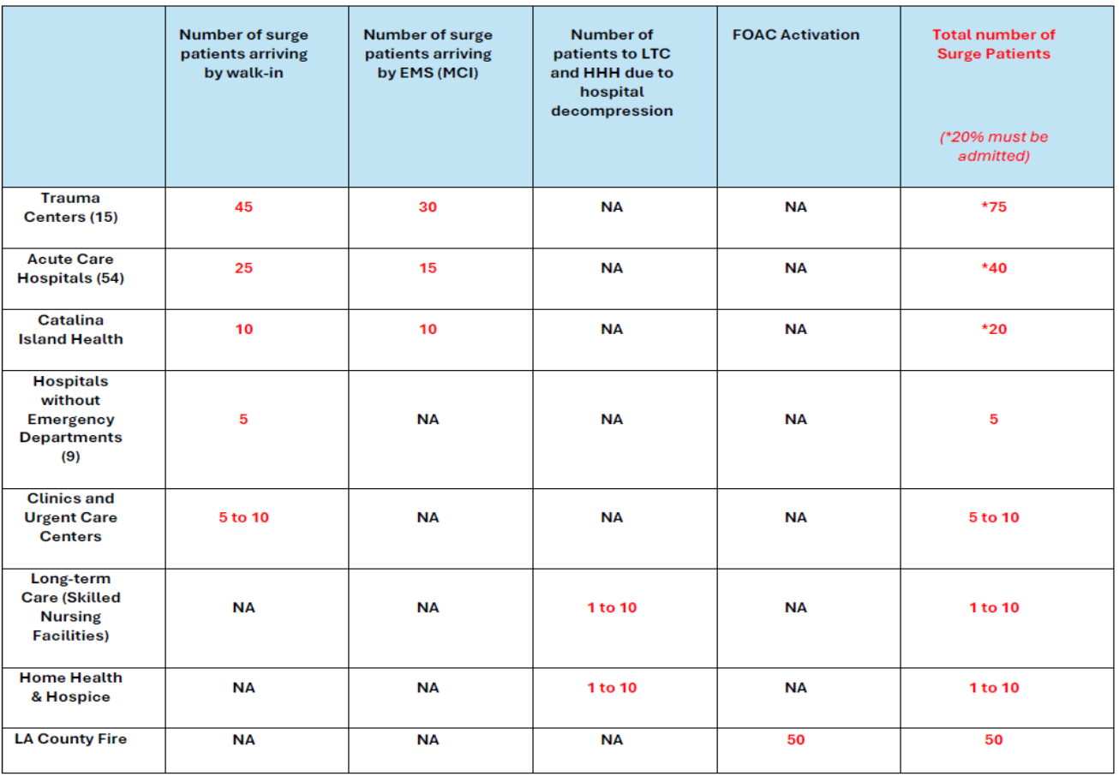Table 2: Patient Allocation Chart. **Clinics and Urgent Care Centers have the option of receiving up to 10 walk-in patients with minor injuries. These patients are in addition to the 10% patient surge.
Bed Availability: Hospital Capacity Survey
All participating HPP Hospitals will participate in the “Hospital Capacity Survey” in the ReddiNet assessment module. The deadline for submitting the data is the end of the next business day following the conclusion of the exercise.
Staffed beds mean those beds which are equipped and available for patient use. Staffed beds include those that are occupied and those that are vacant.
The following data elements are required:
Pre Exercise (Patient Surge Data):
- How many staffed beds (including both vacant and occupied beds) were available at the beginning of the exercise, prior to receiving patients?
- Number of existing in-patients (census) at the beginning of the exercise, prior to receiving patients
During and Post Exercise (Patient Surge Data):
- How many existing in-patients could be safely discharged to accommodate surge patients (decompress)?
- How many total staffed beds were available after increasing surge capacity?
- Number of surge patients requiring admission for inpatient care based on triage assessment
- How many surge patients that arrived in your emergency department were admitted for inpatient care?
- Number of surge patients requiring outpatient care who will not be admitted based on your triage assessment (discharged from ED)

Exercise Assumptions and Artificialities
In any exercise, assumptions and artificialities may be necessary to complete play in the time allotted and/or account for logistical limitations. Exercise participants should accept that assumptions and artificialities are inherent in any exercise and should not allow these considerations to negatively impact their participation.

Assumptions
Assumptions constitute the implied factual foundation for the exercise and, as such, are assumed to be present before the exercise starts. The following assumptions apply to the exercise:
- An actual Hospital power failure would most likely result in the facility being placed on Internal Disaster. To not disrupt routine operations taking place during the exercise, participating facilities will not be placed on internal disaster.
- Participating facilities in DRC Region-8 will respond to the Service Level Poll as either “Red” (Limited Services) or “Black” (No Services) for the exercise.
- Participating facilities outside of DRC Region-8 will respond to the Service Level Poll as either “Green” (Normal Operations), “Yellow” (Under Control), or “Orange” (Modified Services).
- The exercise is conducted in a no-fault learning environment wherein capabilities, plans, systems, and processes will be evaluated.
- The exercise scenario is plausible, and events occur as they are presented.
- Exercise simulation contains sufficient detail to allow players to react to information and situations as they are presented as if the simulated incident were real.
- Participating agencies may need to balance exercise play with real-world emergencies. Real-world emergencies take priority.

Artificialities
During this exercise, the following artificialities apply:
- Some hospitals will be disproportionately impacted more than others. For example, the 10% licensed bed capacity of Torrance Memorial is a larger number compared to the 10% licensed bed capacity of Emanate Foothill Presbyterian (FHP) Hospital. Sending 40 surge patients to Torrance Memorial is less than their 10% surge capacity, while sending 40 surge patients to FHP is greater than their 10% surge capacity.
- Exercise communication and coordination are limited to participating exercise organizations, venues, and the SimCell.
- Only communication methods listed in the Communications Directory are available for players to use during the exercise.

Exercise Evaluation
Evaluation of the exercise is based on the exercise objectives and aligned capabilities, capability targets, and critical tasks, which are documented in Exercise Evaluation Guides (EEGs). Evaluators have EEGs for each of their assigned areas. Additionally, players will be asked to complete participant feedback forms. These documents, coupled with facilitator observations and notes, will be used to evaluate the exercise, and compile the After-Action Report (AAR)/Improvement Plan (IP).

Module 1: Heightened Security

Scenario

Pre-Exercise: November 17, 2026, 08:00 hours:
2028 Summer Olympics are underway.
Local law enforcement has issued a “Be on the Lookout” (BOLO) alert to the community requesting anyone observing suspicious Unmanned Aircraft System (UAS) - drone activity to report it to authorities.
There has been an increase in threats to critical infrastructure sectors in the Los Angeles area. Specifically, to power plants, sports stadiums, and the medical and health sector.
The BOLO is to remain in place for the duration of the Olympic Games.
News broadcast reports of alleged threats to Olympic sports venues, power-plants, and hospitals.

Reporters arrive at your facility and begin airing footage of overcrowding in emergency departments, lack of security presence, and interviewing staff about threats and security protocols.

Instructions
- You have 20-30 minutes to consider the questions in this module.
- Participants are not required to address every assigned question. Take a moment to review the questions in their entirety and then focus on the critical issues of major concern for your group at this point in the exercise.
- Elect a spokesperson and a scribe/note taker for your group to discuss the group’s findings after each module and document them.
- Groups should work to identify any additional questions, critical issues, or decisions they feel should be addressed at this time. Each participant should record their thoughts, issues, and questions on the provided Participant Feedback Form.
- Make decisions using the information provided and your best judgment of how to proceed.

Key Issues
- Heightened Security
- Law Enforcement BOLO / Threat Notifications
- Targeted Violence Preventive Measures
- Media / Public Relations

Questions
Based on the information provided, participate in the discussion concerning the issues. Identify any critical issues, decisions, requirements, or questions that should be addressed at this time.

The following questions are provided as suggested subjects that you may wish to address as the discussion progresses. These questions are not meant to constitute a definitive list of concerns to be addressed, nor is there a requirement to address every question.

All Sectors:

- In the scenario above what actions would you take?

- What strategies do you have in place to address questions from media?

- Non-hospital sectors, would this affect your site? If yes, in what way?

Module 2: MCI Initiation

Scenario

November 19, 2026, 08:00 hours:
At 07:25, an Unmanned Aircraft System (UAS) drone attack occurs at an Olympic event near your facility.
Many victims sustained mild to moderate injuries and self-dispatched to nearby clinics and hospitals.
The Fire Department arrives on scene and initiates an MCI with the Medical Alert Center (MAC) and activates a FOAC for additional ambulances.
News crews respond to the scene of the incident and begin emergency broadcasting.
Victims are transported by ground ambulance resulting in a patient surge to emergency departments throughout the County.
At 08:55 hours the Fire Department cleared the MCI and all patients from the incident have been transported to various emergency departments in the County.
Law enforcement, USAR teams, and others remain on scene assessing damage to the structure.

Instructions
- You have 20-30 minutes to consider the questions in this module.
- Participants are not required to address every assigned question. Take a moment to review the questions in their entirety and then focus on the critical issues of major concern for your group at this point in the exercise.
- Elect a spokesperson and a scribe/note taker for your group to discuss the group’s findings after each module and document them.
- Groups should work to identify any additional questions, critical issues, or decisions they feel should be addressed at this time. Each participant should record their thoughts, issues, and questions on the provided Participant Feedback Form.
- Make decisions using the information provided and your best judgment of how to proceed.

Key Issues
- MCI Initiation
- Activation / Notification
- Patient Surge

Questions
Based on the information provided, participate in the discussion concerning the issues. Identify any critical issues, decisions, requirements, or questions that should be addressed at this time.

The following questions are provided as suggested subjects that you may wish to address as the discussion progresses. These questions are not meant to constitute a definitive list of concerns to be addressed, nor is there a requirement to address every question.

All Sectors:

- In the scenario above would you activate your facility’s mass casualty incident and/or medical surge plans? What are the “triggers” to activate your surge plan?

- What could your site do to assess with the surge (consider staff, space, stuff)? Or strategies do you have in place to increase capacity for your facility? What factors are needed if strategies to increase capacity are tier leveled, progressive (e.g. what strategies to implement and when to implement - when to decompress or discharge patients, when to call-in additional staff, when to cancel elective surgeries, etc.)?

Module 3: Power Outage

Scenario
At 09:00 hours, a targeted UAS strike occurred at a local electric sub-station resulting in total grid power failure and forcing your facility on back-up generator or resulting in total power loss.
Power outage is impacting your operations requiring use of a back-up power source to maintain operations.

Key Issues
- Power Outage
- Emergency Back-up Power Needs
- Back-up Power and Fuel
- Continuity of Operations

Instructions
- You have 20-30 minutes to consider the questions in this module.
- Participants are not required to address every assigned question. Take a moment to review the questions in their entirety and then focus on the critical issues of major concern for your group at this point in the exercise.
- Elect a spokesperson and a scribe/note taker for your group to discuss the group’s findings after each module and document them.
- Groups should work to identify any additional questions, critical issues, or decisions they feel should be addressed at this time. Each participant should record their thoughts, issues, and questions on the provided Participant Feedback Form.
- Make decisions using the information provided and your best judgment of how to proceed.

Questions
Based on the information provided, participate in the discussion concerning the issues raised in Module 3. Identify any critical issues, decisions, requirements, or questions that should be addressed at this time.
The following questions are provided as suggested subjects that you may wish to address as the discussion progresses. These questions are not meant to constitute a definitive list of concerns to be addressed, nor is there a requirement to address every question.

Facilities with Back-Up Power:
- What is the fuel capacity of your generator? How many hours of fuel do you have on hand? What is the process to re-fuel your generator?
- Will patient care change if your facility is on backup power? If yes, how?
- Do you have policies/MOUs for utilization as a powering station for patients that need to charge DME?
- How long has the generator that provides the backup power to your facility been in place?
- Has your facility undergone any upgrades that may impact the total electrical load the facility has now compared with the electrical load in place when the generator was installed? Your facility’s electrical requirements may have remained the same, or they may have increased or decreased. Decreased requirements are seen especially if facility upgrades have replaced older “harder start” industrial electrical motors with “softer start” electrical motors that do not have as large an initial electrical draw requirement on startup. Conducting a facility electrical review every three years is a good way to ensure your facility’s backup power requirements can be met. Obtain an assessment of your facility to know what size and type of generator you might need following an outage to the electrical grid.

- If the estimated date for commercial power grid restoration is estimated to be several weeks away, what then? Remember, however, that generators will be in high demand once the electrical power grid suffers an outage.
Facilities without Back-Up Power:
- Do you have a policy and/or procedure for a power outage? If yes, how often are staff trained on it?
- Do you have a back-up power source?
All Sectors:
- Does your facility have an Emergency Operations Plan and/or Business Continuity Plan?
- How will/can your facility maintain operations or minimize disruption to operations in the event of a power outage?
- How will you manage patient care during a power outage? Is patient care addressed in your BCP?
- Who needs to be notified if you experience a power outage?
ASC Sector:
- What is the process for continuing procedures on backup power?
Dialysis Sector:
- Do patients have standing orders for changes to diet and/or medication if your facility is unable to dialysis them?
- What dietary instructions have the patients been provided? Orders for Kayexalate?
- What does the Business Continuity Plan look like for managing a surge of dialysis for patients who have been displaced due to a power outage?
- Are staff trained in the use of “hand-crank” procedures? How often should the crank be turned? Is it okay to instruct patients to “hand crank” their own machine?
EMS Agency:
- What is the EMS Agency’s role if any in a power outage event impacting the Medical and Health sector?
Home Health Hospice Sector:
- Do you have a "medical priority" list for power dependent patients?
- Do you have policies/MOUs for powering stations for patients on DME? If your office has a backup power source, could patients use it for their power dependent equipment?
- Are patients provided with alternatives to power in the event circumstances prohibit evacuation of power dependent patients?
- Is power outage discussed with patients that have power dependent equipment at the initial intake?
Skilled Nursing Facility Sector:
- Does your Business Continuity Plan address supporting a surge of LTC patients who have been displaced from another site due to a power outage?
- Does CAHF have a role in a power outage? If yes, what is it?

Appendix A: Exercise Schedule
Note: Because this information is updated throughout the exercise planning process, appendices may be developed as stand-alone documents rather than part of the SitMan.
Date | [Insert Date]
[Time] | [Player Check-In]
[Time] | [Exercise Briefing]
[Time] | [Start Exercise]
[Time] | [Capture Initial Data Elements]
[Time] | [Objectives]
[Time] | [Objectives]
[Time] | [Capture Ending Data Elements]
[Time] | [End Exercise]
[Time] | [Hot wash]
[Time] | [Closing Comments]

Appendix B: Exercise Participants
Participating Organizations
County
Medical Alert Center
[County Participant]
[County Participant]
City
[City Participant]
[City Participant]
[City Participant]
[Jurisdiction A]
[Jurisdiction A Participant]
[Jurisdiction A Participant]
[Jurisdiction A Participant]
[Jurisdiction B]
[Jurisdiction B Participant]
[Jurisdiction B Participant]
[Jurisdiction B Participant]

Appendix C: Relevant Plans

- Los Angeles County Healthcare Facility Emergency Power Resilience Playbook

Appendix D: Acronyms
Acronym | Term
DHS | U.S. Department of Homeland Security
ASPR | Administration of Strategic Preparedness and Response
EMS Agency | Los Angeles County Emergency Medical Services Agency
ExPlan | Exercise Plan
HHS | U.S. Department of Health and Human Services
HPP | Hospital Preparedness Program
HSEEP | Homeland Security Exercise and Evaluation Program
MAC | Medical Alert Center
MCI | Mass-Casualty Incident
SME | Subject Matter Expert
USGS | U.S. Geological Survey
FOAC | Fire Operational Area Coordinator

Appendix E: Detail on Los Angeles County Emergency Medical Services Agency’s Emergency Power Status Reporting Protocols

The LAC EMS Agency’s Emergency Power Status Reporting Protocol is one of several protocols and recommended best practices introduced in this Playbook. The status reporting protocol will provide government officials with improved situational awareness of generator status in hospitals and sub-acute SNFs during power outages, enabling accelerated response when these facilities face a threat to emergency power. This response may include placing hospitals on diversion status if clinical services are significantly limited or no longer available, deploying temporary government generators if requested, and assisting with any evacuations that may become necessary.

The Emergency Power Status Reporting Protocol requires Tier 1 and Tier 2 hospitals, and sub-acute SNFs, to report their generator status through ReddiNet anytime a power outage lasts more than 30 minutes. However, if a facility’s reliance on emergency power results in a drop in available clinical services beyond the reduction that would likely accompany reliance on a properly functioning emergency power system, the facility must report its generator status as soon as possible. Subsequent status updates will also be required as soon as possible, but no longer than 30 minutes after fuel levels for any generator drop below 24 hours of generator run time, or a further drop in clinical services occurs due to reliance on emergency power. For Tier 2 hospitals or sub-acute SNFs that experience a mechanical problem or failure of any generator that triggers a call to a generator service provider, they must report their generator status through ReddiNet immediately. ReddiNet is the communications system used by hospitals and sub-acute SNFs in LAC to provide status updates on a facility’s ability to treat and receive patients during incidents such as power outages. These updates are closely monitored by the LAC EMS Agency, which works closely with the LAC Department of Public Health to address threats facing sub-acute SNFs.

Generator Status “Pill”

To accommodate the EMS Agency’s emergency power status reporting protocols and risk rating of hospital emergency power systems, ReddiNet has added a generator “pill” next to each hospital’s name on the ReddiNet dashboard under the Diversation Status screen. The generator “pill” is modeled after other dashboard “pills” that signal the status of available clinical services. (See Figure 1). (A generator “pill” was already in place for sub-acute SNFs and modifications have been made to ReddiNet to align sub-acute SNF generator status reporting with the new hospital reporting protocol.)

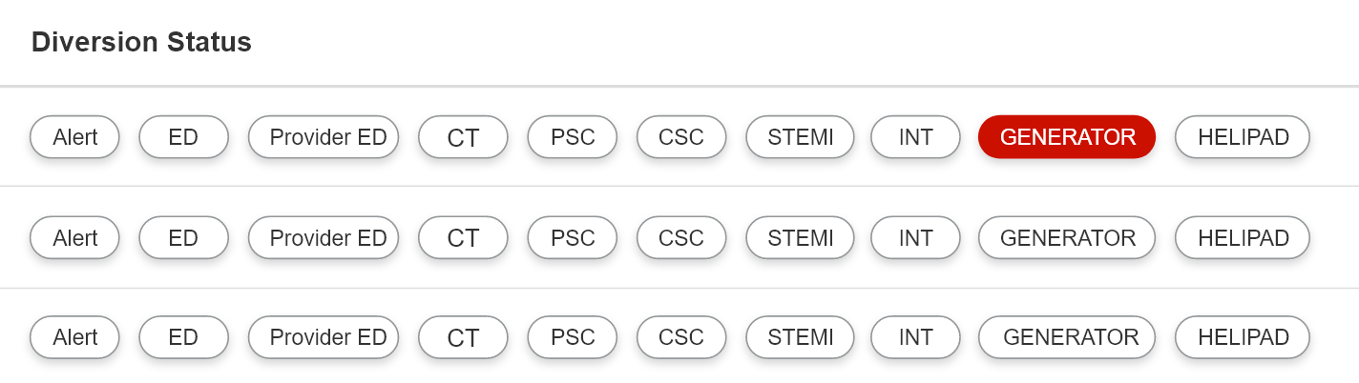
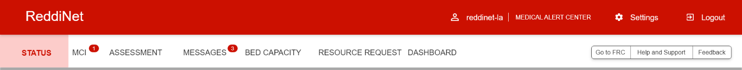
A hospital or sub-acute SNF will report its generator status during an outage, either within the 30-minute timeframe or sooner if a triggering event occurs, by answering a series of questions regarding generator status, any drop in clinical services below the reduced level expected when the facility is operating on emergency power, and available fuel. (See Figure 2). Based on the facility’s risk status as a Tier 1 or Tier 2 facility and the answers provided, the generator pill color will change to green, yellow, orange, or red to reflect the current risk level.

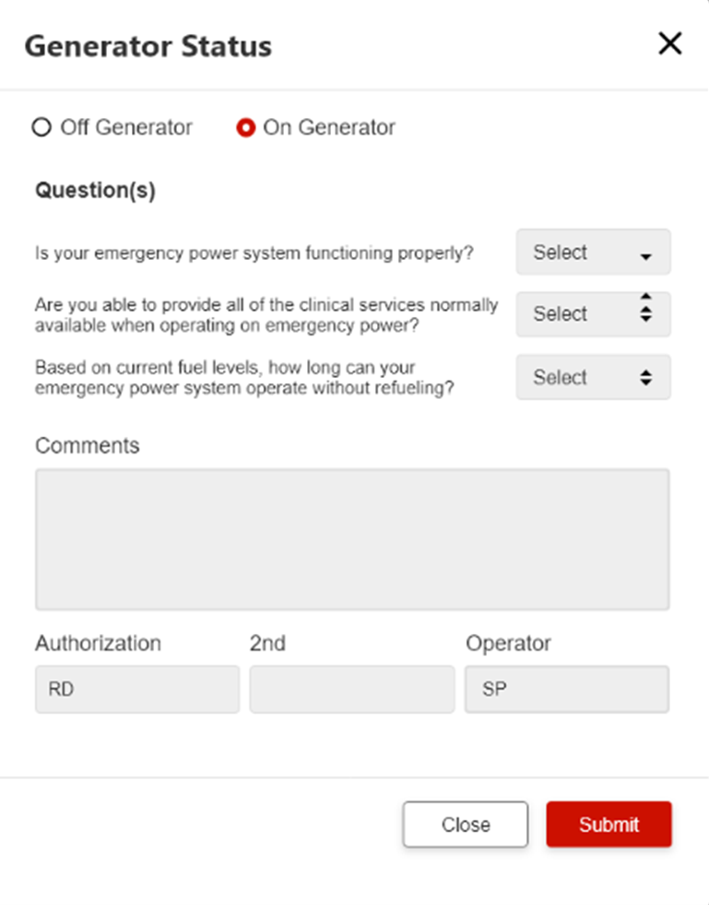
A facility’s emergency power status will be reflected through the color of ReddiNet’s generator “pill” which will be monitored by the Medical Alert Center (MAC), staffed 24/7, 365 days per year by the LAC EMS Agency. MAC personnel currently monitor clinical service “pills” reflecting the status of clinical services at a facility and will now begin tracking the facility’s generator status. Anytime the color of a facility’s generator “pill” signals any severe threats to emergency power, or when a facility requests assistance, MAC personnel will notify appropriate county officials, who can then communicate with an impacted facility and help coordinate any support that may be needed. Any hospital that seeks to close for internal disaster and temporarily stop EMS transportation to their facility due to emergency power failure or any other reason, must receive approval from the MAC.
Figure 1

Given the responsibilities of the MAC during disasters, MAC personnel may be unable to constantly monitor ReddiNet’s clinical service pills and generator status
Figure 2

pills. As such, hospitals and sub-acute SNFs should contact the MAC anytime a serious threat to emergency power occurs (866-940-4401). This contact will augment status reports submitted via ReddiNet and enable a facility to explain their situation and address any potential assistance that may be sought.

The flow charts on the following pages illustrate the sequence of emergency power status reporting required from a Tier 1 or Tier 2 hospital or sub-acute SNF.

