CE Test_EmergiPress May-June 2026

- What findings suggest that envenomation occurred after a snakebite?
  - Bruising / Ecchymosis
  - Severe Pain
  - Swelling
  - All of the above

- A “dry-bite” can be determined in the field, preventing the need for transport if the patient has no symptoms.
  - True
  - False

- Where can one find reliable information about the availability of antivenom at 911 receiving hospitals in Los Angeles County?
  - Artificial Intelligence (AI) App
  - Dispatch
  - RAPID LA County Medic App
  - Poison Control

- You respond to a patient who has been bitten by a wild snake near his home. He states that he ran inside after the bit but believes that the snake remains just outside his back door. What is the best way to provide information to the receiving hospital on the snake type to guide treatment?
  - Capture the snake and bring it to the Emergency Department
  - Get close enough to describe the shape of the snake’s eyes
  - Get close to take a high-resolution picture
  - Take a picture from a distance if able, though treatment will be the same

- What cardiac rhythm is shown in the following rhythm strip?
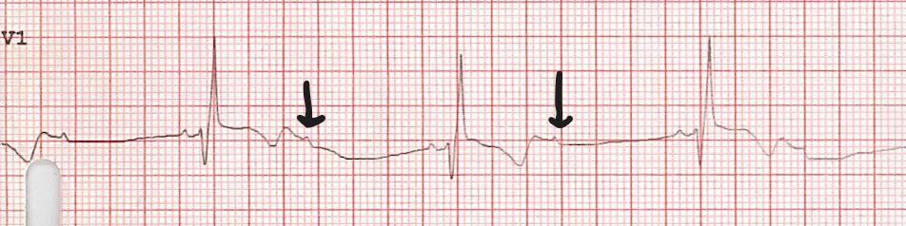
  - Junctional Bradycardia
  - Mobitz I AV block
  - Mobitz II AV block
  - Sinus Bradycardia

