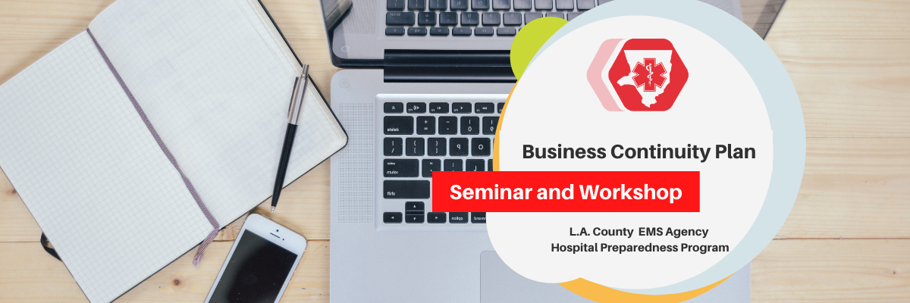
Hospital Preparedness Program
BUSINESS CONTINUITY PLAN WORKSHOP AND SEMINAR

Seminar Session Agenda
Santa Fe Springs Town Hall Center
Santa Fe Springs, CA

Tuesday, May 10, 2022
Time: 12:30pm – 4:00pm

12:30 – 1:00 REGISTRATION

1:00 – 1:10 WELCOME & INTRODUCTIONS – Terry Crammer and Darren Verrette (EMS Agency)

1:10 – 1:50 COVID-19 PLAYBOOK – Jennifer Waldron (Huntington Hospital)

1:50 – 2:30 BUSINESS CONTINUITY: SEVERAL APPROACHES TO THE SAME GOAL – Alex Lichtenstein (Ronald Reagan UCLA Medical Center)

2:30 – 2:40 BREAK

2:40 – 3:15 CRISIS COMMUNICATION – Adam Richards (Kaiser Permanente - Los Angeles Medical Center)

3:15 – 3:50 CYBER SECURITY – Troy Adams (U.S. Health and Human Services HC3)

3:50 – 4:00 CLOSING REMARKS – Darren Verrette (EMS Agency)

