**MHLA DHS CENTRAL FILL**

**Glucometer and Test Strips**

MHLA DHS Central Fill will now use a different brand of test strips: **Glucocard Expression.**

Glucocard Expression is an audible glucose monitoring system.

While MHLA will deliver test strips to patients, please inform MHLA patients to call the following number to obtain a free meter.

**Glucometer – Glucocard Expression Meter Kit**

For free meters, please call **800-566-8558.**

Clinics are able to call and obtain free meters to dispense to patients from the clinics.

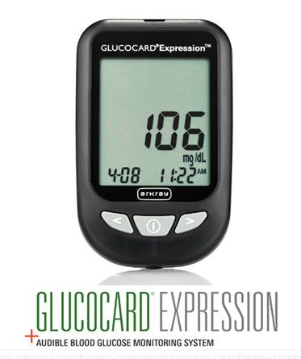

|  |  |  |
| --- | --- | --- |
|  | **Package Size** | **NDC** |
| **Glucocard Expression Test Strips** | #50/Box | 08317-5700-50 |

**Test Strips**