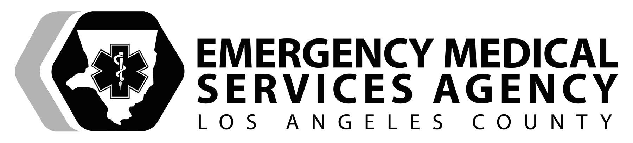NAME ____________________________

DATE _____/_____/_____

SKILL PERFORMANCE EVALUATION

NEUROLOGICAL EMERGENCY / SPINAL MOTION RESTRICTION (SMR)
LONG SPINE BOARD

PERFORMANCE OBJECTIVES
Demonstrate proficiency in performing and directing team members in spinal motion restriction using a long spine board.

EQUIPMENT
Live model or manikin, various sizes of rigid collars, long spine board, straps or binders, approved head-neck stabilization device, padding material, 2-3" cloth tape, 2-3 assistants, eye protection, masks, gown, gloves, trauma bag.

SCENARIO: ___________________________________________________________________________________________
PASS
FAIL
EXAMINER(S):______________________ Attempt: 1st 2nd 3rd (final)

PREPARATION
Performance Criteria |  | YES | NO | Comments
Establishes appropriate BSI precautions
Assess the environment for scene safety
Determines the level of SMR required
Requests three (3) additional rescuers
Approaches the patient from the front – if possible
Evaluates the need for additional BSI
Directs the patient not to move or turn his/her head: | Explains importance of remaining still
 | Explains the care being delivered
PROCEDURE
Performance Criteria |  | YES | NO | Comments
Places the patient’s head in neutral in-line position and maintains axial stabilization
Relinquishes manual stabilization of the head/neck to an assistant as soon as they arrive.
Directs an assistant to take over maintaining manual stabilization of the patient’s head and neck
Ensures manual stabilization of the head and neck is always maintained during the switch
Directs an assistant to remove the patient’s shoes and socks
Assesses all four (4) extremities for: | Circulation
 | Sensation
 | Motor movement
Sizes and applies an extrication collar using the appropriate technique
Ensures that collar does not obstruct the airway, or hinder mouth opening, ventilation or circulation

Performance Criteria |  | YES | NO | Comments
Checks for signs and symptoms of obstructed breathing | Choking
 | Coughing
 | Cyanosis
 | Unable to speak
Ensures that all team members are in the proper position prior to log rolling the
Directs one (1) assistant to bring and position the long board parallel to the patient on the opposite side of the rescuers

Gives the signal and log roll the patient towards the team members while maintaining body alignment
Assesses the back | Uses one (1) hand to hold the shoulder
 | Uses the opposite hand to palpate the back
Directs the assistant near patient’s hips to slide the board into position next to patient
Gives the signal to roll the patient back onto the board while maintaining body alignment
Centers patient vertically on board | Slides the patient towards foot of board
 | THEN
 | Slides the patient towards the head of board
Fills in spaces between the body and the board and straps with padding – if required | Occipital |  |  | Scenario dependent
 | Shoulder
 | Torso
Secures chest, hips and legs to board with straps or binder | Ensure chest expansion is not compromised and intra-abdominal pressure is not increased |  |  | Scenario dependent
Ensure the patient can take full tidal
volume breaths (chest expansion).
Restricts motion of head and neck by using an approved device

Ensure that device does not compromise patient’s airway, carotid arteries or neck veins

Performance Criteria |  | YES | NO | Comments
Ensures the patient’s arms are secured prior to transport – as appropriate for the patient’s condition: | Conscious
 | Unconscious
Re-assesses the extremities for: | Circulation
 | Sensation
 | Motor function
Lifts the long spine board with the patient onto the gurney
Secures the spine board with the patient to the gurney
Rolls the gurney to the ambulance
Rolls the patient off the long board prior to loading the patient into the ambulance, while maintaining SMR of the head and neck
Developed 3/10 Revised 11/2017

