

**EMS SKILL**

SOFT TISSUE INJURY / BANDAGING

**PENETRATING CHEST INJURIES**

**PERFORMANCE OBJECTIVES**

Demonstrate competency in applying a dressing to an open chest wall injury. (No through and through injury to the back)

**CONDITION**

Assess and apply a vented chest seal OR a three (3) sided occlusive dressing to an open chest wall injury. Necessary equipment will be adjacent to the patient or brought to the field setting.

**EQUIPMENT**

Manikin or live model, bag-mask-ventilation device, O2 connecting tubing, oxygen source with flow regulator, vented chest seal, petroleum gauze dressings, 4 X 4 gauze squares, 2 inch tape, clear plastic wrap, foil, goggles, masks, gown, gloves.

**PERFORMANCE CRITERIA**

• Items designated by a diamond (⧫) must be performed successfully to demonstrate skill competency.

• Items identified by double asterisks (**) indicate actions that are required if indicated.

• Items identified by (§) are not skill component items, but should be practiced.

|  |  |
| --- | --- |
|  | |
| **PREPARATION** | |
| **Skill Component** | **Key Concepts** |
| ⧫ Establish body substance isolation precautions | • Mandatory (minimal) personal protective equipment – gloves |
| ⧫ Assess for scene safety/scene size-up  ***\*\*Consider spinal motion restriction (SMR) - if indicated*** | • SMR should be initiated when spinal trauma is suspected by taking bystander information and mechanism of injury into consideration. |
| ⧫ Evaluate the need for additional BSI precautions | • Situational - goggles, mask, gown |
| ⧫ Places the patient on oxygen at 15L/min via non-rebreather  ***\*\*Monitor the oxygen saturation level – if able***  ***\*\*Provide positive pressure ventilation – if indicated*** | * All patients with a suspected pneumothorax get high flow oxygen. * If available, use pulse oximetry to guide oxygen delivery. The desired SpO2 for most non-critical patients is 94-98%   **SPECIAL CONSIDERATION:** For patients with chronic obstructive pulmonary disease (COPD), the goal is to titrate oxygen to keep the SpO2 at 88-92%.   * SpO2 reading must always be documented on the EMS Report or ePCR. * The indications for positive pressure ventilation are:   + Apnea/Respiratory Arrest   + Cardiopulmonary Resuscitation   + Respiratory Failure: shortness of breath, tachypnea, air hunger (feeling like you cannot breathe, cyanosis, ALOC, drowsiness   + Stridor   + Gasping |
| ⧫ Remove enough clothing to expose the entire chest and back and look for wounds | * Penetrating wounds to the chest may cause an open pneumothorax. * The patient’s back must also be assessed for the presence of through and through wounds. |

|  |  |
| --- | --- |
| **Skill Component** | **Key Concepts** |
| ⧫ Verbalizes the signs and symptoms of a tension pneumothorax:   * Apprehension * Pain aggravated by breathing * Bruising * Dyspnea * Absent lung sounds on the affected side * Tachycardia * Hypotension * Tracheal deviation * Subcutaneous emphysema * Decreased level of consciousness | * A tension pneumothorax is a life-threatening emergency. Air continues to enter the pleural space and the intrathoracic pressure increases. The lung on the affected side collapses as the pressure continues to build up. The structures in the mediastinum are displaced to the other side of the chest. Ultimately, this affects venous return to the heart and leads to a decreased cardiac output and obstructive shock. * Tracheal deviation is a late finding and rarely seen in the prehospital setting. * Distended neck veins may not be present in cases where the patient as lost a significant amount of blood. * The presence of subcutaneous emphysema is a common finding. Air escapes through the chest wall into the tissues surrounding the injury. A crackling sensation is felt when the skin around the injury is palpated. * A common finding is decreased lung sounds on the affected side   ***NAEMT, Prehospital Trauma Life Support, Eight edition, page 344-345*** |
|  | |
| **PROCEDURE** | |
| **Skill Component** | **Key Concepts** |
| ⧫ Place your gloved hand and gauze over the penetrating wound | * Placing a gloved hand over the penetrating wound provides a temporary seal. |
| ⧫ Wipe away any excess blood around the chest wound | * Consider the use additional BSI measures - if warranted. |
| ⧫ Peel the backing off of the vented chest seal  ***\*\* Place the chest seal directly over the wound. (Wound should be in the center of the vented chest seal)*** | * Air leaks may be minimized by placing the wound under the center of the chest seal. |
| ⧫ Apply a vented chest seal over the chest wound | * The initial management of a penetrating chest injury includes sealing the chest defect. * The wound should be in the center of the vented chest seal. |
| ⧫ Apply an occlusive dressing to a penetrating chest would if a vented chest seal is not available:  ***\*\* Seal the chest wound with an occlusive dressing***  ***and secure the dressing on three (3) sides.*** | * There is no evidence to support whether sealing the dressing on three (3) sides is better than sealing all four (4) sides. |
| ⧫ Remove the occlusive dressing if:   * The patient status deteriorates * There are signs and symptoms of a tension pneumothorax   ***\*\* Transport the patient by ALS*** | * Removal of the occlusive dressing should allow the tension pneumothorax to decompress through the wound. * The definitive treatment for a tension pneumothorax includes needle decompression of the chest which can only be performed by ALS providers. |

|  |  |
| --- | --- |
| **RE-ASSESSMENT**  **(Ongoing Assessment)** | |
| **Skill Component** | **Key Concepts** |
| § Re-assess the patient every five (**5) minutes or sooner for** unstable patients and every **15 minutes for stable** patients.   * Primary assessment * Relevant portion of the secondary assessment * Vital signs: Blood pressure, pulse and respirations * Lung sounds * SpO2 * Pain scale   ***\*\*Manage patient condition as indicated.*** | • A patient with an open chest wound is an unstable patient as they may have abnormal vital signs, S/S of poor perfusion, and their condition may deteriorate rapidly.   * Patients must be re-evaluated at least every five (5) minutes or sooner if any treatment was initiated, medication administered, or if a change in the patient’s condition is anticipated. * Evaluating and comparing results assists in recognizing if the patient is improving, responding to treatment, or if their condition is deteriorating. |
| **PATIENT REPORT AND DOCUMENTATION** | |
| **Skill Component** | **Key Concepts** |
| § Verbalize/Document:  • Mechanism of injury  • Description of injury  • Treatment rendered | • Documentation must be on the Los Angeles County EMS Report form, departmental ePCR, or Patient Care Record form.  • Documenting re-assessment information provides a comprehensive picture of patient’s response to treatment. |

Developed: 11/2018



SOFT TISSUE INJURY / BANDAGING

**PENETRATING CHEST INJURY**

**Supplemental Information**

**SIGNS & SYMPTOMS OF A TENSION PNEUMOTHORAX:**

* Apprehension
* Chest discomfort
* Absent lung sounds on the affected side
* Tachypnea
* Tachycardia
* Juglar venous distension (JVD)
* Tracheal Deviation
* Subcutaneous emphysema
* Hypotension
* Decreased level of consciousness

**NOTES:**

* Penetrating injuries to the chest creates a hole in the chest wall thereby allowing air to flow into and out of the pleural space.
* As more and more air is drawn into the pleural space, the lung begins to collapse and there is decreased ventilation.
* Pneumothorax is present in 20% of severe chest injuries and it is a life threatening event.
* The management of a penetrating chest injury is aimed at early recognition of providing ventilatory support and preventing a simple pneumothorax from developing into a tension pneumothorax.
* Communication with the patient, family, or care giver is important. Explain all care being rendered.
* Occlusive dressings consist of a chest shield, plastic wrap, foil, or sheeting.

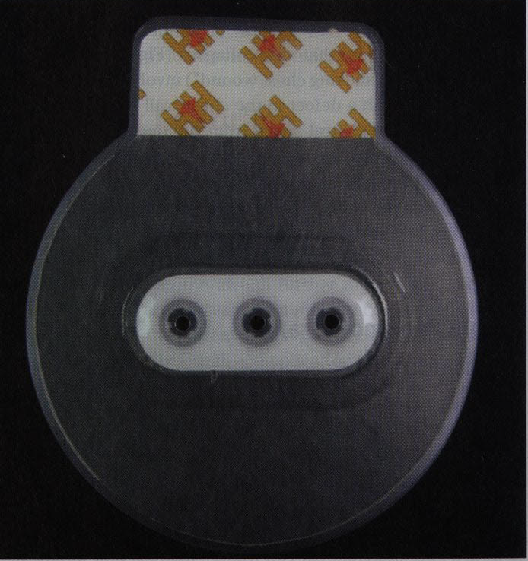

***NAEMT, Prehospital Trauma Life Support, Eight edition, pages 344-345***

|  |  |  |
| --- | --- | --- |
| **COMPONENTS OF A TRAUMA BAG:** | | |
| **Adhesive dressings (Band-Aid®** | **Dressings – Trauma, 4X4, Vaseline** | **Gauze bandages** |
| **Trauma shears** | **Splints – long, short, and traction** | **Extrication device** |
| **Commercial chest seals** | **Tape – assorted sizes** | **Head immobilizer device** |
| **Tourniquets** | **Occlusive dressing / Vaseline gauze** | **C-collars** |
| **Hemostatic dressings** | **Normal saline irrigation** | **Flashlight** |
| **PPE: gloves/gown/goggles** | **Burn pack or burn sheet** |  |
|  |  |  |

And