LITHIUM-ION BATTERY SAFETY

Prepared by Chief Executive Office, Risk Management Branch
Loss Control and Prevention Section
320 W. Temple St., Suite 7th Floor, Los Angeles, CA 90012
Call (213) 738-2269 for additional information.

______________________________________________________________________

LITHIUM-ION BATTERIES

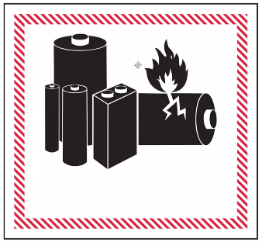
Lithium-ion batteries store a large amount of energy in a small amount of space. Due to this feature, they are used to supply power to many kinds of devices including smart phones, laptops, e-scooters and e-bikes, e-cigarettes, smoke alarms, toys, and even cars. If used incorrectly, such as for an application other than originally designed, or if they become damaged or defective, these batteries can overheat, catch on fire, or explode.

LITHIUM-ION BATTERY SAFETY RECOMMENDATIONS

- Only purchase and use devices, batteries, and charging equipment that are listed by a nationally recognized testing lab and labeled accordingly. Look for these markings or symbols:
  - “CSA” (CSA Group)
  - “ETL” (Intertek)
  - “UL” (Underwriters Laboratories)
  - Note: If product has a “CE” marking, it means it’s sold in Europe and isn’t recommended for use in the United States.
- Always follow the manufacturer’s instructions.
- Only use the battery that is designed for the device.
- Place batteries in the device the right way.
- Only have device repairs performed by a qualified professional.
- Only use the charging equipment that is supplied with your device.
  - Many “aftermarket” chargers have been known to overheat.
- Stop charging a battery once it is full (at 100%) and remove from power source to avoid overheating.
- Store batteries at room temperature when possible.
- Don’t store lithium-ion batteries in direct sunlight or inside vehicles.
- Keep batteries or devices away from heat sources.
- Keep batteries or devices away from anything that can catch fire.
- Do not charge a battery when either the charger or the battery is damaged.
- Do not store batteries in an area that blocks the only exit out of a room.
- Do not attempt to modify the battery or charger.

PROBLEM INDICATORS

Stop using the battery if you notice these problems:
- Odor
- Change in color
- Excessive heat
- Change in shape
- Leaking
- Odd noises

If you encounter any of these and it is safe to do so, move the device away from anything that can catch fire. Call 911 if necessary.

BATTERY DISPOSAL

Do not place lithium-ion batteries in the trash. Recycling is the best option. Do not place discarded batteries in piles. Follow your department’s battery recycling procedure if you must dispose of the battery at your work location.

CHARGING E-BIKE or ELECTRIC VEHICLE

The safest place to charge these devices is outdoors in a flat, dry area away from structures, children, direct sunlight, liquids, tripping hazards, and in a location where the electronic vehicle is not at risk of falling.

