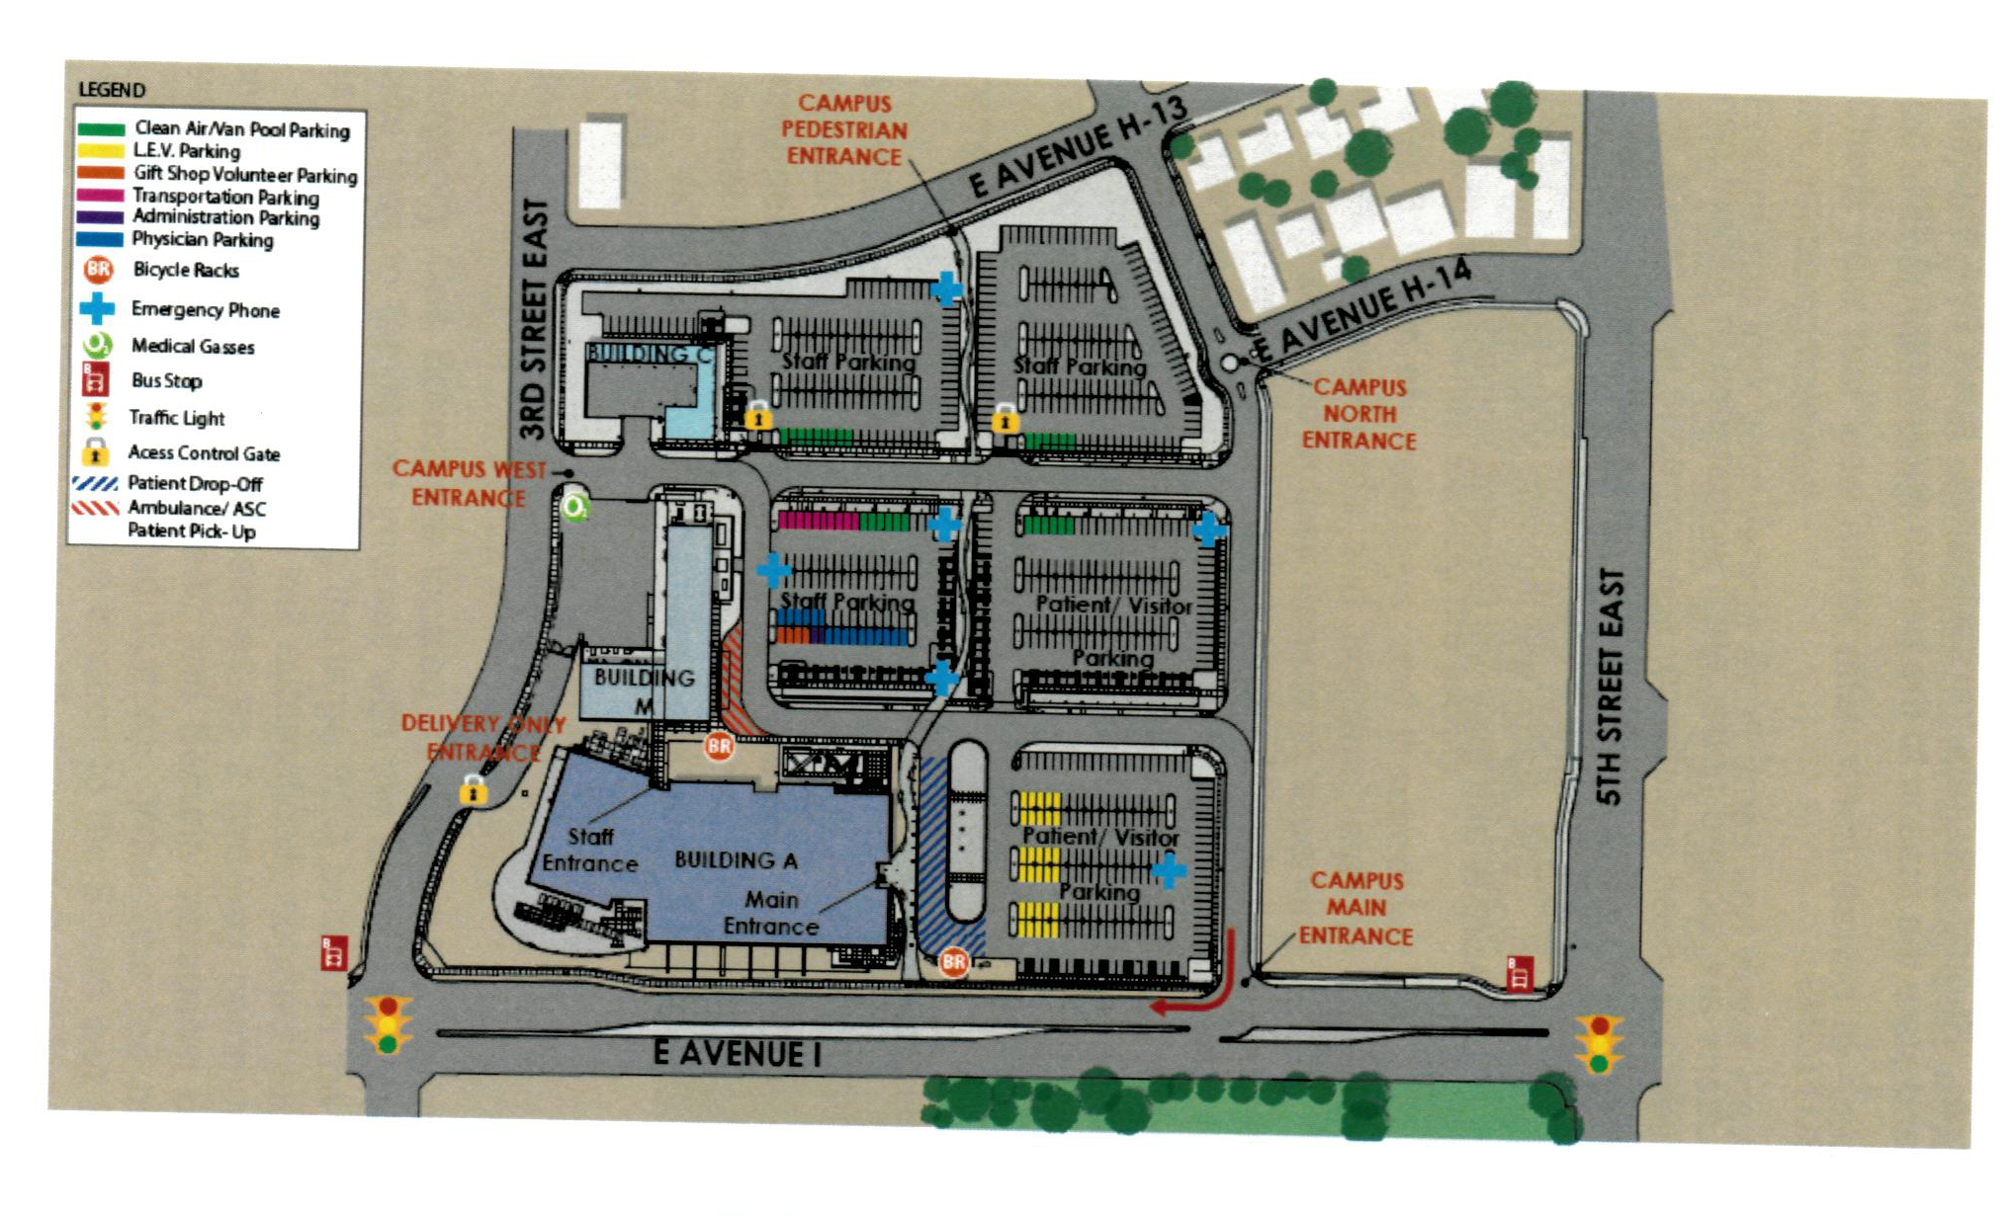
Bus Stop 641 Bus #11 EB
Bus Stop 640 Bus #11 EB
HUB Unit 12

Bus: Take bus number 11 and stop at 640 on 3rd Street East or 641 on 5th Street East
Walk into Building A Main Entrance and register in the lobby. HUB is on the 1st floor Unit 12
By car, park anywhere in the patient/visitor parking lots and walk into Building A Main Entrance and register in the lobby. HUB is on the 1st floor Unit 12

