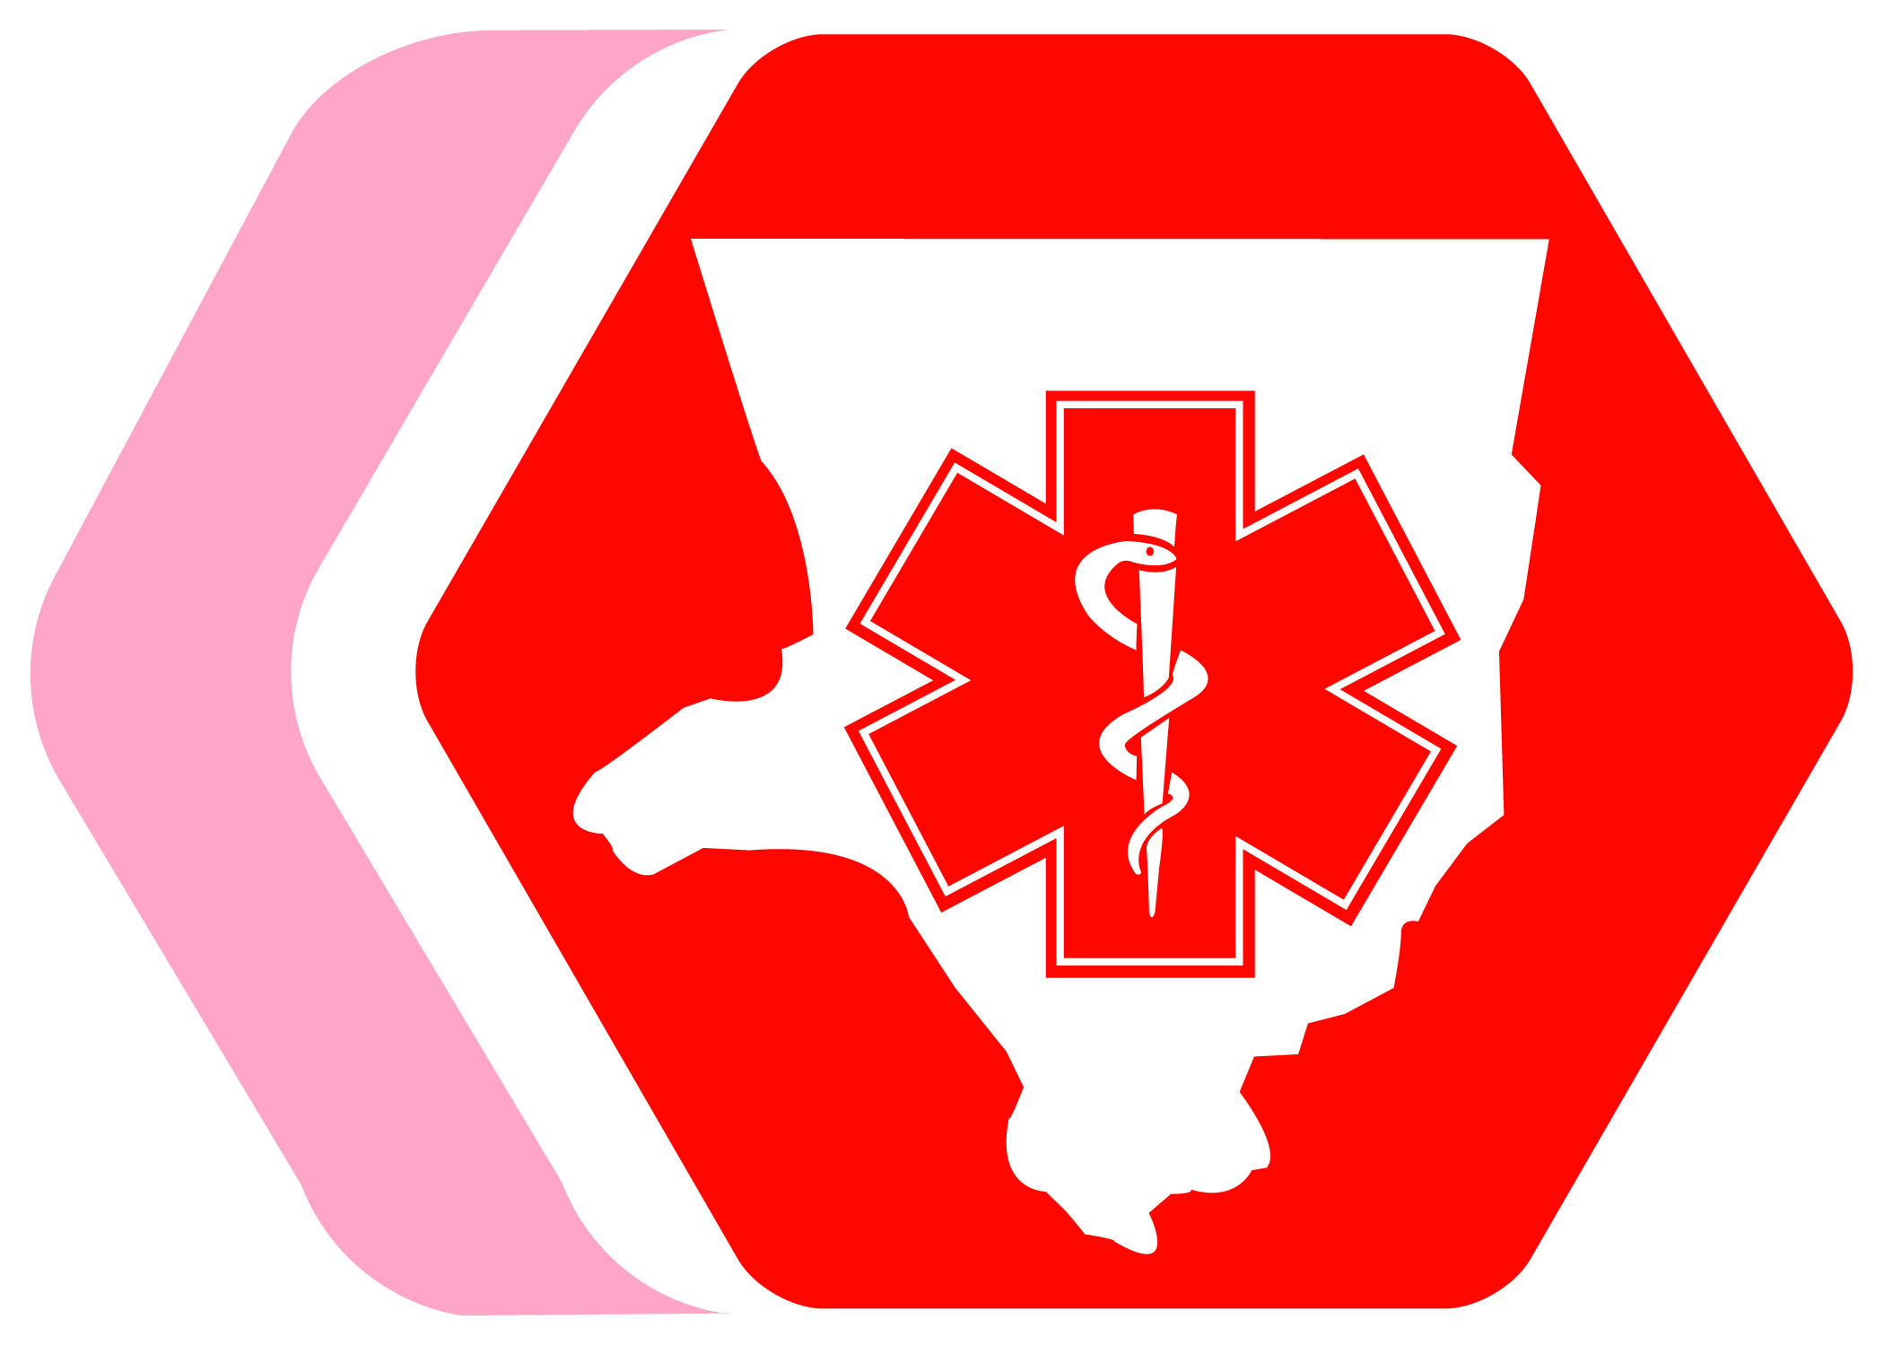

Los Angeles County Emergency Medical Services Agency

Recommended Actions for EMS Providers
To Prepare For and Respond to Pandemic Influenza

Updated December 2009

Table of Contents

Overview 1
Community Wide Coordination and Control 2
Key Contact Information 3
Planning Assumptions 4

Quick Reference Charts
Pandemic Influenza Guidelines for EMS Providers – Management 5
Pandemic Influenza Guidelines for EMS Providers – Responders 6

Recommended Actions
Preparedness Period 7
Enhanced Operations Period 10
Pandemic Response Period 13
Recovery Period 16

Additional Resources
Web Resources 17
Comparison of Seasonal, Pandemic and H1N1 Influenza 20
Sample: Stopping the Spread of Germs at Work Handout 22
Sample: Cover Your Cough Poster 24
US DHHS EMS and Non-Emergent (Medical) Transport Organizations Pandemic Influenza Planning Checklist 25
Influenza-like Illness (ILI) Assessment Tool 32
9-1-1 Public Safety Answering Points (PSAP) and EMD 33
Sample: Call Flow for Standard EMD Calls vs Pandemic Flu Calls 35
Patient Assessment 36
Infection Control 37
US DHHS Pandemic Influenza Plan, Supplement 4 Infection Control, Pre-Hospital Excerpt 38
Personal Protective Equipment (PPE) 42
Use of Masks During a Pandemic 45
Conservation of Resources 46
Sample: Steps for Safe Redonning (Reuse) of Your N95 Respirator Poster 49
Patient Transport 50
Cleaning Emergency Service Transport Vehicles 51
Staffing Considerations 52
Human Resources Policy Considerations 54
Employee Health Considerations 56
Occupational Health Management of Health Care Workers During an Influenza Pandemic 58
Sample: Employee Health Evaluation and Management Flow Chart 59
Vaccine Information 60
Antiviral Information 61
Workforce Support: Psychosocial Considerations 62
WHO Pandemic Influenza Phases 65
US DHHS Pandemic Severity Index 67

overview

For EMS providers, the winter season is routinely characterized as a time of high volume and taxing demand. Not surprisingly then, during even normal circumstances, the healthcare system in Los Angeles County (LAC) can be easily overwhelmed. The projected tremendous and unprecedented demand for healthcare services during a pandemic will likely challenge our healthcare resources to levels not previously experienced.

All of the preplanning in the world will not eliminate the increased demand that comes with a pandemic, but preparation can ease the burden on EMS personnel and administration. In order to assist EMS Providers to better prepare for and cope with a region-wide pandemic, the LAC Emergency Medical Services Agency developed lists of Recommended Actions to Prepare EMS Providers for Pandemic Influenza by Pandemic Phase, released in March 2007.

In 2009, we gained experience and learned lessons as we responded to the Influenza A H1N1 pandemic. As a result, the LAC Emergency Medical Services Agency has released this updated guidance, Recommended Actions for EMS Providers to Prepare for and Respond to Pandemic Influenza. The most notable change is the decreased reliance on the World Health Organization’s Pandemic Influenza Phases as triggers for action, and the increased need for local situational awareness, assessment and impact as the basis for alterations in operations.

In the vein of all-hazards or generalized planning, these Recommended Actions continue to focus on pandemic influenza planning as a whole, rather than specific H1N1 preparedness and response. They can also be applied to any infectious communicable disease outbreak, not just influenza. During a pandemic, all stakeholders will have to collaborate to assure the best achievable coordination and outcome for patients, staff and their families.

NOTE: In the initial response phase to a novel virus, a more conservative approach may be taken, e.g., implementing the use of airborne protection (N95 respirators). This may change to droplet precautions (e.g., the use of surgical masks) or remain at airborne precautions based on the mode of virus transmission, communicability, and virulence of the circulating virus as more information becomes known.

To make recommendations for future updates, please contact Kay Fruhwirth, Assistant Director, LAC EMS Agency, at 562-347-1602 or kfruhwirth@dhs.lacounty.gov.

community wide coordination and control

Declaration of an Influenza Pandemic Emergency
Responsible for declaring when an outbreak of a novel virus has reached the pandemic stage:
- Globally: World Health Organization (WHO)
- United States: U.S. Centers for Disease Control and Prevention (CDC)
- Los Angeles County: The LAC Health Officer, as Incident Manager for the county’s public health response, will determine when the novel virus is present and impacting LAC.

Once the novel virus has been identified locally, the Health Officer may do any or all of the following:
- Activates the operational aspects of LAC’s Pandemic Influenza Preparedness and Response Planning Guidelines
- Notifies the members of the LAC Emergency Management Council
- Notifies the LAC Board of Supervisors
- May declare a local Public Health Emergency and enact legislated public health powers detailed in the State Health and Safety Code, but the Board of Supervisors must approve the declaration of a local emergency
- If the county’s Emergency Operations Center (EOC) is activated to manage the county’s response effort, the Health Officer will designate personnel to staff the county EOC and represent the Department at the Operational Area level

Coordination of the LAC Health Response
The coordination of the LAC’s medical and health response will be a collaborative effort between the LAC Department of Health Services (DHS) and LACDPH. The DHS Department Head will activate the DHS Department Operations Center (DOC) to assist with the management of the healthcare system and emergency medical services response. The DOC is organized according to the Incident Command System.

Coordination of the LAC EMS Response
As part of an overall preparedness plan for dealing with periods of excess demand on emergency medical services, the DHS, in cooperation with EMS Provider Agencies and hospitals, may implement the following actions:
- Initiate a tracking system for trending the impact of the pandemic on EMS providers and hospitals.
- The EMS Agency may permit BLS ambulances to honor emergency department diversion and transport patients to the next closest facility.
- If the trend indicates a region-wide crisis and there is no value in diverting ambulances away from emergency departments, the Director of the EMS Agency may require all hospitals to maintain an “open” emergency department and no emergency department diversions will be honored. Re-evaluation of this policy would take place every 24 hours until the pandemic is over.
- Public Health may issue advisories to the public regarding the pandemic and the appropriate use of 9-1-1 services and emergency departments versus clinics, urgent care and/or alternate care centers.
- EMS Agency, EMS Provider Agencies, Public Health, Los Angeles County Medical Association, Los Angeles County Emergency Medical Directors Association, Community Clinic Association of Los Angeles County and other stakeholders may participate in ongoing conference calls to assist in the development of appropriate coordination and response planning to the pandemic.

Pandemic Response Guidance
During the pandemic, the LACDPH will provide guidance on infection control (including PPE), altered standards of care, alternate care sites, vaccine, antiviral medications, and community containment measures. The guidance will be based on information and best practices from WHO, CDC, California Department of Public Health (CDPH), and other jurisdictions affected by the pandemic.

Key Contact Information
Los Angeles County Department of Health Services Emergency Medical Services Agency
- General: 562-347-1500
- 24/7 Medical Alert Center (MAC): 866-940-4401
- http://ems.dhs.lacounty.gov

Los Angeles County Department of Public Health Acute Communicable Disease Control, Biological Incident Reporting
- Business hours: 213-240-7941; After hours: 213-974-1234
- http://www.lapublichealth.org

Los Angeles County Department of Mental Health
- 24/7 hotline: 888-854-7771
- http://dmh.lacounty.gov

Los Angeles County Department of Coroner
- 24/7: 323-343-0714
- http://coroner.lacounty.gov
Planning assumptions

Adapted from CA Emergency Medical Services Authority Pandemic Influenza Planning and Preparedness Framework For Local Emergency Medical Services Agencies, October 8, 2009: www.emsa.ca.gov/about/files/PandemicFrameworkForEMSProviders.doc

During a pandemic, EMS providers will be required to continue to respond to day-to-day medical calls while also responding to the increased volume, or surge, of medical calls due to influenza-like illness. The increase in call volume will be exacerbated by hospital overload and diversion and absenteeism. EMS Providers should develop plans and protocols to modify practices to maximize resources and maintain an adequate level of EMS services.

EMS goals for pandemic planning include:
- Reducing transmission among staff and protecting the workforce;
- Protecting people (patients) who are at increased risk of influenza related complications from getting infected with influenza; and
- Maintaining EMS services and business operations.

EMS Pandemic influenza planning assumptions include:
- One solution or protocol may not be applicable for all EMS Providers. A baseline assessment of your organization’s absenteeism, call volume, wait time, etc., is crucial in determining triggers for altering operations.
- Planning for surge management and alteration of EMS practices must address implementation triggers, guidance for decision-making, communication strategies, and just-in-time training and education for personnel.
- Modification of protocols should be based on local need with collaboration between the EMS Provider, the LAC EMS Agency and LACDPH.
- EMS response to pandemic influenza should be flexible, scalable, dynamic and timely with the ability to change rapidly based on new information about the pandemic virus.
- Optimal patient outcomes will depend on an EMS system’s pre-planned ability to quickly integrate emerging medical research and information. The effectiveness of patient care will require responsive medical direction, training, and coordinated system oversight.
- EMS providers can play an important role in pandemic influenza mitigation due to their capability to rapidly respond, assess, treat, and report patients with signs and symptoms of influenza-like illness (ILI).
- Mutual aid may be limited or non-existent within or from outside of California.

See the US DHHS EMS and Non-Emergent (Medical) Transport Organizations Pandemic Influenza Planning Checklist on page 25 for a comprehensive planning guide.

pandemic influenza guidelines for EMS Providers – Management
preparedness | Actions
TRIGGERS FOR ACTION | - Assess supplies needed for universal precautions  - Review the differences between seasonal and pandemic influenza  - Fit test staff for N-95 masks  - Educate staff on how they can stop the spread of germs  - Post 'respiratory etiquette' posters and signs in work areas  - Provide boxes of facial tissues and trash receptacles  - Provide alcohol-based hand washing gel in all emergency vehicles  - Subscribe to LAC Public Health Flu Watch Listserv  - Develop pandemic influenza plan  - Determine EMS provider essential functions
Impact on Day-to-Day EMS Operations
None; this is a period of preparedness
enhanced operations | Actions
TRIGGERS FOR ACTION | - Review and update internal emergency operations plans  - Plan for infrastructure disruptions  - Establish vacation and on-call procedures for peak periods  - Locate supplemental transport assets  - Evaluate triage models  - Consider placing masks on all patients transported with flu-like symptoms  - Educate staff on the current situation  - For updated information, review:  - US DHHS, http://www.pandemicflu.gov/  - LAC Public Health, http://lapublichealth.org/  - Activate internal emergency operations plans and educate staff  - Engage mutual aid partners  - Maximize usage of supplies needed for universal precautions and other basics  - Conserve usage of BLS and ALS units  - Begin creating adjusted staffing patterns  - Implement changes to vacation and on-call policies  - Update staff on the current situation  - Educate staff on staffing and procedures changes  - Implement guidelines received from LAC EMS Agency
Impact on Day-to-Day EMS Operations
Possible impacts that may trigger the need for enhanced or altered operations include:
- Confirmed or suspect cases near Los Angeles County
- Increased staff absenteeism by x%
- Increased call volume by x%
- Decreased resource availability
- Increased wait time by x%

NOTE: Each department/agency will need to determine their own thresholds based on baseline assessments of these trigger points and the level of impact upon the department/agency.
pandemic response | Actions
TRIGGERS FOR ACTION | - Implement internal emergency operations plans  - Implement adjusted staffing patterns  - Implement essential staffing and services only  - Limit the number of responders to the minimum necessary  - Maintain 6 foot separation of all staff in sleeping quarters  - Monitor the health of staff  - Implement plan to evaluate symptomatic staff before report for duty  - Reassess staffing and consider redistribution of resources  - Decontaminate ambulances using standard operating procedures  - Follow LAC EMS Agency guidelines for patient transport, as available  - Follow Public Health guidelines for vaccine and/or antivirals, as available
Impact on Day-to-Day EMS Operations
Possible impacts that may trigger the need for enhanced or altered operations include:
- Confirmed or suspect cases in Los Angeles County, and/or among staff
- Increased staff absenteeism by x%
- Increased call volume by x%
- Decreased resource availability
- Increased wait time by x%
Recovery | Actions
TRIGGERS FOR ACTION | Prepare for a possible next wave:  - Conduct staff debriefings on what went well and what needs improvement  - Implement appropriate changes based on debriefing and other analysis  - Replenish supplies  - Continue to monitor the health of staff
Impact on Day-to-Day EMS Operations
Possible impacts that may trigger the need for enhanced or altered operations include:
- All triggers returns to baseline

pandemic influenza guidelines for EMS Providers – responders
preparedness | Actions
TRIGGERS FOR ACTION | - Use universal precautions for every patient encounter  - Review the differences between seasonal and pandemic influenza  - Get fit tested for N-95 masks  - Learn how to stop the spread of germs  - Follow 'respiratory etiquette'  - Use facial tissues and trash receptacles  - Use alcohol-based hand washing gel after all patient contact
Impact on Day-to-Day EMS Operations
None; this is a period of preparedness
enhanced operations | Actions
TRIGGERS FOR ACTION | - Continue to use universal precautions for every patient encounter  - Perform safe work practices  - Review internal emergency operations plans  - Review triage models  - Consider placing masks on all patients transported with flu-like symptoms  - Notify receiving facility that patient has flu-like symptoms  - Attend trainings on the current situation  - Implement guidelines received from LAC EMS Agency
Impact on Day-to-Day EMS Operations
Possible impacts that may trigger the need for enhanced or altered operations include:
- Confirmed or suspect cases near Los Angeles County
- Increased staff absenteeism by x%
- Increased call volume by x%
- Decreased resource availability
- Increased wait time by x%

NOTE: Each department/agency will need to determine their own thresholds based on baseline assessments of these trigger points and the level of impact upon the department/agency.
pandemic response | Actions
TRIGGERS FOR ACTION | - Continue to use universal precautions for every patient encounter until otherwise instructed  - Consider placing masks on all patients transported with flu-like symptoms  - Ventilate ambulances if possible  - Notify receiving facility that patient has flu-like symptoms  - Implement internal emergency operations plans  - Load ambulances with more than one patient with like symptoms  - Limit the number of responders to the minimal necessary  - Maintain 6 foot separation of all staff in sleeping quarters  - Decontaminate ambulances using standard operating procedures  - Follow LAC EMS Agency for patient transport, as available  - Follow Public Health guidelines for vaccine and/or antivirals, as available
Impact on Day-to-Day EMS Operations
Possible impacts that may trigger the need for enhanced or altered operations include:
- Confirmed or suspect cases in Los Angeles County, and/or among staff
- Increased staff absenteeism by x%
- Increased call volume by x%
- Decreased resource availability
- Increased wait time by x%
recovery | Actions
TRIGGERS FOR ACTION | Prepare for a possible next wave:  - Participate in debriefings on what went well and what needs improvement
Impact on Day-to-Day EMS Operations
Possible impacts that may trigger the need for enhanced or altered operations include:
- All triggers returns to baseline

Recommended Actions: preparedness Period

TRIGGERS FOR ACTION
Impact on Day-to-Day EMS Operations
None; this is a period of preparedness

Management
- Assess supplies needed for universal precautions. Identify baseline consumption during a regular flu season. Identify possible supply chain disruptions including identification of necessary supplies, purchase, storage and distribution. Review Conservation of Resources on page 46.
- Review the differences between seasonal and pandemic influenza. See chart on the Comparison of Seasonal Influenza, Pandemic Influenza and H1N1 Influenza on page 20.
- Fit test staff for N-95 masks. However, surgical masks may be used as needed. See Use of Masks During a Pandemic on page 45.
- Educate staff on stopping the spread of germs at the work place. See CDC handout on page 22.
- Post 'respiratory etiquette' posters and signs in work areas. See CDC poster: Cover Your Cough on page 24.
- Provide boxes of facial tissues and trash receptacles in the work place and for patient transport.
- Provide alcohol-based hand washing gel in all emergency vehicles and the work place and promote its use.
- Subscribe to LAC Public Health Flu Watch Listserv. The Influenza Watch LISTSERV of the LAC DPH is maintained by the Acute Communicable Disease Control Program. The purpose of this LISTSERV is to keep health professionals informed about local, state and national influenza activity. Influenza Watch is sent out to all subscribers every week during flu season. Send an email to ListServ@ListServ.ladhs.org, and in the body of the email enter SUBSCRIBE FLUWATCH. No information in the subject line is needed. All Influenza Watch editions are also posted at http://publichealth.lacounty.gov/acd/Flu_Sea_Surveillance.htm.
- Review the US DHHS Pandemic Influenza Planning Checklist for Emergency Medical Services on page 25. Planning considerations include:
  - Consider what is the threshold at which it may not be possible to respond to all calls for service
  - Protocol development for field assessment and treatment based on latest information available from the CDC
  - What operational procedures would need to be altered to respond as effectively as possible (e.g., loading ambulances with more than one patient with like symptoms).
  - Consider protocols for nontransport, alternate destinations, alternative transportation
- Develop plan for infection control
- Develop plan for employee screening
- Plan and develop protocols for assessment, triage and transport with medical control with consideration to alternative care sites and modified response and treatment protocols for all patients including those with pandemic influenza
- Participate in planning with EMS, public health and emergency management for pandemic influenza
- Develop security plan for facility, vehicles, and personnel
- Mutual aid agreements
- Plan for vaccination and/or prophylaxis of personnel and families
- Discuss the coordination of public information planning program; determine what and how are you going to tell the public if/when you are forced to curtail services
- Revise transfer agreements and transfer protocols with healthcare (including skilled nursing and long term care) facilities and hospitals which reflect modified procedures to be used during a pandemic
- Coordinate suggested referral policies or agreements with local home health agencies
- Plan for housing, food and water etc for staff who must remain close to work
- Psychosocial issue: review the Impact of Pandemic Influenza on Healthcare Workers and the Checklist for Workforce Support Services/Resources on page 62.
- Fatality management: The current role of EMS providers in fatality management should be modified to allow the rapid return to service of EMS resources. The response of the LAC Department of Coroner to the scene of a death may be delayed by hours or days during a pandemic. Under current protocols, EMS providers may not be able to leave the scene until another authority arrives. Contact should be made with the Coroner to identify procedures.
- Determine EMS provider essential functions (or primary mission) that must be continued to meet community or contractual requirements.
- Plan for the continuation of essential functions and identify the resources that can be used and/or redirected to maintain the essential functions
- Identify front-line, highly technical, and skilled personnel that provide the essential functions or provide support for the front-line providers (e.g., dispatch)
- Plan for triage and conserve use of advanced life support (ALS) versus basic life support (BLS) units
- Identify non-essential functions that may be suspended or cancelled during peak pandemic response.
- Determine the triggers for termination and resumption of non-essential functions as the pandemic evolves.
- Plan for communication to staff, partners, and other stakeholders when non-essential services are terminated and resumed.

Responders
- Use universal precautions for every patient encounter.
- Review the differences between seasonal, pandemic and H1N1 influenza. See chart on the Comparison of Seasonal, Pandemic and H1N1 Influenza on page 20.
- Get fit tested for N-95 masks. However, surgical masks may be used as needed. See Use of Masks During a Pandemic on page 45.
- Learn how and follow steps to stop the spread of germs.
- Follow 'respiratory etiquette' procedures.
- Use facial tissues and trash receptacles.
- Use alcohol-based hand washing gel after all patient contact.

Recommended Actions: enhanced operations

TRIGGERS FOR ACTION
Impact on Day-to-Day EMS Operations
Possible impacts that may trigger the need for enhanced or altered operations include:
- Confirmed or suspect cases near Los Angeles County
- Increased staff absenteeism by x%
- Increased call volume by x%
- Decreased resource availability
- Increased wait time by x%

NOTE: Each department/agency will need to determine their own thresholds based on baseline assessments of these trigger points and the level of impact upon the department/agency.

Management
- Review and update internal emergency operations plans. Consider appointing a workplace coordinator(s) who will be responsible for addressing pandemic flu issues and their impact at the workplace. Examples of responsibilities include:
  - Acting as the point of contact with EMS Agency, LACDPH, healthcare providers, and other key response partners for situation status and current information and recommendations.
  - Developing, revising, and implementing response protocols.
  - Monitoring and tracking employee health and safety.
  - Monitoring and reporting trends, critical issues, and inventories of essential supplies.
  - Identifying the triggers (conditions) for activation of the EOP and COOP and the transition to emergency operations and termination of emergency response and a return to readiness.
- Plan for infrastructure disruptions that may result due to staffing shortages in other industries. These may include a reduction or lack of services in utility, sanitation, transportation (including fuel), information technology, supply chain, communications, and education fields. Develop contingency plans to maintain operations if one or more of these industries are impacted and services decline.
- Establish vacation and on-call procedures for peak periods. Review Human Resources Policy Considerations on page 54.
- Locate supplemental transport assets.
- Evaluate triage models and dispatch screening. Review PSAP and EMD Guidance on page 33.
- Consider placing masks on all patients transported with flu-like symptoms. Review the Influenza-Like Illness Assessment Tool on page 32. Review the US DHHS Pandemic Influenza Plan, Supplement 4, Pre-Hospital Excerpt on page 38 for additional infection control information.
- Educate staff on the current pandemic influenza situation. Establish internal mechanisms for rapid communication of information to employees, including call down lists/call trees, hotline numbers, emails and text messages, conference calls. Minimize use of on-site face-to-face briefings. Communicate with staff and provide “just-in-time” training on EOP activation and emergency operations roles and responsibilities. Updated information will be distributed by the LACEMS Agency to all EMS providers as well as posted on the LAC EMS Agency website, http://ems.dhs.lacounty.gov/.
- For updated information, review: US DHHS, www.pandemicinfluenza.gov and LACDPH, http://lapublichealth.org/acd/Pandemicflu.htm.
- Activate internal emergency operations plans, and educate staff on these plans.
- Encourage safe work practices among EMS personnel to prevent transmission of influenza. Activities include:
- Avoid touching one’s face with contaminated gloves.
- Avoid unnecessary touching of surfaces in the ambulance vehicle.
- Arrange for the receiving facility staff to meet the patient at the ambulance door to limit the need for EMS personnel to enter the emergency department in contaminated PPE. (It may not be practical to change PPE before patient transfer into the facility.) Remove and discard PPE after transferring the patient at the receiving facility and perform hand hygiene. Treat used disposable PPE as medical waste.
- Engage mutual aid partners, if possible.
- Maximize usage of supplies needed for universal precautions and other basics. Determine trigger for possible conservation and appropriate reuse of supplies. See page 46 for more information on conservation.
- Conserve usage of BLS and ALS units. Develop protocols to ensure the proper dispatch of units based on patient acuity.
- Begin creating adjusted staffing patterns. This may include implementing changes to vacation and on-call policies; adjusting the minimum number of essential personnel required for transport; adjusting sick leave policies; cross-training staff; and using volunteers/others for non-technical positions. Staff assignments may be affected by influenza/health status; review Occupational Health Management During an Influenza Pandemic (“Fit for Work”) on page 58 and the sample Employee Health Evaluation and Management Flow Chart on page 59.
- Update staff on the current pandemic influenza situation.
- Educate staff on staffing and procedure changes.
- Implement guidelines received from the LAC EMS Agency.

Responders
- Continue to use universal precautions for every patient encounter based on recommendations from LACDPH, Centers for Disease Control, and Cal/OSHA Aerosol Transmissible Disease guidance.
    - 2009 H1N1 and novel virus guidance indicate that EMS personnel wear N95 respirators for all patient encounters who meet the case definition or have suspect influenza-like illness.
- Perform safe work practices to prevent transmission of influenza. Activities include:
- Avoid touching one’s face with contaminated gloves.
- Avoid unnecessary touching of surfaces in the ambulance vehicle.
- Arrange for the receiving facility staff to meet the patient at the ambulance door to limit the need for EMS staff to enter the emergency department in contaminated PPE. (It may not be practical to change PPE before patient transfer into the facility.) Remove and discard PPE after transferring the patient at the receiving facility and perform hand hygiene. Treat used disposable PPE as medical waste.
- Review internal emergency operations plans.
- Review triage models.
- Place masks on all patients transported with flu-like symptoms, if tolerated. Review the Influenza-Like Illness Assessment Tool on page 32.
- Notify the receiving facility that the patient has flu-like symptoms.
- Attend trainings on the current pandemic influenza situation.
- Implement guidelines received from the LAC EMS Agency.

Recommended Actions: Pandemic response

TRIGGERS FOR ACTION
Impact on Day-to-Day EMS Operations
Possible impacts that may trigger the need for enhanced or altered operations include:
- Confirmed or suspect cases in Los Angeles County, and/or among staff
- Increased staff absenteeism by x%
- Increased call volume by x%
- Decreased resource availability
- Increased wait time by x%

NOTE: Each department/agency will need to determine their own thresholds based on baseline assessments of these trigger points and the level of impact upon the department/agency.

Management
- Implement internal emergency operations procedures.
- Implement adjusted staffing patterns.
- Implement essential staffing and services only.
- Limit the number of responders to the minimum necessary.
- Maintain a 6 foot separation of all staff in sleeping quarters. See page 52 for more guidance.
- Monitor the health of staff for the development of influenza-like symptoms or possible exposure. See page 56 for more information.
- Implement plan to evaluate symptomatic personnel before they report for duty. This may include taking temperatures on all staff prior to coming to work or inside the station/building. Consider sending febrile staff home.
- Reassess staffing and consider redistribution of resources.
- Decontaminate ambulances using standard operating procedures. Implement procedures for post-transport management of the contaminated vehicle. The objective is to safely clean vehicles used for transport of influenza patients to prevent pandemic influenza transmission to staff and future patients. See page 51 for Cleaning Emergency Service Transport Vehicles.
- Follow LAC EMS Agency guidelines for patient transport, as available.
- Follow Public Health guidelines for vaccine and/or antivirals, as available.

Responders
- Continue to use universal/recommended precautions for every patient encounter.
- Consider placing masks on all patients transported with flu-like symptoms. Screen patients requiring emergency transport for symptoms of influenza. If possible, place a surgical mask on the patient to contain droplets expelled during coughing. If this is not possible (i.e., would further compromise respiratory status, difficult for the patient to wear), have the patient cover the mouth/nose with tissue when coughing.
- Ventilate ambulances if possible.
- When possible, use vehicles that have separate driver and patient compartments that can provide separate ventilation to each area. Close the door/window between these compartments before bringing the patient on board. Set the vehicle’s ventilation system to the non-recirculating mode to maximize the volume of outside air brought into the vehicle. If the vehicle has a rear exhaust fan, use it to draw air away from the cab, toward the patient-care area, and out the back end of the vehicle. Some vehicles are equipped with a supplemental recirculating ventilation unit that passes air through HEPA filters before returning it to the vehicle. Such a unit can be used to increase the number of air changes per hour (NIOSH HETA report 95-0031-2601, www.cdc.gov/niosh/hhe/reports/pdfs/1995-0031-2601.pdf).
- If a vehicle without separate compartments and ventilation must be used, open the outside air vents in the driver area and turn on the rear exhaust ventilation fans to the highest setting. This will create a negative pressure gradient in the patient area.
- Oxygen delivery with a non-rebreather face mask may be used to provide oxygen support during transport. If needed, positive-pressure ventilation should be performed using a resuscitation bag-valve mask, preferably one equipped to provide HEPA or equivalent filtration of expired air.
- If a patient has been mechanically ventilated before transport, HEPA or equivalent filtration of airflow exhaust should be available. (EMS organizations should consult their ventilator equipment manufacturer to confirm appropriate filtration capability and the effect of filtration on positive-pressure ventilation.)
- Cough-generating procedures (e.g., intubation, nebulizer treatment) should be avoided during prehospital care.
- Notify the receiving facility that the patient has flu-like symptoms.
- Implement internal emergency operations plans.
- Load ambulances with more than one patient with like symptoms.
- Limit the number of responders to the minimal necessary. In addition, family members and other contacts of influenza patients should not ride in the ambulance if possible. If necessary, they should be evaluated for fever and respiratory symptoms and, if either is present, asked to wear a surgical or procedure mask when riding in the vehicle.
- Maintain a 6 foot separation of all staff in sleeping quarters.
- Decontaminate ambulances using standard operating procedures.
- Follow standard operating procedures for the containment and disposal of regulated medical waste.
- Follow standard operating procedures for containing and reprocessing used linen. Wear appropriate PPE when removing soiled linen from the vehicle. Avoid shaking the linen.
- Clean and disinfect the vehicle in accordance with standard operating procedures. Personnel performing the cleaning should wear a disposable gown and gloves (a respirator should not be needed) during the clean-up process; the PPE should be discarded after use. All surfaces that may have come in contact with the patient or materials contaminated during patient care (e.g., stretcher, rails, stethoscope, pen, control panels, floors, walls, work surfaces) should be thoroughly cleaned and disinfected using an EPA-registered hospital disinfectant in accordance with manufacturer’s recommendations.
- Clean and disinfect reusable patient-care equipment according to manufacturer’s instructions.
- Follow LAC EMS Agency guidelines for patient transport, as available.
- Follow LACDPH guidelines for vaccine and/or antivirals, as available.

Recommended Actions: recovery Period

TRIGGERS FOR ACTION
Impact on Day-to-Day EMS Operations
Possible impacts that may trigger the need for enhanced or altered operations include:
- All triggers returns to baseline

Pandemics are expected to last for 18 to 24 months with “waves” of activity that may last several months, followed by a period of decreased activity, then another wave. At the ends of each pandemic wave, all responders, including EMS and healthcare, must return to readiness and prepare for another pandemic wave.

Management
Prepare for a possible next wave:
- Conduct staff debriefings on what went well and what needs improvement. Develop a corrective action plan.
- Implement appropriate changes to plans or protocols based on debriefing and other analysis.
- Replenish supplies, equipment and pharmaceuticals. Adjust inventory par levels to accommodate a patient surge during the next wave of the pandemic. Communicate with vendors and suppliers about lessons learned and supply challenges and strategize to overcome the challenges experience in the first wave. Strengthen contracts and memorandums of agreements with vendors and suppliers to ensure delivery of supplies and services in the next pandemic wave.
- Continue to monitor the physical and mental health of staff. Ensure appropriate follow-up and care, particularly of staff who transported influenza patients or who lost loved ones during the pandemic.

Responders
Prepare for a possible next wave:
- Participate in debriefings on what went well and what needs improvement.

Web Resources

Los Angeles County
Department of Health Services Emergency Medical Services Agency: http://ems.dhs.lacounty.gov/
- Medical Alert Center: http://ems.dhs.lacounty.gov/MAC/MAC.htm
- Disaster Services: http://ems.dhs.lacounty.gov/Disaster/Disaster.htm
- H1N1 Information: http://ems.dhs.lacounty.gov/Home/SwineFlu.htm
Department of Public Health: http://www.publichealth.lacounty.gov/
- Pandemic Influenza: http://www.publichealth.lacounty.gov/acd/Pandemicflu.htm
- H1N1 Influenza: http://www.publichealth.lacounty.gov/acd/h1n1.htm

California
Department of Public Health: http://www.cdph.ca.gov/
- Division of Communicable Disease Control: http://www.cdph.ca.gov/programs/dcdc/
- Pandemic Influenza: http://www.cdph.ca.gov/HealthInfo/discond/Pages/PandemicFlu.aspx
- H1N1 Influenza: http://www.cdph.ca.gov/HealthInfo/discond/Pages/H1N1Home.aspx
Emergency Medical Services Authority: http://www.emsa.ca.gov/
- Novel H1N1 Influenza Virus: http://www.emsa.ca.gov/about/H1N1/
- Pandemic Framework for EMS Providers: http://www.emsa.ca.gov/about/files/PandemicFrameworkForEMSProviders.doc
Division of Occupational Safety and Health (Cal/OSHA): http://www.dir.ca.gov/dosh/
- H1N1 Guidance: http://www.dir.ca.gov/dosh/SwineFlu/SwineFlu.htm
- Cal/OSHA Interim Enforcement Policy on H1N1 and Section 5199 (Aerosol Transmissible Diseases) Issue Date: 10-22-09: http://www.dir.ca.gov/dosh/SwineFlu/Interim_enforcement_H1N1.pdf
- Appendix A: Respiratory Supply Documentation: http://www.dir.ca.gov/dosh/SwineFlu/H1N1_Interim_Guidance-Respiratory_Supply_Documentation.pdf
- Aerosol Transmissible Diseases (ATD) Standard. August 5, 2009 at www.dir.ca.gov/oshsb/atd0.html
- Aerosol Transmissible Diseases Cal/OSHA Standard: http://www.dir.ca.gov/title8/5199.html
- Cal/OSHA Guidance for Employers and Employees Regarding Recent H1N1 (Swine Flu) Cases (7-15-09): http://www.dir.ca.gov/dosh/SwineFlu/Cal-oshaguidanceswineflu.pdf

Federal
Department of Health and Human Services: http://www.pandemicflu.gov/
- EMS Planning Checklist: http://pandemicflu.gov/professional/hospital/emgncymedical.html
- Business Planning Checklist: http://pandemicflu.gov/professional/business/businesschecklist.html
- Interim Guidance on Planning for the Use of Surgical Masks and Respirators in Health Care Settings during an Influenza Pandemic: http://pandemicflu.gov/plan/healthcare/maskguidancehc.html
Centers for Disease Control and Prevention (CDC): http://www.cdc.gov/flu/
- FluSurge: A tool for estimating the surge in demand for hospital-based services (including beds and ventilators): www.cdc.gov/flu/tools/flusurge
- Stopping the Spread of Germs at Work: http://www.cdc.gov/germstopper/work.htm
- Cover Your Cough: http://www.cdc.gov/flu/protect/covercough.htm
- Updated Interim Recommendations for the Use of Antiviral Medications in the Treatment and Prevention of Influenza for the 2009-2010 Season, September 8, 2009: http://www.cdc.gov/h1n1flu/recommendations.htm
- Interim Guidance for Infection Control for Care of Patients with Confirmed or Suspected Novel Influenza A (H1N1) Virus Infection in a Healthcare Setting at www.cdc.gov/swineflu/guidelines_infection_control.htm
- Interim Guidance for Emergency Medical Services (EMS) Systems and 9-1-1 Public Safety Answering Points (PSAPs) for Management of Patients with Confirmed or Suspected Swine-Origin Influenza A (H1N1) Infection, May 2009: http://www.cdc.gov/h1n1flu/guidance_ems.htm
- Guidance for Businesses and Employers To Plan and Respond to the 2009-2010 Influenza Season, Oct 21, 2009: http://pandemicflu.gov/professional/business/guidance.html
- Community Strategy for Pandemic Influenza Mitigation: http://pandemicflu.gov/plan/community/community_mitigation.pdf
Department of Homeland Security
- Pandemic Influenza Preparedness, Response and Recovery Guide for Critical Infrastructure and Key Resources: http://www.pandemicflu.gov/plan/pdf/cikrpandemicinfluenzaguide.pdf
Federal Emergency Management Agency: http://www.fema.gov/
- Continuity of Operations (COOP) Planning Guidance: http://www.fema.gov/government/coop/index.shtm
National Highway Traffic Highway Safety Administration (NHTSA): http://www.nhtsa.dot.gov/
- EMS Pandemic Influenza Guidelines for Statewide Adoption: http://www.nhtsa.gov/people/injury/ems/PandemicInfluenzaGuidelines/
- Preparing for Pandemic Influenza: Recommendations for Protocol Development for 9-1-1 Personnel and Public Safety Answering Points (PSAPs), May 03, 2007: http://www.nhtsa.gov/people/injury/ems/PandemicInfluenza/
Occupational Safety and Health Administration: http://www.osha.gov/
- Guidance on Preparing Workplaces for an Influenza Pandemic: http://www.osha.gov/Publications/influenza_pandemic.html
- Pandemic Influenza Preparedness and Response Guidance for Healthcare Workers and Healthcare Employers, 2007. http://www.osha.gov/Publications/3328-05-2007-English.html

International
World Health Organization
- Pandemic Preparedness: http://www.who.int/csr/disease/influenza/pandemic/en/index.html
- Pandemic Influenza Preparedness and Response (WHO guidance document): http://www.who.int/csr/disease/influenza/pipguidance2009/en/index.html
- Pandemic (H1N1) 2009 Influenza: http://www.who.int/csr/disease/swineflu/en/index.html
- Avian (H5N1) Influenza: http://www.who.int/csr/disease/avian_influenza/en/

Other
CIDRAP/SHRM: Doing business during an influenza pandemic: human resource policies, protocols, templates, tools, & tips, Nov 2009: http://www.cidrap.umn.edu/cidrap/files/33/cidrap-shrm-hr-pandemic-toolkit.pdf

Comparison of Seasonal, Pandemic and H1N1 Influenza

- Susceptibility to the pandemic influenza virus will be universal.
- Rates of serious illness, hospitalization, and deaths will depend on the virulence of the pandemic virus and differ by an order of magnitude between more and less severe scenarios.
- The typical incubation period (interval between infection and onset of symptoms) for seasonal influenza is approximately 2 days.
- Persons who become ill may shed virus during and before the onset of illness. Viral shedding and the risk of transmission are likely to be greatest during the first 2 days.
- An influenza pandemic could last from18 months to several years, with two to three waves of activity. Waves may last 6 to 8 weeks in affected communities.

 | Seasonal Flu | Pandemic Flu | H1N1 Influenza
Cause | Known circulating flu viruses | A novel virus  Implication: Since no previous exposure, humans will have little or no pre-existing immunity | Novel virus:  Influenza A 2009 H1N1
Transmission | Large droplet and fomites | Large droplet and fomites | Large droplet and fomites.  Appears to be transmitted from person to person through close contact in ways similar to other influenza viruses.  All respiratory secretions and bodily fluids, including diarrheal stools, of patients with 2009 H1N1 influenza are considered to be potentially infectious.
Infectious Period | - Adults: 1 day prior to symptom onset, 5 days post illness  - Children: 10 days  - Immune-compromised shed for weeks to months | - Unknown  - Likely similar to seasonal flu, but unknown.  Implication: Complicates the use of quarantine, isolation and masks for protection. | - Adults: 1 day prior to symptom onset, 7 days post illness or until 1 day after fever is gone
Prevention & Treatment | - Annual vaccination  - Respiratory hygiene  - Four antivirals for treatment and prophylaxis  - However, viral strains are becoming resistant | - Unknown  - No vaccine currently exists  - Antiviral effectiveness is unknown.  Implication: Still using a 1950s model for vaccine production. Availability and effectiveness of antivirals for pandemic flu is uncertain. | - Tamiflu® (oseltamivir) or Relenza® (zanamivir)  - 2009 H1N1 vaccine
When does it occur and how is it spread? | Winter seasons in the Northern and Southern Hemispheres | - Unknown  - Year-round without warning  - Rapid worldwide spread.  Implication: Most important differentiating factor. | Cases began in Mexico, and spread to the US in April 2009. Proximity to Mexico and tourist travel hastened its spread in the US.  Appears to be transmitted from person to person through close contact in ways similar to other influenza viruses.
Who is seriously affected? | - Elderly  - Young children  - Chronic conditions | Everyone including the young and healthy.  Implication: Could greatly impact community infrastructure. | - Children  - Pregnant women  - Immunosuppressed or compromised  - Serious cases of pneumococcal disease coincident with increases in influenza-associated hospitalizations
How many are affected? | In US…varies each season, on average:  - 36,000 deaths  - 200,000 hospitalizations | In US*…  - 314,000–734,000 hospitalizations  - 89,000–207,000 deaths  Implication: Can have a devastating impact on hospitals, funeral homes, etc. | CDC estimates that 22 million people were infected with 2009 H1N1 occurred between April and October 17, 2009.  CDC estimates about 98,000 H1N1-related hospitalizations occurred between April and October 17, 2009.  CDC estimates that 3,900 2009 H1N1-related deaths occurred between April and October 17, 2009.  Latest updates: http://www.cdc.gov/h1n1flu/estimates_2009_h1n1.htm

* A wide range of estimates exists. This is a midrange estimate provided by the Centers for Disease Control and Prevention.
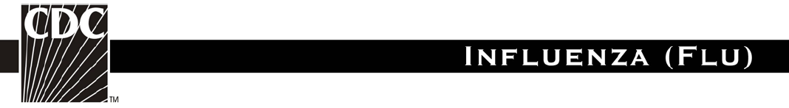

Stopping the Spread of Germs at Work

To download this in PDF, Spanish, Chinese, Vietnamese, or Tagalog, visit the CDC site http://www.cdc.gov/germstopper/work.htm

How Germs Spread
Illnesses like the flu (influenza) and colds are caused by viruses that infect the nose, throat, and lungs. The flu and colds usually spread from person to person when an infected person coughs or sneezes.

How to Help Stop the Spread of Germs
Take care to:
- Cover your mouth and nose when you sneeze or cough
- Clean your hands often
- Avoid touching your eyes, nose or mouth
- Stay home when you are sick and check with a health care provider when needed
- Practice other good health habits.

Cover your mouth and nose when you sneeze or cough
Cough or sneeze into a tissue and then throw it away. Cover your cough or sneeze if you do not have a tissue. Then, clean your hands, and do so every time you cough or sneeze.

Clean your hands often
When available, wash your hands -- with soap and warm water -- then rub your hands vigorously together and scrub all surfaces. Wash for 15 to 20 seconds. It is the soap combined with the scrubbing action that helps dislodge and remove germs.

When soap and water are not available, alcohol-based disposable hand wipes or gel sanitizers may be used. You can find them in most supermarkets and drugstores. If using a gel, rub the gel in your hands until they are dry. The gel doesn't need water to work; the alcohol in the gel kills germs that cause colds and the flu.*
*Source: FDA/CFSAN Food Safety A to Z Reference Guide, Sept 2001: Handwashing, www.cfsan.fda.gov/%7Edms/handwashing

Avoid touching your eyes, nose, or mouth
Germs are often spread when a person touches something that is contaminated with germs and
then touches their eyes, nose, or mouth. Germs can live for a long time (some can live for 2 hours or more) on surfaces like doorknobs, desks, and tables.

Stay home when you are sick and check with a health care provider when needed
When you are sick or have flu symptoms, stay home, get plenty of rest, and check with a health care provider as needed. Your employer may need a doctor’s note for an excused absence. Remember: Keeping your distance from others may protect them from getting sick. Common symptoms of the flu include:

- fever (usually high)
- headache
- extreme tiredness
- cough
- sore throat
- runny or stuffy nose
- muscle aches, and
- nausea, vomiting, and diarrhea, (much more common among children than adults).

Practice other good health habits
Get plenty of sleep, be physically active, manage your stress, drink plenty of fluids, and eat nutritious food. Practicing healthy habits will help you stay healthy during flu season and all year long.

More Facts, Figures, and How-To Ideas
CDC and its partner agencies and organizations offer a great deal of information about handwashing and other things you can do to stay healthy and avoid the germs that cause flu, the common cold, and other illnesses. See Other Resources (http://www.cdc.gov/germstopper/resources.htm) and Posters (http://www.cdc.gov/germstopper/materials.htm) on this Stop the Spread of Germs site for a select listing of Web sites, materials, and contact information.

Cover Your Cough

To download this in PDF, Spanish, Portuguese, French, Chinese, Vietnamese, Hmong, Khmer or Tagalog, or to get a poster size version, visit the CDC site http://www.cdc.gov/flu/protect/covercough.htm

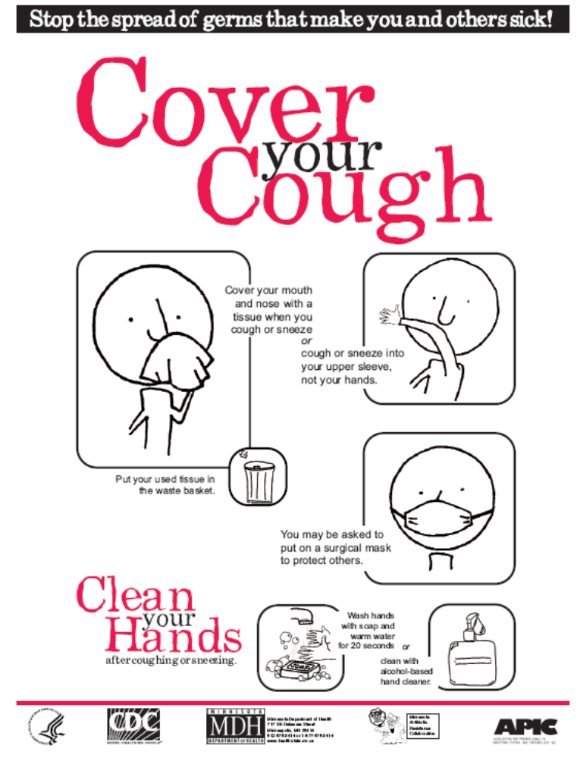

US DHHS EMS and Non-Emergent (Medical) Transport Organizations Pandemic Influenza Planning Checklist

This checklist is available at http://pandemicflu.gov/professional/hospital/emgncymedical.html, or for PDF download at http://pandemicflu.gov/professional/pdf/ems.pdf.

Planning for pandemic influenza is critical for ensuring a sustainable health care response. The Department of Health and Human Services (HHS) and the Centers for Disease Control and Prevention (CDC) have developed the following checklist to help emergency medical services (EMS) and non-emergent (medical) transport organizations assess and improve their preparedness for responding to pandemic influenza. EMS organizations will be involved in the transport of acutely ill patients with known or suspected pandemic influenza to emergency departments; some of these patients might require mechanical ventilation for life support and/or other lifesaving interventions. Non-emergent (medical) transport organizations will be called upon to transport recovering pandemic influenza patients to their home, residential care facility, or possibly to alternate care sites set up by state or local health departments.

This checklist is modeled after one included in the HHS Pandemic Influenza Plan. The list is comprehensive but not complete; each organization will have unique and unanticipated concerns that also will need to be addressed as part of a pandemic planning exercise. Also, some items on the checklist might not be applicable to all organizations. Collaborations among hospital, public health and public safety personnel are encouraged for the overall safety and care of the public.

This checklist identifies key areas for pandemic influenza planning. EMS and non-emergent (medical) transport organizations can use this tool to self-assess and identify the strengths and weakness of current planning. Links to websites with information are provided throughout the document. However, actively seeking information that is available locally or at the state level will be necessary to complete the development of the plan. Also, for some elements of the plan (e.g., education and training programs), information may not be immediately available and monitoring of selected websites for new and updated information will be necessary.

Checklist Sections
- Structure for planning and decision making
- Development of a written pandemic influenza plan
- Elements of an influenza pandemic plan

1. Structure for planning and decision making.
Completed | In Progress | Not Started | Tasks
 |  |  | Pandemic influenza has been incorporated into emergency management planning and exercises for the organization.
 |  |  | A planning committee has been created to specifically address pandemic influenza preparedness.
 |  |  | A person has been assigned responsibility for coordinating pandemic influenza preparedness planning (hereafter referred to as the pandemic response coordinator) for the organization. (Insert name, title, and contact information.)
Members of the planning committee include the following: (Insert below or attach a list with name title and contact information for each.)
Administration:
Medical staff:
EMS providers:
Phone triage personnel/dispatch center:
Emergency management officer:
Local health official:
Law enforcement official (for quarantine/security):
Other member:
 |  |  | A point of contact (e.g., internal staff member assigned infection control responsibility for the organization or an outside consultant) for questions/consultation on infection control has been identified. (Insert name, title, and contact information.)

2. Development of a written pandemic influenza plan.
Completed | In Progress | Not Started | Tasks
 |  |  | Copies of relevant sections of the Department of Health and Human Services Pandemic Influenza Plan have been obtained. www.hhs.gov/pandemicflu/plan.
 |  |  | Copies of available community and state pandemic plans have been obtained.
 |  |  | A written plan has been completed or is in progress that includes the elements listed in #3 below.
 |  |  | The plan describes the organizational structure (i.e., lines of authority) that will be used to operationalize the plan.
 |  |  | The plan complements or is part of the community response plan.

3. Elements of an influenza pandemic plan.
Completed | In Progress | Not Started | Tasks
 |  |  | A plan is in place for surveillance and detection of pandemic influenza in the population served and the appropriate organizational response:
 |  |  | - Responsibility has been assigned for monitoring national and state public health advisories (e.g., www.cdc.gov/flu/weekly/fluactivity.htm) and informing the pandemic response coordinator and members of the pandemic influenza planning committee when cases of pandemic influenza have been reported in the United States and when they are nearing the geographic area (e.g., state or city). (Insert name, title, and contact information of person responsible.)
 |  |  | - A system has been created to track influenza-like illness in patients transported to hospitals and among EMS staff and to report this information to the pandemic response coordinator (i.e., weekly or daily number of patients with influenza-like illness). For more information see www.cdc.gov/flu/professionals/diagnosis/. (Having a system for tracking illness trends in patients and staff during seasonal influenza will ensure that organizations can detect stressors that may affect operating capacity, such as staffing and supply needs, and hospital and emergency department capacity during a pandemic.)
A communication plan has been developed:
(Insert below or attach a list with the name, title, and contact information for each.)
- Key public health points of contact for pandemic influenza have been identified.
- Local health department contact:
- State health department contact:
- Local emergency management contact:
- State emergency management contact:
- Federal health emergency contact(s):
- The organization's point person for external communication has been assigned. (Insert name, title, and contact information.)
(Having one person who speaks with the health department, and if necessary, media, local politicians, etc., will help ensure consistent communication is provided by the organization.)
 |  |  | - A list of healthcare entities and their points of contact (e.g., other local EMS and non-emergent [medical] transport organizations, local hospitals and their emergency departments, community health centers, residential care facilities has been created. (Insert location of or attach copy of contact list.)
 |  |  | - A list of healthcare entities and their points of contact (e.g., other local EMS and non-emergent [medical] transport organizations, local hospitals and their emergency departments, community health centers, residential care facilities has been created. (Insert location of or attach copy of contact list.)
 |  |  | - The pandemic response coordinator has contacted local or regional pandemic influenza planning groups to obtain information on communication and coordination plans, including how EMS will be represented in the planning process. (For more information on state and local planning, see www.hhs.gov/pandemicflu/plan/part2.html#overview.)
 |  |  | - The pandemic response coordinator has contacted other EMS and non-emergent (medical) transport organizations regarding pandemic influenza planning and coordination of services.
 |  |  | A plan is in place to ensure that education and training on pandemic influenza is provided to ensure that all personnel understand the implications of, and control measures for, pandemic influenza and the current organization and community response plans:
 |  |  | - A person has been designated to coordinate education and training (e.g., identify and facilitate access to education and training programs, ensure that staff attend, and maintain a record of attendance at education and training programs). (Insert name, title, and contact information.)
 |  |  | - Current and potential opportunities for long-distance (e.g., web-based) and local (e.g., health department or hospital sponsored programs, programs offered by professional organizations or federal agencies) education of EMS and medical transport personnel have been identified. (For more information see www.cdc.gov/flu/professionals/training/.)
 |  |  | - Language and reading-level-appropriate materials for professional and non-professional personnel on pandemic influenza (e.g., available through state and federal public health agencies and professional organizations) have been identified and a plan is in place for obtaining these materials
 |  |  | - Education and training include information on infection control measures to prevent the spread of pandemic influenza.
 |  |  | - Differences between responding to pandemic influenza and a mass casualty event have been incorporated into education and training programs.
 |  |  | A plan has been developed for triage and management of patients during a pandemic that includes the following:
 |  |  | - A system for phone triage of patients calling 911 or other emergency numbers that might be used (provide/post list of appropriate numbers) that includes pre-established criteria and coordination protocols to determine who needs emergency transport. The system includes points of referral for patients who do not need emergency transport.
 |  |  | - A plan for coordination with receiving facilities (e.g., hospital emergency departments), other EMS and non-emergent (medical) transport organizations, and local planning groups to manage the transportation of large numbers of patients at the height of the pandemic.
 |  |  | - A policy and procedure for transporting multiple patients with pandemic influenza during a single ambulance run.
 |  |  | - The plan considers the possible necessity of sharing transportation resources or using vehicles other than those designed for emergency or medical transport (e.g., buses).
 |  |  | An infection control plan is in place and includes the following: (For information on infection control recommendations for pandemic influenza, see www.hhs.gov/pandemicflu/plan/sup4.html).
 |  |  | - A plan for implementing Respiratory Hygiene/Cough Etiquette for patients with a possible respiratory illness.
 |  |  | - The plan includes distributing masks to symptomatic patients who are able to wear them (adult and pediatric sizes should be available), providing facial tissues and receptacles for their disposal, and hand hygiene materials in EMS and medical transport vehicles.
 |  |  | - Implementation of Respiratory Hygiene/Cough Etiquette has been exercised during seasons when seasonal influenza and other respiratory viruses (e.g., respiratory syncytial virus, parainfluenza virus) are circulating in communities.
 |  |  | - A policy that requires healthcare personnel to use Standard Precautions (www.cdc.gov/ncidod/dhqp/gl_isolation_standard.html) and Droplet Precautions (i.e., mask for close contact) (www.cdc.gov/ncidod/dhqp/gl_isolation_droplet.html) with symptomatic patients.
 |  |  | An occupational health plan has been developed that includes the following:
 |  |  | - A liberal/non-punitive sick leave policy for managing EMS and non-emergent (medical) transport personnel who have symptoms of, or documented illness with, pandemic influenza.
- The policy considers the following:
  - Handling of staff who become ill at work.
  - When personnel may return to work after recovering from pandemic influenza.
  - When personnel who are symptomatic but well enough to work will be permitted to continue working.
  - Personnel who need to care for their ill family members.
 |  |  | - A system for evaluating symptomatic personnel before they report for duty that has been tested during a non-pandemic influenza period.
 |  |  | - A list of mental health and faith-based resources available to provide counseling to personnel during a pandemic.
 |  |  | - Management of personnel who are at increased risk for influenza complications (e.g., pregnant women, immunocompromised healthcare workers) by placing them on administrative leave or altering their work locations.
 |  |  | - The ability to monitor seasonal influenza vaccination of personnel.
 |  |  | - Offering annual influenza vaccine to personnel.
 |  |  | - Tracking and reporting of suspected work-related exposure, including reason PPE was not used or how PPE was breached
 |  |  | - Access to antivirals for treatment of work-related exposure and illness
 |  |  | A vaccine and antiviral use plan has been developed:
 |  |  | - Websites containing current CDC and state health department recommendations for the use and availability of vaccines and antiviral medications have been identified. (For more information, see www.hhs.gov/pandemicflu/plan/sup6.html and www.hhs.gov/pandemicflu/plan/sup7.html.)
 |  |  | - An estimate has been made of the number of personnel who will be targeted as first and second priority for receipt of pandemic influenza vaccine, based on HHS guidance for use. (For more information, see www.hhs.gov/pandemicflu/plan/appendixd.html.)
 |  |  | Concerns related to surge capacity during a pandemic have been addressed:
 |  |  | - A plan is in place for managing a staffing shortage within the organization because of illness in personnel or their family members.
 |  |  | - The minimum number and categories of personnel necessary to sustain EMS and non-emergent (medical) transport services on a day-to-day basis have been determined for your organization.
 |  |  | - Contingency staffing plans have been developed in collaboration with other local EMS and non-emergent (medical) transport providers.
 |  |  | - Anticipated consumable resource needs (e.g., masks, gloves, hand hygiene products) have been estimated.
 |  |  | - A primary plan and contingency plan to address supply shortages have been developed. These include detailed procedures for the acquisition of supplies through normal channels and requesting resources for replenishing supplies when normal channels have been exhausted.
 |  |  | - Plans include stockpiling at least a week's supply of resources when evidence exists that pandemic influenza has reached the United States.
 |  |  | - An understanding of the process for requesting and obtaining assets for the organization through the community response plan.

Influenza-like Illness (ILI) Assessment Tool

Adapted from: Los Angeles County Department of Public Health Pandemic Influenza Plan, Guidelines for Acute Care Hospital Settings, 3-1-06, available at http://search.lapublichealth.org/acd/Pandemicflu.htm.

An ILI assessment tool is to be used for immediate triage of patients or staff, and for accommodation or cohort of patients prior to further clinical management. This is not intended to be used as a clinical management tool.

ILI in the general population is determined by the presence of 1, 2, 3 and any of 4 (a–f) which could be due to influenza virus:
Please check the following.
- 1. Acute onset of respiratory illness
- 2. Fever (>38 C)*
- 3. Cough
- 4. One or more of the following:
- a. sore throat
- b. arthralgia
- c. myalgia or prostration
- d. diarrhea**
- e. vomiting**
- f. abdominal pain*

* May not be present in elderly people
** May be present in children

9-1-1 Public Safety Answering Points (PSAP) and EMD

Adapted from LA County EMS Agency Swine Flu (H1N1) Update, May 03, 2009: http://ems.dhs.lacounty.gov/Home/SF-Update5409.pdf; National Highway Traffic Highway Safety Administration (NHTSA) Preparing for Pandemic Influenza: Recommendations for Protocol Development for 9-1-1 Personnel and Public Safety Answering Points (PSAPs), May 03, 2007: http://www.nhtsa.gov/people/injury/ems/PandemicInfluenza/; and CA Emergency Medical Services Authority Pandemic Influenza Planning and Preparedness Framework For Local Emergency Medical Services Agencies, October 8, 2009: www.emsa.ca.gov/about/files/PandemicFrameworkForEMSProviders.doc

Emergency Medical Dispatch
It is important for PSAPs to question callers to determine if there is anyone at the incident location who is possibly afflicted by the pandemic influenza.

Step 1: Patient Screening
When using EMD protocols, further interrogation may be needed for severe respiratory infection (flu-like) symptoms:
- Question #1: Are they febrile or have a fever, and if so, is it higher than 100°F (37.8°C)?
- Question #2: Do they have a cough, sore throat, or any other respiratory symptoms like difficulty breathing?

Step 2: Notification
Dispatchers should report the responses to these questions to EMS personnel before they arrive on scene.

Step 3: Additional Inquiry
EMS personnel should request more information from dispatchers when sent to a patient with respiratory complain or a sick person with fever if limited information is provided by dispatch.

Additional Considerations
Develop criteria to triage and prioritize calls to maximize efficient and appropriate use of EMS resources. The following should be considered:
- Protocols to prioritize the order of response, i.e., triaging calls
- Protocols to provide for tiered response of different EMS unit types, e.g., conserving ALS for the most acute patients.
- Advise caller that no ambulance transport is available or may be delayed because requests for assistance have exceeded system overcapacity
- Advise caller of locally designated patient collection and treatment points

In the event of pandemic influenza, the PSAP may become a source of information for those who are accustomed to calling 9-1-1 for their perceived emergencies, whether urgent or not.
- Develop a protocol or script for operators to advise callers on how to care for an ill person at home if they are not severely ill, or transfer caller to a resource that can provide that information, such as LA County Hotline 2-1-1, or direct them to the LA County Dept of Public Health website:
  - http://www.lapublichealth.org/, or CDC website:
  - http://www.cdc.gov/h1n1flu/guidance_homecare.htm.
- Provide dispatch and PSAP operators with up-to-date information on the location, capability, and level of care of ACSs to direct triaged callers for care, if established.
- Fatality management: PSAPs will likely get calls from family members about the deceased as well as for general information. Plans should take this likelihood into account, with a coordinated effort with alternate call centers and resources. The goal is to identify and divert these non-emergency calls to a more appropriate alternate source.

Sample Call Flow for Standard EMD Calls versus Pandemic Flu Calls

Adapted from National Highway Traffic Highway Safety Administration (NHTSA) Preparing for Pandemic Influenza: Recommendations for Protocol Development for 9-1-1 Personnel and Public Safety Answering Points (PSAPs), May 03, 2007: http://www.nhtsa.gov/people/injury/ems/PandemicInfluenza/

This call flow chart may be modified as needed for different levels of response or type of outbreak.

 | Standard EMD Call Flow |  | Pandemic Flu Call Flow  (using local Pan Flu protocols)
1. | Telephone answered at 9-1-1 PSAP | 1. | Telephone answered at 9-1-1 PSAP
2. | EMD call taker obtains address, call back phone number, and chief complaint | 2. | EMD call taker obtains address, call back phone number, and chief complaint
3. | EMD queries caller with standard questions using existing EMD process | 3. | EMD queries caller with standard questions using existing EMD process
4. | EMD call taker assigns an incident type code to case | 4. | For those callers meeting predetermined criteria (established with EMS and Public Health authorities), EMD call take queries caller using PAN FLU SPECIFIC PROTOCOL QUESTIONS (developed by local EMS and Public Health authorities), then assigns an incident type code to case
5. | EMS units are selected for response based on the pre-determined response schemes for standard EMS operations | 5. | EMS or alternative units are selected for response OR call taker transfers to alternative call center, if established, based on pre-determined PAN FLU EMS DISPATCH PROTOCOLS (modified response developed to EMS and Public Health in advance)
6. | EMS units are alerted and respond to the scene | 6. | EMS units are alerted and respond to the scene ONLY on designated incident types from PAN FLU EMS DISPATCH PROTOCOLS
7. | EMD call taker provides standard pre-arrival or post-dispatch instructions while UMS units respond | 7. | EMD call take provides standard pre-arrival or post-dispatch instructions, or modified PAN FLU POST-DISPATCH INSTRUCTIONS (developed by local EMS and Public Health authorities in advance)
8. | EMS units arrive at scene | 8. | EMS units arrive at scene ONLY on designated incident types from PAN FLU EMS DISPATCH PROTOCOLS
9. | Patient is transported to hospital or ED or other appropriate destination via ambulance | 9. | Patient is transported ONLY on designated incident types from PAN FLU EMS OPERATING PROTOCOLS

At different points in the Pandemic Flu Call Flow process, an EMD call taker may transfer a call to an alternative call center (e.g., 211, poison control centers, nurse advice lines, health care call centers) based on pre-determined Pan Flu EMS Dispatch Protocols. PSAPs should also plan to accept incoming calls from alternative call centers. A community’s mitigation strategy may include call takers instructing callers on social distancing, home care or other care options.
patient assessment

Based on Recommendations from the US Centers for Disease Control and Prevention (CDC), August 05, 2009: http://www.cdc.gov/h1n1flu/guidance_ems.htm; and LA County EMS Agency Swine Flu (H1N1) Update, May 03, 2009: http://ems.dhs.lacounty.gov/Home/SF-Update5409.pdf

The most important reminder is that EMS personnel should wash hands frequently with soap and water or alcohol-based hand sanitizer and use airborne precautions.

Symptoms of acute febrile respiratory illness:
Fever plus one or more of the following: nasal congestion/rhinorrhea, sore throat, or cough

If pandemic strain has not been reported in Los Angeles County, EMS providers should assess all patients as follows:
- EMS personnel should stay more than 6 feet away from patients and bystanders with symptoms and exercise appropriate routine respiratory droplet precautions while assessing all patients for suspected cases of swine-origin influenza.
- Assess all patients for symptoms of acute febrile respiratory illness (fever plus one or more of the following: nasal congestion/rhinorrhea, sore throat, or cough).
  - If no acute febrile respiratory illness, proceed with normal EMS care.
  - If symptoms of acute febrile respiratory illness, then assess all patients for exposure to confirmed cases of pandemic influenza within the last 7 days.
    - If exposure, don appropriate PPE for suspected case of pandemic influenza.
    - If no exposure, place a standard surgical mask on the patient (if tolerated) and use appropriate PPE for cases of acute febrile respiratory illness without suspicion of pandemic influenza (as described in PPE section).

If pandemic strain has been reported in Los Angeles County, EMS providers should assess all patients as follows:
- Address scene safety:
  - If PSAP advises potential for acute febrile respiratory illness symptoms on scene, EMS personnel should don PPE (N95 respirator, eye protection, disposable gloves and gown) prior to entering scene.
  - If PSAP has not identified individuals with symptoms of acute febrile respiratory illness on scene, initially assess patients and bystanders for symptoms from more than 6 feet away. If patient meets criteria for acute febrile illness, don PPE.
  - If there are not symptoms of acute febrile respiratory illness after EMS initial assessment, provide routine EMS care. Routine EMS care may include routine respiratory droplet precautions.
infection control

Based on US Centers for Disease Control and Prevention (CDC) Interim Guidance for Emergency Medical Services (EMS) Systems and 9-1-1 Public Safety Answering Points (PSAPs) for Management of Patients with Confirmed or Suspected Swine-Origin Influenza A (H1N1) Infection, August 05, 2009: http://www.cdc.gov/h1n1flu/guidance_ems.htm

NOTE: In the initial response phase to a novel virus, a more conservative approach may be taken, e.g., implementing the use of airborne protection (N95 respirators). This may change to droplet precautions (e.g., the use of surgical masks) or remain at airborne precautions based on the mode of virus transmission, communicability, and virulence of the circulating virus as more information becomes known.

Influenza Infectious Period - Persons with influenza infection should be considered potentially infectious from one day before to 7 days following illness onset. Persons who continue to be ill longer than 7 days after illness onset should be considered potentially contagious until symptoms have resolved. Children, especially younger children, might potentially be contagious for longer periods.

EMS providers should always practice basic infection control procedures including vehicle/equipment decontamination, hand hygiene, cough and respiratory hygiene, and proper use of FDA cleared or authorized medical personal protective equipment (PPE).

- Pending clarification of transmission patterns for this virus, EMS personnel who are in close contact with patients with suspected or confirmed pandemic cases should wear a fit-tested disposable N95 respirator, disposable non-sterile gloves, eye protection (e.g., goggles; eye shields), and gown, when coming into close contact with the patient.
- All EMS personnel engaged in aerosol generating activities (e.g. endotracheal intubation, nebulizer treatment, and resuscitation involving emergency intubation or cardiac pulmonary resuscitation) should wear a fit-tested disposable N95 respirator, disposable non-sterile gloves, eye protection (e.g., goggles; eye shields), and gown, unless EMS personnel are able to rule out acute febrile respiratory illness or travel to an endemic area in the patient being treated.
- All patients with acute febrile respiratory illness should wear a surgical mask, if tolerated by the patient.
- Use non-sterile gloves for contact with patient, patient secretions, or surfaces that may have been contaminated. Follow hand hygiene including hand washing or cleansing with alcohol-based hand disinfectant after contact.
- Encourage good patient compartment vehicle airflow/ventilation to reduce the concentration of aerosol accumulation when possible.
- Perform a thorough cleaning of the stretcher and all equipment that has come in contact with or been within 6 feet with an approved disinfectant, upon completion of the call.
US DHHS Pandemic Influenza Plan, Supplement 4 Infection Control, Pre-Hospital Excerpt

Adapted from the US DHHS site: http://www.hhs.gov/pandemicflu/plan/sup4.html#prehosp

Infection control practices for pandemic influenza are the same as for other human influenza viruses and primarily involve the application of standard and droplet precautions (Box 1) during patient care in healthcare settings (e.g., hospitals, nursing homes, outpatient offices, emergency transport vehicles).

Patient-care equipment
Follow standard practices for handling and reprocessing used patient-care equipment, including medical devices:
- Wear gloves when handling and transporting used patient-care equipment.
- Wipe heavily soiled equipment with an EPA-approved hospital disinfectant before removing it from the vehicle. Follow current recommendations for cleaning and disinfection or sterilization of reusable patient-care equipment.
- Wipe external surfaces of portable equipment with an EPA-approved hospital disinfectant upon removal from the patient’s room.

Prehospital care (emergency medical services)
Patients with severe pandemic influenza or disease complications are likely to require emergency transport to the hospital. The following information is designed to protect EMS personnel during transport.
- Screen patients requiring emergency transport for symptoms of influenza.
- Follow standard and droplet precautions when transporting symptomatic patients.
- Consider routine use of surgical or procedure masks for all patient transport when pandemic influenza is in the community.
- If possible, place a procedure or surgical mask on the patient to contain droplets expelled during coughing. If this is not possible (i.e., would further compromise respiratory status, difficult for the patient to wear), have the patient cover the mouth/nose with tissue when coughing, or use the most practical alternative to contain respiratory secretions.
- Oxygen delivery with a non-rebreather face mask can be used to provide oxygen support during transport. If needed, positive-pressure ventilation should be performed using a resuscitation bag-valve mask.
- Unless medically necessary to support life, aerosol-generating procedures (e.g., mechanical ventilation) should be avoided during prehospital care.
- Optimize the vehicle’s ventilation to increase the volume of air exchange during transport. When possible, use vehicles that have separate driver and patient compartments that can provide separate ventilation to each area.
- Notify the receiving facility that a patient with possible pandemic influenza is being transported.
- Follow standard operating procedures for routine cleaning of the emergency vehicle and reusable patient care equipment.

Box 1. Summary of Infection Control Recommendations for Care of Patients with Pandemic Influenza
Component | Recommendations
Standard Precautions | See www.cdc.gov/ncidod/dhqp/gl_isolation_standard.html
Hand hygiene | Perform hand hygiene after touching blood, body fluids, secretions, excretions, and contaminated items; after removing gloves; and between patient contacts. Hand hygiene includes both handwashing with either plain or antimicrobial soap and water or use of alcohol-based products (gels, rinses, foams) that contain an emollient and do not require the use of water. If hands are visibly soiled or contaminated with respiratory secretions, they should be washed with soap (either non-antimicrobial or antimicrobial) and water. In the absence of visible soiling of hands, approved alcohol-based products for hand disinfection are preferred over antimicrobial or plain soap and water because of their superior microbicidal activity, reduced drying of the skin, and convenience.
Personal protective equipment (PPE)  - Gloves  - Gown  - Face/eye protection (e.g., surgical or procedure mask and goggles or a face shield) | - For touching blood, body fluids, secretions, excretions, and contaminated items; for touching mucous membranes and nonintact skin  - During procedures and patient-care activities when contact of clothing/exposed skin with blood/body fluids, secretions, and excretions is anticipated  - During procedures and patient care activities likely to generate splash or spray of blood, body fluids, secretions, excretions
Safe work practices | Avoid touching eyes, nose, mouth, or exposed skin with contaminated hands (gloved or ungloved); avoid touching surfaces with contaminated gloves and other PPE that are not directly related to patient care (e.g., door knobs, keys, light switches).
Patient resuscitation | Avoid unnecessary mouth-to-mouth contact; use mouthpiece, resuscitation bag, or other ventilation devices to prevent contact with mouth and oral secretions.
Soiled patient care equipment | Handle in a manner that prevents transfer of microorganisms to oneself, others, and environmental surfaces; wear gloves if visibly contaminated; perform hand hygiene after handling equipment.
Soiled linen and laundry | Handle in a manner that prevents transfer of microorganisms to oneself, others, and to environmental surfaces; wear gloves (gown if necessary) when handling and transporting soiled linen and laundry; and perform hand hygiene.
Needles and other sharps | Use devices with safety features when available; do not recap, bend, break or hand-manipulate used needles; if recapping is necessary, use a one-handed scoop technique; place used sharps in a puncture-resistant container.
Environmental cleaning and disinfection | Use EPA-registered hospital detergent-disinfectant; follow standard facility procedures for cleaning and disinfection of environmental surfaces; emphasize cleaning/disinfection of frequently touched surfaces (e.g., bed rails, phones, lavatory surfaces).
Disposal of solid waste | Contain and dispose of solid waste (medical and non-medical) in accordance with facility procedures and/or local or state regulations; wear gloves when handling waste; wear gloves when handling waste containers; perform hand hygiene.
Respiratory hygiene/cough etiquette  Source control measures for persons with symptoms of a respiratory infection; implement at first point of encounter (e.g., triage/reception areas) within a healthcare setting. | Cover the mouth/nose when sneezing/coughing; use tissues and dispose in no-touch receptacles; perform hand hygiene after contact with respiratory secretions; wear a mask (procedure or surgical) if tolerated; sit or stand as far away as possible (more than 3 feet) from persons who are not ill.
Droplet Precautions | www.cdc.gov/ncidod/dhqp/gl_isolation_droplet.html
Patient placement | Place patients with influenza in a private room or cohort with other patients with influenza.* Keep door closed or slightly ajar; maintain room assignments of patients in nursing homes and other residential settings; and apply droplet precautions to all persons in the room.  *During the early stages of a pandemic, infection with influenza should be laboratory-confirmed, if possible. Personal protective equipment - Wear a surgical or procedure mask for entry into patient room; wear other PPE as recommended for standard precautions.
Patient transport | Limit patient movement outside of room to medically necessary purposes; have patient wear a procedure or surgical mask when outside the room.
Other | Follow standard precautions and facility procedures for handling linen and laundry and dishes and eating utensils, and for cleaning/disinfection of environmental surfaces and patient care equipment, disposal of solid waste, and postmortem care.
Aerosol-Generating Procedures | During procedures that may generate small particles of respiratory secretions (e.g., endotracheal intubation, bronchoscopy, nebulizer treatment, suctioning), healthcare personnel should wear gloves, gown, face/eye protection, and a fit-tested N95 respirator or other appropriate particulate respirator.

Box 2. Respiratory Hygiene/Cough Etiquette
Concern | Recommendation
To contain respiratory secretions, all persons with signs and symptoms of a respiratory infection, regardless of presumed cause, should be instructed to: | - Cover the nose/mouth when coughing or sneezing.  - Use tissues to contain respiratory secretions.  - Dispose of tissues in the nearest waste receptacle after use.  - Perform hand hygiene after contact with respiratory secretions and contaminated objects/materials.  - Provide surgical masks for sick patients to wear, if tolerated
Healthcare facilities should ensure the availability of materials for adhering to respiratory hygiene/cough etiquette in waiting areas for patients and visitors: | - Provide tissues and no-touch receptacles for used tissue disposal.  - Provide conveniently located dispensers of alcohol-based hand rub.  - Provide soap and disposable towels for handwashing where sinks are available.

personal protective equipment (PPE)

Based on Recommendations from the US Centers for Disease Control and Prevention (CDC), August 05, 2009: http://www.cdc.gov/h1n1flu/guidance_ems.htm; LA County EMS Agency and LA County Department of Public Health Influenza A H1N1 (Swine Flu) – First Responder/EMS Guidance #1, April 28, 2009: http://ems.dhs.lacounty.gov/Home/SF-FirstRespGuidance1.pdf; LA County EMS Agency H1N1 Interim Guidelines, October 01, 2009: http://ems.dhs.lacounty.gov/Home/SF-H1N1InterimGuidelines.pdf.

Until more is known about this disease, the Centers for Disease Control and Prevention (CDC) and Cal/OSHA recommends the use of approved N95 respirators when providing care to patients with flu-like symptoms (fever, cough and sore throat) or anyone a provider suspects may have the pandemic virus.

When treating a patient with a suspected case of the novel or pandemic influenza as defined above, the following PPE should be worn:
- Fit-tested disposable N95 respirator and eye protection (e.g., goggles; eye shield), disposable non-sterile gloves, and gown, when coming into close contact with the patient.
- When treating a patient that is not a suspected case of swine-origin influenza but who has symptoms of acute febrile respiratory illness, the following precautions should be taken:
- Place a standard surgical mask on the patient, if tolerated. If the mask cannot be tolerated, encourage the patient to cover his/her mouth/nose with a tissue when coughing or sneezing. Provide a receptacle (e.g., trash bag) to discard used tissues. If available, use a small surgical mask for children; however, children may have difficulty wearing a mask correctly and consistently.
- Use good respiratory hygiene – use non-sterile gloves for contact with patient, patient secretions, or surfaces that may have been contaminated.
- Follow hand hygiene including hand washing or cleansing with alcohol based hand disinfectant after contact.
- Encourage good patient compartment vehicle airflow/ ventilation to reduce the concentration of aerosol accumulation when possible.

EMS providers should ensure that they have the equipment and supplies readily available to meet any local requirements for personal protective equipment.

PPE Controversy and H1N1 PPE Guidance
It should be noted that, while the LAC EMS Agency recommends following local, state and federal guidelines, there is some controversy in those guidelines being disseminated. The Society for Healthcare Epidemiology of America (SHEA), Infectious Diseases Society of America (IDSA), and Association of Professionals in Infection Control and Epidemiology (APIC) expressed significant concern with the federal guidance concerning the use of PPE by healthcare workers in treating suspected or confirmed cases of H1N1 influenza. It is not clear why the federal PPE guidance and requirements do not reflect the best available scientific evidence, which demonstrates that N95 respirators are not superior to surgical masks in the prevention of transmission of influenza in most patient care settings.

Cal/OSHA Aerosol Transmissible Diseases Policy
While protection with appropriate PPE is the best strategy for reducing risk of contracting the disease, any novel virus such as that causing pandemic influenza, it may be unclear whether the virus is transmitted via droplet or aerosol. Based on this and the fact that there is a limited supply of N95 respirators, on September 08, 2009, Cal/OSHA in their Interim Enforcement Policy on H1N1 and Section 5199 (Aerosol Transmissible Diseases) stated:

“Where an extreme shortage of respirators exists despite all reasonable efforts to maintain a sufficient reliable supply, the employer may shift to a prioritized respirator use mode in which respirator use is assured for employees exposed to H1N1 in connection with high hazard procedures. In this mode, respirator use may be temporarily discontinued for employees in H1N1 exposure scenarios considered less likely to cause disease transmission as necessary to maintain the supply for employees exposed to high-hazard procedures.”

This policy also states “If the employer is unable to provide a respirator to employees who provide care to H1N1 suspected and confirmed cases, the employer should provide those employees with surgical masks. While surgical masks are not designed or certified to prevent the inhalation of small airborne contaminants, it is likely they will provide droplet protection and should therefore be chosen over no protection at all.”

Inventory the airborne respiratory protection equipment available to employees and providers:
  - N95 Filtering Facepiece Respirator (NIOSH Certified)
    - Fit-testing must be conducted to ensure a well-fitting respirator model and size and ensures the user can achieve a good seal between the respirator and the face
      - OSHA requires that workers be medically cleared and fit tested prior to the first use of a filtering facepiece respirator.
      - N95 respirators will not form a seal on the face if there is facial hair or the bone structure precludes the respirator conforming to the face.
    - Plan for three N95 respirators per person, per day (current Cal/OSHA recommendation):
      - Respirator can be reused by the same wearer until the respirator becomes damaged, moist, difficult to breathe through while wearing, or visibly soiled.
      - N95 respirators are considered disposable. There are currently no recommendations for cleaning and disinfecting them for reuse.
    - Use appropriate hand hygiene before and after removal of the respirator
    - Wearing a full faceshield over the respirator may prevent surface contamination of the N95 and prolong life.
  - Reusable elastomeric respirators - full and half face piece:
    - Have a face piece that can be cleaned, disinfected, reused, and worn by multiple users. Some offer eye protection (full facepiece).
    - Use filters that are multi-use until difficult to breathe through.
    - Require fit-testing (as described above) and users with facial hair or certain types of bone structures will not be able to obtain a seal.
    - Consider the reusable respirator to ensure employee protection should supplies of disposable (e.g., N95) respirators be limited (e.g., pandemic).
      - Replacement filters should be stocked by providers for exchange as needed.
    - Provider infection control programs should address proper donning, doffing, cleaning/disinfection, and reuse of the elastomeric respirator.
  - Powered air-purifying respirators (PAPRs):
    - There are lightweight PAPRs (e.g., the 3M Breathe Easy™) that provide protection but are much lighter and cooler than the PAPRs for chemical exposures.
    - PAPRs provide a higher level of protection than N95 respirators, meet the OSHA recommendation for protection during high hazard procedures (e.g., intubation, nebulizer treatment, deep suctioning), and may be considered for long transports.
    - PAPR components (battery pack, hose, belt) can be cleaned and disinfected for multiple users. There are currently no recommendations for cleaning disposable headgear/ hoods, although guidance may be provided during a pandemic when supplies are scarce. Headgear/hoods can be worn multiple times by the user until soiled or damaged.
    - Fit-testing is not required for PAPRs. Medical screening may be required as directed by the employer’s respiratory protection program.

Other Personal Protective Equipment
In addition to respiratory protection, PPE during a pandemic includes:
    - Clean, non-sterile gloves: should be single use only and changed between patients
  - Eye protection (e.g., goggles, face shield):
    - Face shields may be cleaned and reused. Plan for reuse X 10. Face shields can also protect N95 respirators, as described above.
    - Goggles are usually non-disposable and can be cleaned when soiled or between users. Plan for reuse X 50.
  - Long sleeved, fluid resistant gown.
    - Disposable gowns are single use and disposed of after each patient contact,
    - Cloth gowns should be changed between patient contacts and laundered before reuse.
use of masks during a pandemic

Adapted from: Los Angeles County Department of Public Health Pandemic Influenza Plan, Guidelines for Acute Care Hospital Settings, 3-1-06, available at http://search.lapublichealth.org/acd/Pandemicflu.htm

When to wear a mask *
- Early phase of a pandemic, it may be prudent for healthcare workers to wear masks when interacting in close face-to-face contact with coughing individuals to minimize influenza transmission
  - This use of masks is advised when immunization and antivirals are not yet available.
- Masks should be worn by healthcare workers to prevent transmission of other organisms from patients with undiagnosed cough
- When the virus is circulating widely in the community, there is no evidence that the use of masks in general public settings will be protective

using surgical masks
- Use only once and change if wet (masks become ineffective when wet)
- Cover both the nose and the mouth
- Avoid touching the mask while it is being worn
- Do not dangle around the neck
- Discard masks into an appropriate receptacle

Special masks
- I.e., high-efficiency dust/mist masks
- Required for patients with infectious tuberculosis and for non-immune healthcare workers entering the room of a patient with measles or disseminated varicella.

* The term mask refers to surgical masks, not to special masks or respirators.

Additional mask and respirator information can be found at:
OSHA Guidance on Preparing Workplaces for an Influenza Pandemic: http://www.osha.gov/Publications/influenza_pandemic.html#mask_respirator_difference
US DHHS Interim Guidance on Planning for the Use of Surgical Masks and Respirators in Health Care Settings during an Influenza Pandemic: http://pandemicflu.gov/plan/healthcare/maskguidancehc.html
Cal/OSHA Interim Enforcement Policy on H1N1 and Section 5199 (Aerosol Transmissible Diseases), Issue Date: 10-22-09: http://www.dir.ca.gov/dosh/SwineFlu/Interim_enforcement_H1N1.pdf
Conservation of Resources

Adapted from Cal/OSHA Interim Enforcement Policy on H1N1 and Section 5199 (Aerosol Transmissible Diseases), Issue Date: 10-22-09: http://www.dir.ca.gov/dosh/SwineFlu/Interim_enforcement_H1N1.pdf

Prioritization of PPE
Although during a pandemic, PPE may be in short supply and resupply delayed, respiratory protection must be given high priority, especially during high risk procedures (e.g., intubation) and for actively coughing, sneezing patients. Facial protection should be ensured as resources permit.

Measures to maximize and conserve respirator supplies
Given the increased demand for respirators created by a pandemic and the finite supply, measures to conserve respirator supplies to the extent reasonably possible should be implemented. This will help ensure that a sufficient supply of respirators will remain on hand to treat patients with the pandemic virus, tuberculosis, or any other disease requiring respiratory protection. These conservation measures are consistent with the ATD standards and the CDC Interim Infection Control guidance dated October 14, 2009, that delineates a hierarchy of controls to prevent influenza transmission in healthcare settings. These policies should include:
- Reviewing patient flow and work organization to determine whether unnecessary employee contact with suspected or confirmed pandemic influenza cases can be reduced.
- Taking full advantage of opportunities to obtain respirators through non-medical supply chains, such as safety equipment suppliers. These respirators are of comparable quality and efficacy to those provided by medical distributors.
- Taking full advantage of opportunities to use the variety of NIOSH-certified respirators available and appropriate for use in work involving close contact with pandemic influenza patients. For example, if an institution’s policy has been to order only fluid-resistant or “surgical” N95 respirators, other N95 respirators not designated as “surgical” can be used in patient-care scenarios where contact with splashes or sprays of body fluids is not anticipated as long as they are NIOSH-certified. Surgical N95s are required when needed to protect against splashes or sprays of bodily fluids, and may also be required for infection control during surgery, but are not required in situations where fluid contact is not an issue.

Extended use and re-donning as conservation measures
Cal/OSHA regulations require employers to develop policies for the use, cleaning, and decontamination and/or disposal of respirators as appropriate so that they remain effective in protecting employees and do not become a hazard. A respirator should always be removed and discarded if it becomes damaged or deformed, or it no longer forms an effective seal to the employee’s face. A reuseable respirator may be shared between users, but only if cleaned and disinfected between users. In addition, in health care settings, respirator use may be affected by infection control policies.

Disposable respirators should never be shared between users. A disposable respirator should always be discarded if (1) it becomes contaminated with a hazardous substance, (2) it becomes contaminated with blood, respiratory or nasal secretions, or other bodily fluids from patients, (3) it has been used during an aerosol generating procedure or during surgery, (4) it becomes wet or visibly dirty, or (5) breathing through it becomes more difficult.

Studies have consistently found that materials that are captured in a respirator filter will not be released, even if the user coughs or sneezes, or if the respirator is dropped. However, materials that may be on the outside of the respirator can be transferred to the employee’s hands, just as materials that are on the employees face or clothing can be transferred. Therefore employees should be instructed to perform hand hygiene whenever their hands touch the outside of the respirator. Respirators can be continuously worn between patients without removal (“extended use”) without creating a hazard for the patients or the employees, so long as hand hygiene and other standard precautions are maintained. Respirators should not be worn between patients after high hazard procedures or surgery, or if the respirator has become contaminated with bodily fluids.

Disposable filtering facepiece respirators may be removed, stored, and re-donned by an employee if the employer has established procedures for this type of use, provided appropriate facilities for storage, and trained employees in how to remove, store, inspect, and re-don the respirator. Employees must also be trained in how to recognize a respirator that must be discarded. Employer re-donning policies cannot include an absolute limit on the number of respirators that will be furnished to an exposed employees during a given period of time.

Protecting the outside surfaces of the respirator
It may be possible to prolong the useful life of the respirator by protecting the outer surface from sprays with a face shield, but a face shield may be used only if it does not interfere with the function of the respirator. Cal/OSHA regulations require that respirators be used as approved by the National Institute for Occupational Safety and Health (NIOSH) and must not be altered. Therefore surgical masks should not be placed over the respirator, as they may unseat or deform the respirator and may also make it more difficult to breathe through.

Respirator doffing, storage and re-donning procedures
When an employee removes a respirator in the context of re-donning practices, the employee should lift the respirator straps from the back of the head. The respirator should be handled as little as possible, and the employee should avoid touching the inside surfaces of the respirator. If the respirator is visibly contaminated with blood or other bodily fluids, if it is wet, dirty or deformed, it should be discarded. If it is in good condition, the respirator should be placed in a clean container labeled with the employee’s name or other identifier.

The respirator container should be located in an area free from chemical contamination, and it should be sufficient to protect the respirator against contamination or crushing, but it need not be “airtight.” Prior to re-donning, the employee should inspect the respirator, including straps, clips, sealing surfaces and general condition. If it is in good condition, the employee should don the respirator according to instructions provided for the specific respirator, and perform the user seal check. After handling the respirator, the employee should perform hand hygiene.

Additional information about donning and taking off (doffing) personal protective equipment, including respirators, is available from the CDC at http://www.cdc.gov/ncidod/dhqp/ppe.html.

Conserving Essential Resources and Maintaining the Supply Chain
The day-to-day availability of essential EMS supplies, equipment, and services may also be severely disrupted during a pandemic. To maintain or restore the supply chain, Local EMS agencies and providers should contact regular vendors to assess their ability to provide resources, contact alternate vendors as backups, and recognize that the time between order and delivery may increase substantially.

- Assess current inventories of essential response supplies
  - Identify essential equipment, supplies and medications that are used day-to-day and will be needed during the pandemic.
  - Consider stocking additional essential patient care supplies and personnel protective equipment supplies over normal par levels.
- Maintain an up-to-date contact list of suppliers and vendors
- Identify essential services that must be maintained in order to function (e.g., fuel suppliers)
- Continuously monitor and track the use of essential patient care and employee protective equipment and procure/resupply early before supplies are extinguished.
- Establish allocation and use policies for essential equipment and modify practices to preserve equipment and supplies, as feasible.
- Secure essential equipment and supplies and allocate according to plans.

SAMPLE: Steps for Safe Redonning (Reuse) of Your N95 Respirator

- N95 may be reused until crushed, soiled, wet or difficult to breathe through.
- Never use a N95 respirator for longer than one shift!
- Employees are not required to reuse respirators.
- Staff should use the N95 respirators for which they were fit –tested.

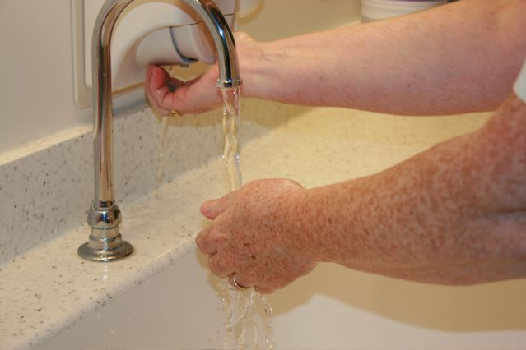  1. Wash hands | 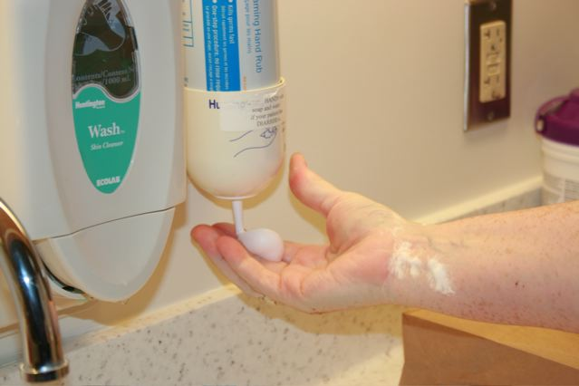  2. Or use alcohol rub if hands are not soiled | 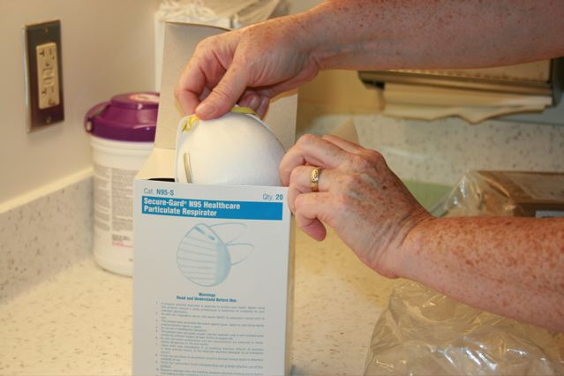  3. Take out new mask
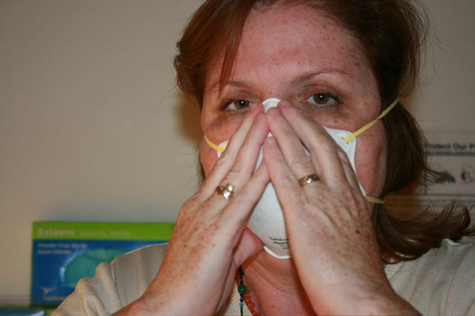  4. Put on mask and fit check |   5. Get paper bag; write your name on bag, leave on counter, and enter patient room | 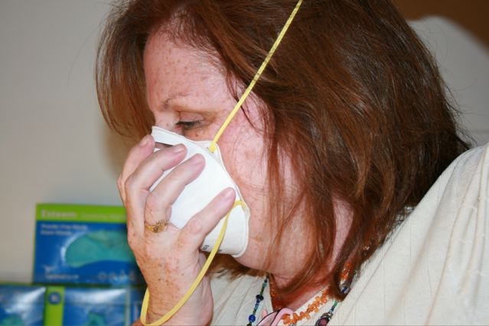  6. After exiting patient room, remove N95
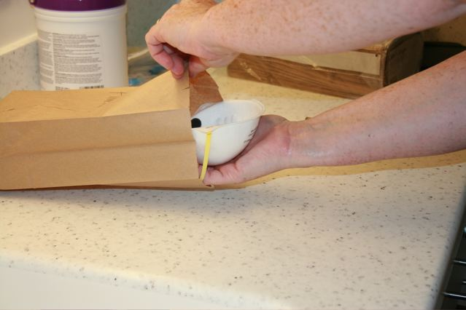  7. Insert N95 for later reuse | 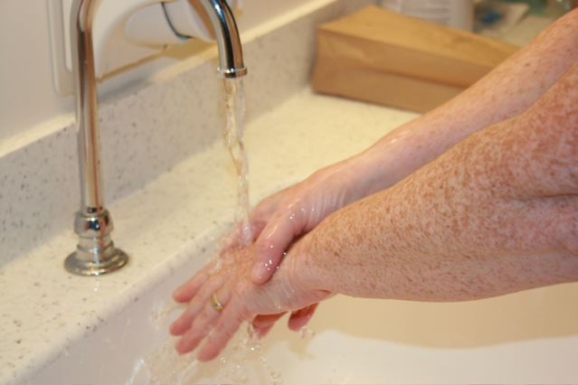  8. Hands are contaminated; perform hand hygiene | 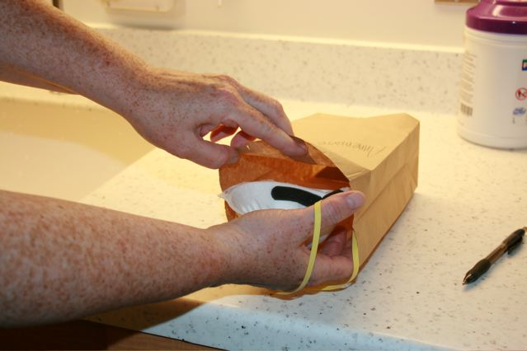  9. Upon return, remove 95 from bag, being careful not to touch inside of mask
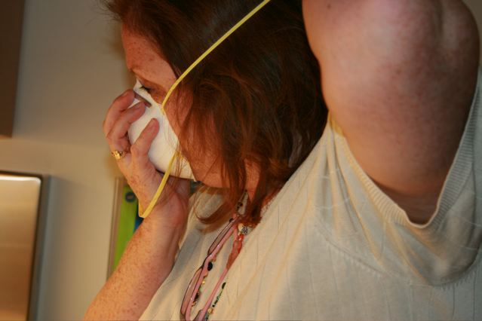  10. Redon N95; perform fit check | 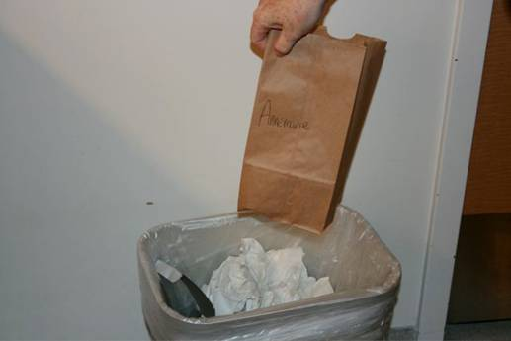  11. Throw away bag after one use | 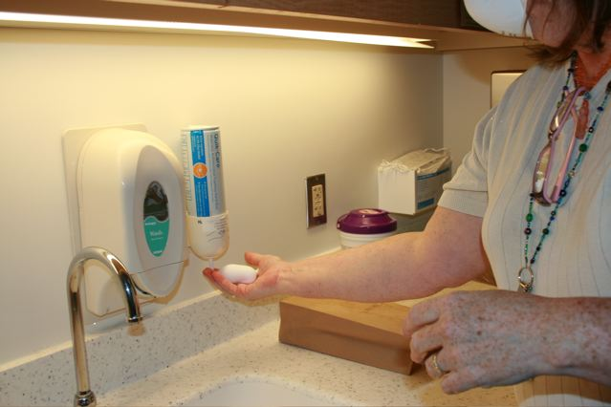  12. Hands are contaminated; perform hand hygiene

patient Transport

Based on US Centers for Disease Control and Prevention (CDC) Interim Guidance for Emergency Medical Services (EMS) Systems and 9-1-1 Public Safety Answering Points (PSAPs) for Management of Patients with Confirmed or Suspected Swine-Origin Influenza A (H1N1) Infection, August 05, 2009: http://www.cdc.gov/h1n1flu/guidance_ems.htm

EMS personnel involved in the transfer of patients with suspected or confirmed pandemic influenza should use standard, droplet and contact precautions for all patient care activities.
EMS personnel should wear:
- A fit-tested disposable N95 respirator
- Disposable non-sterile gloves
- Eye protection (e.g., goggles, eyeshield)
- Gown

Patient
- Patients with acute febrile respiratory illness should wear a surgical mask, if tolerated. Its use can help to minimize the spread of infectious droplets in the patient care compartment.
- Small facemasks are available that can be worn by children, but it may be problematic for children to wear them correctly and consistently. No facemasks (or respirators) have been cleared by the FDA specifically for use by children.
- Consider transporting multiple non-emergent patients or more than one patient with like symptoms (cohort) per ambulance run, despite the potential complications of insurance billing.

EMS Vehicle
- Encourage good patient compartment vehicle airflow/ventilation to reduce the concentration of aerosol accumulation when possible.
- Open windows for fresh (outside) air flow.
- Operate ambulance ventilation system in the non-recirculation mode to increase fresh airflow.
- Use air conditioning system with HEPA filtration, if available.
- Close the door between the driver and patient compartment, if possible.
- Keep cabinet doors closed in the unit to reduce possible contamination of supplies and equipment.
- Decontaminate vehicle after transport.

Facility Notification
When transporting a patient with symptoms of acute febrile respiratory illness, EMS personnel should notify the receiving healthcare facility so that appropriate infection control precautions may be taken prior to patient arrival.
Cleaning Emergency Service Transport Vehicles

Based on US Centers for Disease Control and Prevention (CDC) Interim Guidance for Emergency Medical Services (EMS) Systems and 9-1-1 Public Safety Answering Points (PSAPs) for Management of Patients with Confirmed or Suspected Swine-Origin Influenza A (H1N1) Infection, August 05, 2009: http://www.cdc.gov/h1n1flu/guidance_ems.htm

Key Points
- Influenza viruses are susceptible to inactivation by a number of chemical disinfectants readily available from consumer and commercial sources.
- Routing cleaning and disinfection practices play a role in minimizing the spread of influenza.
- Viruses can persist on nonporous surfaces for 24 hours or more, but quantities of the virus sufficient for human infection are only likely to persist for shorter periods.

Action Steps
Step 1: Ventilation
Prior to cleaning the vehicle, the air within the vehicle should be exhausted by opening doors and windows of the vehicle while the ventilation system is running. This should be done outdoors and away from pedestrian traffic.

Step 2: Clean Patient Care Areas
- Wear non-sterile gloves while cleaning the patient care area and when handling disinfectants.
- Avoid large surface area cleaning methods that produce mists or aerosol or disperse dust in patient care areas.
- Spills of bodily fluids (e.g., vomit, blood) should first be managed by removing visible organic matter with absorbent material.
- Then clean with soap or detergent and water followed by a proper disinfectant.
- For lists of EPA-registered Disinfectants, visit www.epa.gov/oppad001/chemregindex.htm. These products must be used in accordance with label instructions.

Note: Some reusable equipment may need to be covered with plastic covers to protect from it contamination if it cannot be decontaminated with disinfectants without the chance of damage to the equipment (per the manufacturer’s recommendations). These covers should be changed as appropriate.

Step 3: Clean Non-Patient Care Areas
Clean and disinfect non-patient areas, such as the driver’s compartment. These areas can be accidentally contaminated by the use of contaminated gloves or other cross contamination.

Step 4: Disposal
After cleaning, remove and dispose of gloves and cleaning wipes in a leak proof bag or waste container.
Staffing considerations

Adapted from CDC Guidance for Businesses and Employers To Plan and Respond to the 2009-2010 Influenza Season, Oct 21, 2009: http://pandemicflu.gov/professional/business/guidance.html; CA Emergency Medical Services Authority Pandemic Influenza Planning and Preparedness Framework For Local Emergency Medical Services Agencies, October 8, 2009: www.emsa.ca.gov/about/files/PandemicFrameworkForEMSProviders.doc; and CIDRAP/SHRM: Doing business during an influenza pandemic: human resource policies, protocols, templates, tools, & tips, Nov 2009.

The entire healthcare system will be severely impacted by illness and absenteeism among employees and the EMS system’s resources will be in high demand during the pandemic as the system copes not only with the normal call volume but also with the surge of influenza-like illness.

Rates of absenteeism will depend on the severity of the pandemic. In a severe pandemic, absenteeism attributable to illness, the need to care for ill family members, and fear of infection may reach 40% during the peak weeks of a community outbreak, with lower rates of absenteeism during the weeks before and after the peak. Certain public health measures (closing schools, quarantining household contacts of infected individuals) are likely to increase rates of absenteeism.

Preservation of the Workforce
- Provide education and training for EMS personnel.
- Reduce the number of personnel responding to calls (particularly influenza-like illness calls) to decrease exposure.
- Telecommuting may be an option for employees. Investigate the feasibility of working from home for appropriate employees to decrease exposures and maintain productivity.
- Plan for housing and feeding of employees who must remain close to work.
- Psychosocial and employee family support.
- Plan for enhanced security for employees, facilities, supplies and equipment.

Augmentation of the Workforce
- Implement adjusted or flexible staffing plans, especially during peak call times
  - Implement longer shifts (e.g., 12-16 hour shifts) and provide rest periods between shifts, as appropriate.
  - Modify number and staffing of advanced life support versus basic life support units.
- Expand the EMS workforce
  - During an influenza pandemic, normal sources of mutual aid personnel are also likely to be affected. The following represent potential sources of skilled personnel with appropriate skills:
    - Reinstate retired personnel to assume support roles (e.g., call triage, restocking)
    - Plan and develop processes for the use of EMS personnel from outside the jurisdiction.
    - Collaborate with paramedic and EMT-I training programs to use students as EMS extenders.
- Cross-train existing workers to expand the availability of skills and abilities.
- Plan for succession and delegation of authorities for the key leadership and decision-making/authority positions within the organization
  - Identify 2-3 successors for the key leadership positions to ensure coverage for illness and absenteeism.

Absentee Patterns
Businesses should have an understanding of their normal seasonal absenteeism rates and know how to monitor their personnel for any unusual increases in absenteeism through the fall and winter.

Monitoring absentee patterns during a pandemic can alert you before spikes of sick workers occur in different regions where your organization operates. To do so requires that you (1) know what your typical absentee patterns is, particularly regarding seasonal influenza, (2) provide an efficient way for employees to notify you so that you can collect data, and (3) understand the threshold beyond which your organization’s operations will be threatened. Running scenarios about what could happen at different levels of severity is a tool some organizations have used, though its usefulness is more for planning decisions rather than actually predicting changes. Some companies put in place hotlines to allow employees to call in sick if they have symptoms of an influenza-like illness.
Human Resources Policy Considerations

Adapted from CDC Guidance for Businesses and Employers To Plan and Respond to the 2009-2010 Influenza Season, Oct 21, 2009: http://pandemicflu.gov/professional/business/guidance.html; CA Emergency Medical Services Authority Pandemic Influenza Planning and Preparedness Framework For Local Emergency Medical Services Agencies, October 8, 2009: www.emsa.ca.gov/about/files/PandemicFrameworkForEMSProviders.doc; and CIDRAP/SHRM: Doing business during an influenza pandemic: human resource policies, protocols, templates, tools, & tips, Nov 2009.

Review and modify policies for sick leave, vacation time, and employee compensation (e.g., overtime) as appropriate:
- Leave policies should be flexible and non-punitive.
- Policies should allow and encourage ill personnel to stay at home and away from co-workers, or to stay at home to care for ill family members.
  - Consider not requiring a doctor’s note for workers who reported ill with influenza and were off work, if this is a current workplace policy.
- In the event of school closures, allow flexible work schedules or other accommodations to allow employees to attend to child care.
- Review employee assistance programs available to assist with coping and stress during the pandemic.
- Assess the feasibility of clerical and administrative personnel telecommuting from home. Consider the nature of the duties they perform, infrastructure support, etc.

Leave Policies
Employees want and need clarity about your position on sick leave during an influenza pandemic, which understandably is not easy for you, given the unpredictability of influenza. The CDC has asked employers to allow sick workers to stay home without fear of losing their jobs and to plan for two scenarios: (1) mild illness, and (2) that the virus causes more severe illness, in which absenteeism is likely to be more widespread and public health officials invoke more restrictive measures such as school and child care closures. How long they may need to stay home if they have influenza depends on the severity and impact of the outbreak.

For flexible leave policies to effectively encourage sick employees to stay home, an argument can be made that such policies should be communicated as soon as possible to employees and supervisors.
- A mild case of influenza can produce symptoms that resemble other kinds of respiratory illnesses. Some employees may not be able to distinguish the symptoms of a cold or seasonal allergy attack from symptoms of an influenza-like illness.
- Unless managers model staying home when sick, employees will receive a mixed message and not trust that their jobs will be secure if they follow the CDC recommendation

To provide more flexibility, employers discussed having adopted or having considered adopting the following options:
- Allowing employees to exhaust paid time off (PTO) hours and go into negative balances
- Advancing sick time up to a year of accrual (if, for example, the employee normally accrues 5 days of sick time per year and has used all 5 days, then you may want to consider advancing another 5 days)
- Suspending point attendance policies during the influenza pandemic
- Providing a special time off allotment for the influenza pandemic
- Allowing employees to donate leave to others

Pay Policies
When an employee is absent with no paid leave eligibility, the question arises whether federal or state wage and hour laws, nevertheless, may require the employee to be paid. Under the federal Fair Labor Standards Act (FLSA), for example, so-called “nonexempt” employees are required to be paid only for the hours they actually work. So if an employer sends an apparently ill employee home after less than a full day’s work, the employer need only pay the employee for the time worked.

For so-called “exempt” employees lacking any available paid leave, time away from work for 1 or more full days for personal reasons or due to sickness can be unpaid as long as it is in full-day increments (and not FMLA leave). For time off mandated by employers (e.g., closing the business for 3 days), the time away from work for exempt employees can be unpaid only if the employee performs no work whatsoever in that workweek; then, the exempt employee would not receive pay for the full week. If, however, an exempt employee performs any work during a given workweek, the employee must receive the entire weekly salary for that week, even though the employer required the employee to take some time off. Many employers are opting to advance employees vacation/PTO to cover pandemic influenza absences to help ensure workers sick with pandemic influenza do not come to work.

Employee Health Considerations

Adapted from CDC Guidance for Businesses and Employers To Plan and Respond to the 2009-2010 Influenza Season, Oct 21, 2009: http://pandemicflu.gov/professional/business/guidance.html; CA Emergency Medical Services Authority Pandemic Influenza Planning and Preparedness Framework For Local Emergency Medical Services Agencies, October 8, 2009: www.emsa.ca.gov/about/files/PandemicFrameworkForEMSProviders.doc; and CIDRAP/SHRM: Doing business during an influenza pandemic: human resource policies, protocols, templates, tools, & tips, Nov 2009.

Considerations
- Monitor the health of EMS personnel
  - Evaluate personnel for influenza symptoms (e.g., temperature, new cough or sore throat) when they report for duty
  - Symptomatic employees should be sent home
  - Plan for employee return to work after illness
  - Current CDC recommendations state that ill healthcare workers should stay at home/not return to work for 7 days from symptom onset or until the resolution of symptoms, whichever is longer.
- Non-healthcare workers (e.g., dispatch) may return to work when fever free (without use of antipyretic medications such as acetaminophen, ibuprofen, or aspirin) for 24 hours.
- Consider not requiring a doctor’s note for workers who reported ill with influenza and were off work, if this is a current workplace policy.
- Monitor conditions in staff sleeping quarters.

Screening
The symptoms of influenza can include fever, cough, sore throat, runny or stuffy nose, body aches, headache, chills, fatigue, nausea, diarrhea, and vomiting. If your organization adopts screening of employees, become familiar with CDC guidelines for infection control, which state: “In general, the incubation period for influenza is estimated to range from 1 to 4 days with an average of 2 days. Influenza virus shedding (the time during which a person might be infectious to another person) begins the day before illness onset and can persist for 5 to 7 days. The amount of virus shed is greatest in the first 2-3 days of illness and appears to correlate with fever, with higher amounts of virus shed when temperatures are highest.”

Staying Home When Ill
Advise all employees to stay home if they are sick until at least 24 hours after they no longer have a fever (100°F or 38°C) or signs of a fever (have chills, feel very warm, have a flushed appearance, or are sweating). Make sure fever is gone without the use of fever-reducing medicines (any medicine that contains ibuprofen or acetaminophen).

If flu conditions become more severe: “Extend the time sick employees stay home to at least 7 days. People who are still sick after 7 days should continue to stay home until at least 24 hours after symptoms have gone away, even if they feel better sooner.”

Suspending the Requirement for a Doctor’s Note
Consider suspending the requirement for a doctor’s note for workers who are ill with influenza-like illness to validate their illness or to return to work, as doctors’ offices and medical facilities may be extremely busy and may not be able to provide such documentation in a timely way.

Without question, few employees will be able to produce a doctor’s note if they become ill, owing to widespread public health recommendations that people who are sick with mild symptoms not seek medical care, the fact that the healthcare systems will likely be overwhelmed, and the fact that testing for the pandemic virus is reserved for only the sickest who likely will require hospitalization. Requiring a doctor’s note for return to work is likely to keep employees away from the workplace longer than necessary. And yet this is one area with which many organizations are struggling, particularly if legal counsel advises against it.

Sleeping Quarters
- Arrange physical work spaces to provide a 6 foot separation between employees, as possible. (e.g., desks, kitchen areas, recreational areas)
- Provide a 6 foot separation between staff in sleeping quarters
- Cleaning Sleeping Quarters
  - Previous recommendations from the CDC and CDPH referred to the use of disinfectants. However, influenza is an extremely fragile virus that remains infectious for only minutes and is easy to kill after exposure to air. Simple cleaning will remove most of virus along with other material, leaving the remaining virus to be exposed to air and rendered non-infectious within minutes.
  - Clean surfaces and items that are likely to have frequent hand contact by multiple people (e.g., computer keyboards, elevator buttons, shared equipment, doorknobs, and counters).
  - Use the cleaning agents that are usually used in these areas and follow the directions on the label. No additional disinfection beyond routine cleaning is recommended. Special cleaning with bleach and other non-detergent based cleaners is not necessary.

Occupational Health Management of Health Care Workers During an Influenza Pandemic

Adapted from: Los Angeles County Department of Public Health Pandemic Influenza Plan, Guidelines for Acute Care Hospital Settings, 3-1-06, available at http://search.lapublichealth.org/acd/Pandemicflu.htm.

The phrases “fit for work,” “unfit for work” and “fit to work with restrictions” are used by occupational health to communicate a worker’s ability to remain at or return to work depending upon their susceptibility to influenza, immunization status and agreement to use antivirals.

Fit for Work
(a) Ideally, healthcare workers are fit to work when one of the following conditions applies:
- Recovered from an influenza-like-illness during earlier phases of the pandemic
- Immunized against the pandemic strain of influenza
- Taking appropriate antivirals
Scope: May work with all patients
(b) Healthy, unexposed healthcare workers
Scope: Should work in non-influenza areas
(c) Asymptomatic healthcare workers may work even if influenza vaccine & antivirals are unavailable
Scope: Meticulous attention to hand hygiene; avoid touching mucous membranes of the eye and mouth to prevent exposure to the influenza virus and other infective organisms.

Unfit for Work
Ideally, staff with an influenza like illness should be considered “unfit for work” and should not work; nonetheless, due to limited resources, these healthcare workers may be asked to work if they are well enough to do so (see below).

Fit to Work with Restrictions
Symptomatic healthcare workers who are well enough to work
Scope:
- Should only work with patients with an influenza-like-illness
- If they must work with non-exposed patients (non-influenza areas), they should be required to wear a mask if they are coughing and pay meticulous attention to hand hygiene.
- Should not be redeployed to intensive care areas, nurseries or units with severely immuno-compromised patients
sample employee health evaluation and Management flow chart

Courtesy of American Medical Response.

employee with possible influenza exposure
Employee | Has the employee been exposed to:  - Unprotected exposure or breach of PPE  - Patient with flu symptoms  - AND Community has known pan flu outbreak
Infection Control Coordinator | NO | YES
Infection Control Coordinator | NO | Action: Document detail of exposure
Safety Risk | Does the employee feel sick?
Safety Risk | NO | YES
Actions | - Go back to work  - Re-evaluate if symptoms develop | Follow employee with possible influenza symptoms: Evaluation and Management

employee with possible influenza symptoms
Employee | Does the employee have these possible influenza symptoms:  Fever (>100°F) PLUS  - Respiratory symptoms  - Malaise/fatigue  - Nausea/vomiting
Infection Control Coordinator | NO  Symptoms | YES
Infection Control Coordinator | NO  Symptoms | Action: Conduct Nasal Swab Test  If not doing nasal swabs, follow positive result flow
Safety Risk | NO  Symptoms | Negative result | Positive result
Safety Risk | NO  Symptoms | Negative result | Action: Conduct investigation: work related?
Safety Risk | NO  Symptoms | Negative result | NO | YES
Actions | - Go home if too sick to work (sick leave or unpaid)  - Re-evaluate if flu symptoms develop or worsen  - Return to work when healthy | - Go home if too sick to work (sick leave or unpaid)  - Re-evaluate if flu symptoms develop or worsen  - Return to work when healthy | - Recommend visit to primary care provider and get Influenza A and/or pan flu virus testing  - If confirmed pan flu, isolation & antiviral therapy per CDC recommendations  - PTO plan if appropriate  - Return to work per MD | - MD visit with Influenza A and/or pan flu virus testing  - If confirmed pan flu, isolation & antiviral therapy per CDC recommendations  - Workers Comp plan, if appropriate  - PTO plan, if appropriate  - Return to work per MD

Vaccine Information

Adapted from US DHHS and US DHS Guidance on Allocating and Targeting Pandemic Influenza Vaccine, http://www.flu.gov/individualfamily/vaccination/allocationguidance.pdf; LA County EMS Agency H1N1 Interim Guidelines, October 01, 2009: http://ems.dhs.lacounty.gov/Home/SF-H1N1InterimGuidelines.pdf; and CA Emergency Medical Services Authority Pandemic Influenza Planning and Preparedness Framework For Local Emergency Medical Services Agencies, October 8, 2009: www.emsa.ca.gov/about/files/PandemicFrameworkForEMSProviders.doc

Effective allocation of pandemic influenza vaccine will play a critical role in preventing influenza and reducing its effects on health and society when a pandemic arrives. The specific type of influenza that causes a pandemic will not be known until it occurs. Developing a new vaccine in response will take several months and pandemic vaccine may not be available when cases first occur in the United States. Moreover, once vaccine production begins, it will not be possible to make enough new vaccine to protect everyone in the early stages of a pandemic.

Vaccination will be only one of several tools that can be used to fight the spread of influenza when a pandemic emerges. Additional approaches include non-pharmaceutical public health measures in communities, businesses, and households to reduce and slow the spread of infection; using antiviral medications for treatment and prevention; using facemasks and respirators in appropriate settings; and washing hands and covering coughs and sneezes. These strategies will be the initial mainstay of a pandemic response before vaccine is available and continue to have important effects throughout a pandemic. Guidance around vaccine use is meant to be applied in conjunction with and in the context of these other pandemic response efforts.

Vaccine program objectives are most important:
- Protecting those who are essential to the pandemic response and provide care for persons who are ill
- Protecting those who maintain essential community services
- Protecting children
- Protecting workers who are at greater risk of infection due to their job
- Protecting those who are essential to maintaining homeland and national security

Potential Scope of Practice Changes
In response to the 2009 H1N1, a Request of Emergency Approval of Local Optional Scope of Practice for Influenza Vaccine Administration was approved by the California Emergency Medical Services Authority on a temporary basis. This allowed all departments to implement vaccination plans and vaccinate their first responders. It is anticipated that should another influenza pandemic occur, this temporary shift in scope of practice will be submitted and approved again.
Antiviral Information

Based on LA County EMS Agency H1N1 Interim Guidelines, October 01, 2009: http://ems.dhs.lacounty.gov/Home/SF-H1N1InterimGuidelines.pdf; CA Emergency Medical Services Authority Pandemic Influenza Planning and Preparedness Framework For Local Emergency Medical Services Agencies, October 8, 2009: www.emsa.ca.gov/about/files/PandemicFrameworkForEMS
Providers.doc; and CDC Updated Interim Recommendations for the Use of Antiviral Medications in the Treatment and Prevention of Influenza for the 2009-2010 Season, Oct 16, 2009: http://www.flu.gov/individualfamily/prevention/medicine/antiviralsrecommend.html

Treatment
Most people will with influenza will recover without complications. Some people are at highest risk of influenza-related complications and are prioritized for treatment with influenza antiviral drugs. The CDC recommends antiviral treatment for:
- People with more severe illness requiring hospitalization
- People with suspected or confirmed influenza who are high risk for complications
- Children younger than 2 years of age
- Adults 65 years or older
- Pregnant women
- People with certain chronic medical or immunosuppressive conditions

Antiviral Therapy
Oseltamivir (TAMIFLU®) and zanamivir (RELENZA®) have been shown to be effective in treating the seasonal flu, H5N1, and the 2009 H1N1 flu. In addition, PERAMIVIR IV, was authorized under an Emergency Use Authorization (EUA) to treat certain patients with suspected or confirmed 2009 H1N1 influenza virus infection.

Chemoprophylaxis for Exposure
The CDC recommends post-exposure chemoprophylaxis for healthcare workers or public health workers who were not using appropriate personal protective equipment during close contact with an infectious patient, co-worker, or household contact. Most of these exposures can be prevented by using recommended infection control measures.

The CDC does include healthcare personnel who have occupational exposures as a group that can be considered for antiviral treatment following direct contact with a confirmed case and a breach in the use of PPE. However, they are recommending an emphasis on early treatment as an alternative to chemoprophylaxis. Anyone who thinks they were exposed should be counseled about the early signs and symptoms of influenza, and advised to immediately contact their healthcare provider for evaluation, if clinical signs or symptoms develop.

WOrkforce support: psychosocial considerations

Adapted from US DHHS Pandemic Influenza Plan, Supplement 11 Workforce Support: psychosocial considerations and information needs, excerpt – Impact of pandemic influenza on healthcare workers and checklist for workforce support services/resources: http://www.hhs.gov/pandemicflu/plan/sup11.html

Rationale
The response to an influenza pandemic will pose substantial physical, personal, social, and emotional challenges to healthcare providers, public health officials, and other emergency responders and essential service workers. Experience with disaster relief efforts suggests that enhanced workforce support activities can help responders remain effective during emergencies.

During an influenza pandemic, however, the occupational stresses experienced by healthcare providers and other responders are likely to differ from those faced by relief workers in the aftermath of a natural disaster. Globally and nationally, a pandemic might last for more than a year, while disease outbreaks in local communities may last 5 to 10 weeks. Medical, public health, and EMS responders and their families will be at personal risk for as long as the pandemic continues in their community. Special planning is therefore needed to ensure that hospitals, public health agencies, first-responder organizations, and employers of essential service workers are prepared to help employees maximize personal resilience and professional performance. An essential part of this planning effort involves the creation of alliances with community-based organizations and nongovernmental organizations with expertise in and resources for psychosocial support services or training.

Impact of Pandemic Influenza on Healthcare Workers
In addition to the issues faced by all response workers, healthcare workers may experience:
- Increased risk of exposure to pandemic influenza
- Constant need to take special precautions to avoid exposure to the pandemic virus
- Illness and death among patients, as well as among colleagues and family members
- Stigmatization and discrimination associated with being perceived as a source of contagion
- Ethical dilemmas, such as conflicts between one’s roles as healthcare provider and parent/spouse, or concern about receiving vaccines or antiviral drugs before other people
- Increased difficulty in performing crucial tasks and functions as the number of severely ill patients increases, the healthcare staff decreases, and medical and infection control resources are depleted
- Frustration regarding the need/expectation to maintain business as usual
- Physical isolation associated with use of infection control measures that limit interpersonal contact

Checklist for Workforce Support Services/Resources

prepare
Completed | In Progress | Not Started | Tasks
 |  |  | Include psychosocial issues in planning:
 |  |  | - Incorporate psychosocial support services into emergency preparedness planning for an influenza pandemic.
 |  |  | - Coordinate with business, corporations and other private sector interests in planning for behavioral health response and consequences.
 |  |  | - Develop a demographic picture of your staff (e.g., ethnic, racial, and religious groups; most vulnerable; special needs; language minorities) and plan for how they might be reached in a disaster.
 |  |  | - Identify rest and recuperation sites for staff. These sites can be stocked with healthy snacks and relaxation materials (e.g., music, relaxation tapes, movies), as well as pamphlets or notices about workforce support services.
 |  |  | - Develop confidential telephone support lines to be staffed by behavioral health professionals.
 |  |  | - Use behavioral health expertise to train staff on the psychological impact of the use of personal protective equipment (PPE), and conduct other relevant activities.
 |  |  | Identify and access existing resources:
 |  |  | - Work with community-based organizations and to determine the types of psychological and social support services and training courses available in your area.
 |  |  | - Establish links with public and private mental health resources such as Red Cross.
 |  |  | - Develop a plan to manage offers of assistance and invited/uninvited volunteers.
 |  |  | Train behavioral health and related professionals in disaster response strategies:
 |  |  | - Train nonbehavioral health professionals in basic psychological support services.
 |  |  | - Establish links to health and medical entities for purposes of assisting in screening potential victims for mental disorders and psychogenic symptomatology, functional impairment, substance abuse, etc.
 |  |  | Develop resources and materials:
 |  |  | - Prepare educational and training materials on psychosocial issues for distribution to workers during an influenza pandemic.

Checklist for Workforce Support Services/Resources

response
Completed | In Progress | Not Started | Tasks
 |  |  | - Meet basic needs such as food, shelter, and clothing.
 |  |  | - Provide basic psychological support (psychological first aid).
 |  |  | - Provide outreach and information to staff.
 |  |  | - Foster resilience, coping, and recovery.
 |  |  | - Provide psychological and social support services for staff and their families.
 |  |  | - Address stigmatization issues that might be associated with being a first responder.
 |  |  | - Address stigmatization issues that might be associated with participation in such services.
 |  |  | - Implement workforce resilience programs.
 |  |  | - Work with communications experts to shape messages that reduce the psychological impact of the pandemic.
 |  |  | - Receive educational and training materials from public health.
 |  |  | - Provide continued outreach, triage, and services.
 |  |  | - Monitor staff for signs of chronic or severe psychological distress.
 |  |  | - Provide assistance in reintegration for staff who were deployed or isolated from work and family.

WHO pandemic Influenza Phases

Source: http://www.who.int/csr/disease/avian_influenza/phase/en/index.html

In the 2009 revision of the phase descriptions, the World Health Organization (WHO) has retained the use of a six-phased approach for easy incorporation of new recommendations and approaches into existing national preparedness and response plans. The grouping and description of pandemic phases have been revised to make them easier to understand, more precise, and based upon observable phenomena.
- Phases 1-3 correlate with preparedness, including capacity development and response planning activities.
- Phases 4-6 clearly signal the need for response and mitigation efforts.
- Periods after the first pandemic wave are elaborated to facilitate post pandemic recovery activities.

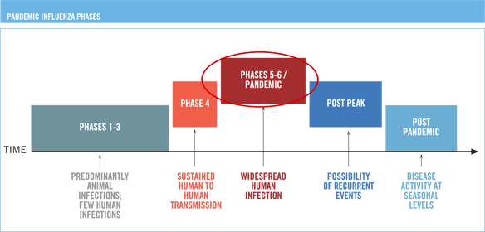

WHO PHASE | KEY INDICATOR | ACTIONS
PHASE 1 | In nature, influenza viruses circulate continuously among animals, especially birds. Even though such viruses might theoretically develop into pandemic viruses, in Phase 1 no viruses circulating among animals have been reported to cause infections in humans. | Usual surveillance.
PHASE 2 | An animal influenza virus circulating among domesticated or wild animals is known to have caused infection in humans, and is therefore considered a potential pandemic threat. | Heightened surveillance.
PHASE 3 | An animal or human-animal influenza reassortant virus has caused sporadic cases or small clusters of disease in people, but has not resulted in human-to-human transmission sufficient to sustain community-level outbreaks. Limited human-to-human transmission may occur under some circumstances, for example, when there is close contact between an infected person and an unprotected caregiver. However, limited transmission under such restricted circumstances does not indicate that the virus has gained the level of transmissibility among humans necessary to cause a pandemic. | Heightened surveillance for disease outbreaks and disease transmission pathways.
PHASE 4 | Verified human-to-human transmission of an animal or human-animal influenza reassortant virus able to cause “community-level outbreaks.” The ability to cause sustained disease outbreaks in a community marks a significant upwards shift in the risk for a pandemic.  Phase 4 indicates a significant increase in risk of a pandemic but does not necessarily mean that a pandemic is a foregone conclusion. | Any country that suspects or has verified such an event should urgently consult with WHO so that the situation can be jointly assessed and a decision made by the affected country if implementation of a rapid pandemic containment operation is warranted.
PHASE 5 | Human-to-human spread of the virus into at least two countries in one WHO region. | While most countries will not be affected at this stage, the declaration of Phase 5 is a strong signal that a pandemic is imminent and that the time to finalize the organization, communication, and implementation of the planned mitigation measures is short.
PHASE 6 | The pandemic phase is characterized by community level outbreaks in at least one other country in a different WHO region in addition to the criteria defined in Phase 5.  Designation of this phase will indicate that a global pandemic is under way. | Full implementation of pandemic influenza emergency operations plans.  Surveillance may be curtailed due to the high number of cases.
POST PEAK | Pandemic disease levels in most countries with adequate surveillance will have dropped below peak observed levels.  The post-peak period signifies that pandemic activity appears to be decreasing; however, it is uncertain if additional waves will occur and countries will need to be prepared for a second wave. Previous pandemics have been characterized by waves of activity spread over months. | Once the level of disease activity drops, a critical communications task will be to balance this information with the possibility of another wave.  Pandemic waves can be separated by months and an immediate “at-ease” signal may be premature.
POST PANDEMIC | Influenza disease activity will have returned to levels normally seen for seasonal influenza.  It is expected that the pandemic virus will behave as a seasonal influenza A virus. | Maintain surveillance  Update pandemic preparedness and response plans accordingly.  An intensive phase of recovery and evaluation may be required.

Pandemic Severity Index

Source: US DHHS / CDC Community Strategy for Pandemic Influenza Mitigation, February 2007,
http://www.pandemicflu.gov/professional/community/commitigation.html

In February 2007, the CDC released a community mitigation interim guidance to help local communities make appropriate decisions about what actions to take to help delay or mitigate the spread of a pandemic, and when to take those actions. These community mitigation actions would be especially critical in the first six months of a pandemic. The interim guidance introduced a Pandemic Severity Index (PSI), akin to the National Weather Service’s hurricane intensity scale. Both scales move up from 1 to 5 as the severity of the situation increases.
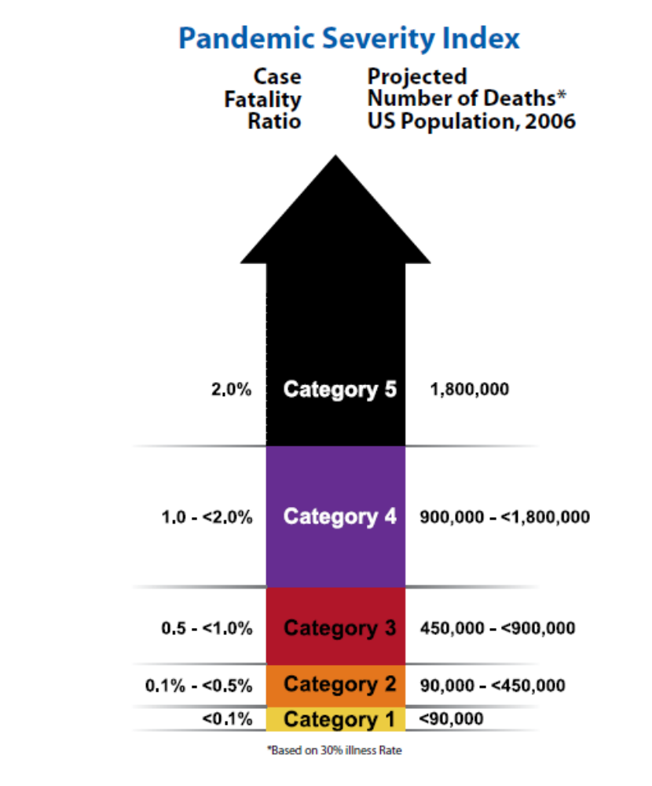
Pandemic Severity Index, which uses case fatality ratio as the critical driver for categorizing the severity of a pandemic. Note that the projected number of U.S. deaths refers to a pandemic in which no response measures are undertaken. Health impacts in the context of an effective response would be much less.

The index is designed to enable estimation of the severity of a pandemic on a population level to allow better forecasting of the impact of a pandemic and to enable recommendations to be made on the use of mitigation interventions that are matched to the severity of future influenza pandemics.

The Pandemic Severity Index links information about the severity of disease spread (number of fatalities) to specific measures that could be implemented These measures range from encouraging individuals to stay home voluntarily when they become ill, to more stringent “social distancing” measures such as closing schools and canceling public gatherings. By quickly adding these multiple actions, communities could help balance the need to protect the public’s health and the need to minimize a pandemic’s social and economic disruptions.

Use of Nonpharmaceutical Interventions (NPI) by Severity Category
This interim guidance proposes a community mitigation strategy that matches recommendations on planning for use of selected NPIs to categories of severity of an influenza pandemic. These planning recommendations are made on the basis of an assessment of the possible benefit to be derived from implementation of these measures weighed against the cascading second- and third-order consequences that may arise from their use.

Cascading second- and third-order consequences are chains of effects that may arise because of the intervention and may require additional planning and intervention to mitigate. The term generally refers to foreseeable unintended consequences of intervention. For example, dismissal of students from school may lead to the second-order effect of workplace absenteeism for child minding. Subsequent workplace absenteeism and loss of household income could be especially problematic for individuals and families living at or near subsistence levels. Workplace absenteeism could also lead to disruption of the delivery of goods and services essential to the viability of the community.

For Category 4 or Category 5 pandemics, a planning recommendation is made for use of all listed NPIs. This approach to pre-pandemic planning will provide a baseline of readiness for community response. Recommendations for use of these measures for pandemics of lesser severity may include a subset of these same interventions and potentially for shorter durations, as in the case of social distancing measures for children.

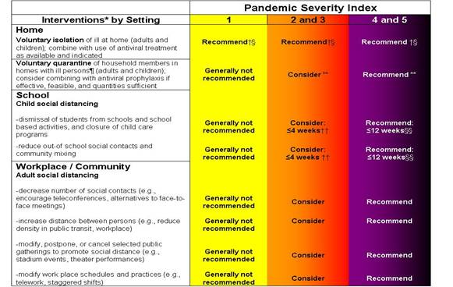
Table Legend
Generally Not Recommended = Unless there is a compelling rationale for specific populations or jurisdictions, measures are generally not recommended for entire populations as the consequences may outweigh the benefits.

Consider = Important to consider these alternatives as part of a prudent planning strategy, considering characteristics of the pandemic, such as age-specific illness rate, geographic distribution, and the magnitude of adverse consequences. These factors may vary globally, nationally, and locally.

Recommended = Generally recommended as an important component of the planning strategy.

*All these interventions should be used in combination with other infection control measures, including hand hygiene, cough etiquette, and personal protective equipment such as face masks.

†This intervention may be combined with the treatment of sick individuals using antiviral medications and with vaccine campaigns, if supplies are available.

§Many sick individuals who are not critically ill may be managed safely at home.

¶The contribution made by contact with asymptomatically infected individuals to disease transmission is unclear. Household members in homes with ill persons may be at increased risk of contracting pandemic disease from an ill household member. These household members may have asymptomatic illness and may be able to shed influenza virus that promotes community disease transmission. Therefore, household members of homes with sick individuals would be advised to stay home.

**To facilitate compliance and decrease risk of household transmission, this intervention may be combined with provision of antiviral medications to household contacts, depending on drug availability, feasibility of distribution, and effectiveness; policy recommendations for antiviral prophylaxis are addressed in a separate guidance document.

††Consider short-term implementation of this measure—that is, less than 4 weeks.

§§Plan for prolonged implementation of this measure—that is, 1 to 3 months; actual duration may vary depending on transmission in the community as the pandemic wave is expected to last 6-8 weeks.

