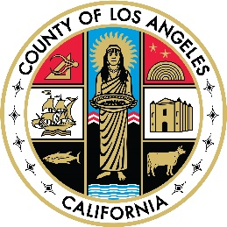

WAIVER REQUEST CHECKLIST AND DOCUMENT WORKFLOW

CONTRACTED PROVIDERS

CHECKLIST

- Complete DHCS Waiver Request form in WORD format
- Submit all required documentation below to Waivers@dmh.lacounty.gov for each candidate
- DHCS Waiver Request form: Waiver Application
- MOU: Memorandum of Understanding
- Curriculum Vitae (CV)
- Transcript
- Please submit each waiver request individually for each candidate
- In the subject line please write “Waiver Request: Candidate’s Name”
- Please attach the DHCS Waiver Request form separately from other documents
- Please ensure the address of your Agency is reflected in the email to assist with formal completion of Waiver cover letter

WAIVER WORKFLOW
- An acknowledgment receipt will be emailed when a waiver request is submitted to Waivers@dmh.lacounty.gov
- LACDMH will review and submit waiver request to DHCS within 2-4 weeks of submission. Please note that any follow up needed from provider during the review may cause delays in submission of waiver request to DHCS
- DHCS reviews and processes waiver request within 2-4 weeks. Please note that any follow up needed from the Provider during the review by DHCS may cause delays
- LACDMH will notify a Provider of DHCS Waiver Request approval ASAP. A Provider will receive an email with a LACDMH Waiver Request Cover letter, DHCS Waiver Request Approval, and Acknowledgment letter that requires a signature
- Provider to return Acknowledgment letter to LACDMH with a signature

For any questions, please email Waivers@dmh.lacounty.gov

System Support Team Contact Information:
Diane Guillory, MPA (213) 251-6809 Email: DGuillory@dmh.lacounty.gov
Norma Cano, Psy.D (213) 251-6886 Email: NCano@dmh.lacounty.gov
Mineh Gharamanian Email: MGharamanian@dmh.lacounty.gov
Anna Shahmirian Email: AShahmirian@dmh.lacounty.gov

