cid:image001.jpg@01CF6F67.7CE74680 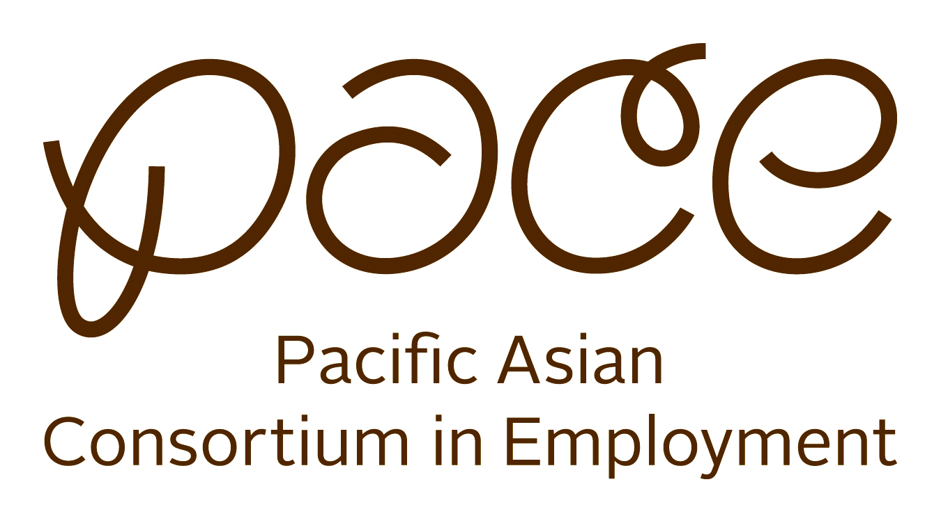



RECRUITMENT

**Hiring for the following Positions**

**Janitor –** Immediate Hiring

Full-time. Flexible schedule - morning, day, early evening.

**Machine Mechanic/Maintenance**

Full-time. Knowledgeable with machines. Assist in troubleshooting, repairing and performing maintenance on a variety of equipment. Pay negotiable and dependent upon experience.

**Mixer** – Immediate Hiring

Full Time or Part Time. Flexible schedule.

Apply Directly with the Employer

Application Accepted Monday – Friday

10:00 am – 4:00 pm

Amay's Bakery & Noodle Co., Inc.

**837 E. Commercial Street**

Los Angeles, CA 90012

Please Bring the Following:

Resume, Photo ID / CA Driver License Social Security Card or Passport