## 

## 

PEER PROFESSIONAL TRAINING & PLACEMENT PROGRAM

Accepting applications on a continual basis

## 

ABOUT THE PROGRAM:

The ***Peer Professional Training & Placement*** program prepares people who are, or who have been, consumers of mental health services for roles in the public mental health system as employees or volunteers, able to support the recovery of others and transform our mental health systems through the skillful use of lived experience.

This training includes classroom instruction and an internship. During the training, participants will learn about:

* + The Recovery Model
  + Effective listening skills
  + Group facilitation
  + Motivational interviewing
  + Documentation
  + TAY services
  + Culture In Recovery
  + Harm reduction
  + Case management
  + Advocacy

**Who can participate?**

* Persons age 18 or older who have personal lived experience with a mental illness and/or a close family member with lived experience.

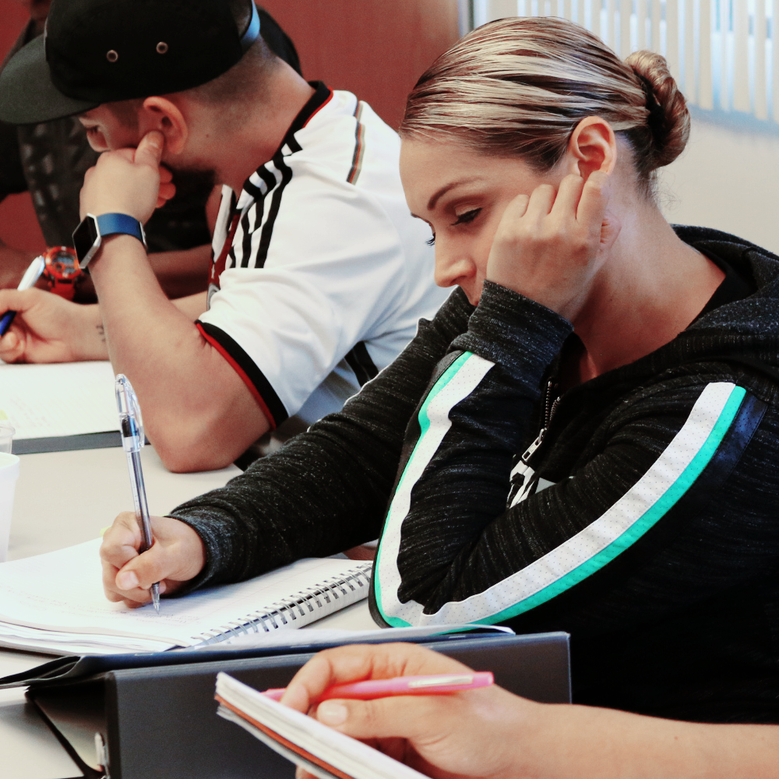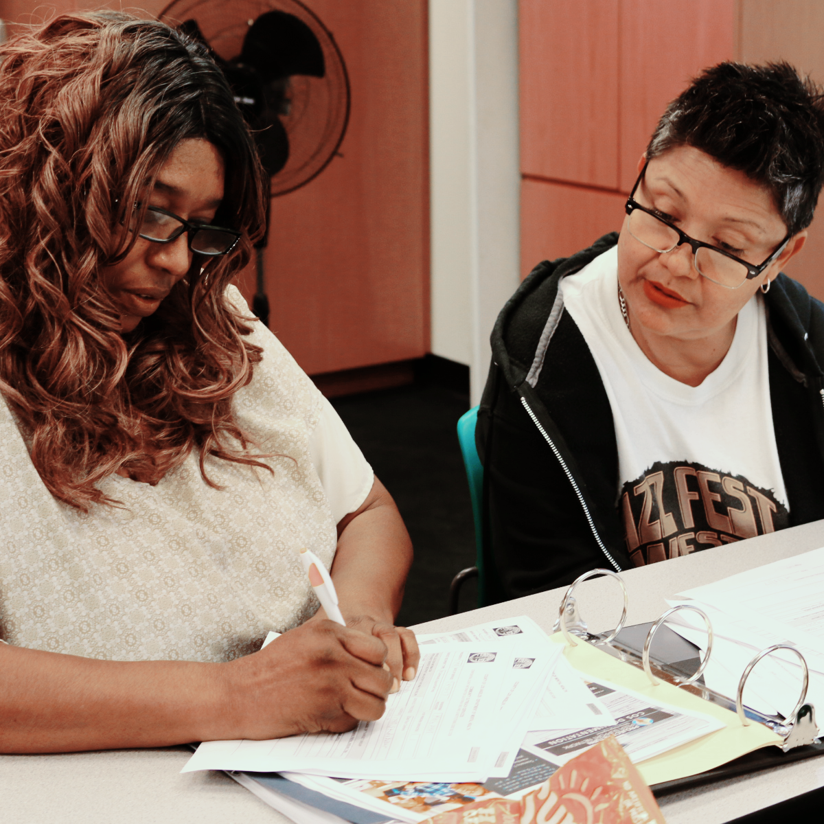

* Those willing to publicly identify as a person living with mental illness

**Requirements:**

Training participants must commit to:

* Attending and actively participating in 8 weeks of training for 8 hours on Saturdays and four hours on Wednesday evenings. An internship of 64 to 128 hours is also required.

If you have questions, you may call or e-mail Jason at:

Office: 323-312-0640

Cell: 562-310-1208

***Jason Garcia,***  
 ***Training Coordinator***

Project Return Peer Support Network  
2677 ½ Zoe Avenue  
Huntington Park, CA 90255

Fax: 323-312-0642

Email: [jgarcia@prpsn.org](mailto:jgarcia@prpsn.org)

* Securing transportation to where the training is held, and to internship locations
* The heart and passion to assist others on their recovery journey

**Applications** are available at **prpsn.org** on the **News/Events page**. All must be filled out online and either emailed, or mailed to:

Hortencia Piceno, Employment Specialist

[hpiceno@prpsn.org](mailto:hpiceno@prpsn.org)

Cell: 323-594-5165

Office: 323-346-0960

Any Questions please call/email Jason or Hortencia

Jason Garcia, Training Coordinator

jgarcia@prpsn.org

Project Return Peer Support Network

2677 ½ Zoe Ave.

Huntington Park, CA 90255

Cell: 562-310-1208

Office: 323-346-0960 ext. 223