**EmergiPress CE Test – May 2020**

1. Approximately what percentage of patients re-arrest after return of spontaneous circulation (ROSC)?
   1. 25%
   2. 40%
   3. 50%
   4. 60%
2. When performing patient handoffs during the COVID-19 pandemic, when should EMS doff PPE?
   1. As determined by the emergency department charge nurse
   2. When entering the emergency department
   3. When entering the designated patient room
   4. Upon completion of patient handoff
3. What is the treatment for the rhythm below if the patient has a pulse but signs of poor perfusion and ALOC?

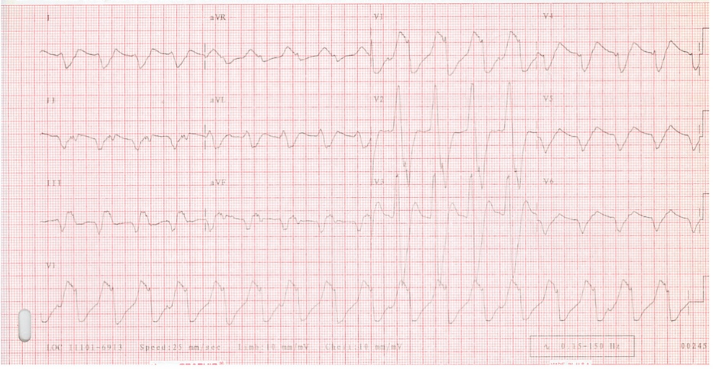

* 1. Adenosine
  2. Amiodarone
  3. Defibrillation
  4. Synchronized Cardioversion

1. A 6 year old male measuring Blue 20kg is having a tonic-clonic seizure. He has no intravenous access. What is the correct dose and volume of intranasal midazolam you administer?
   1. 2mg/0.4mL
   2. 2mg/0.8mL
   3. 4mg/0.4mL
   4. 4mg/0.8mL
2. What is a normal heart rate for a 12 month old, Purple 10kg pediatric patient?
3. 90-140 bpm
4. 100-150 bpm
5. 110-160 bpm
6. 120-170 bpm