EMS SKILL

PATIENT ASSESSMENT / VITAL SIGNS
RESPIRATIONS / BREATHING
PERFORMANCE OBJECTIVES
Demonstrate proficiency in performing an accurate respiratory assessment.

CONDITION
Perform an accurate respiratory assessment for the primary and secondary assessment. The examiner will assess respirations with the examinee to determine the accuracy of the assessment. Necessary equipment will be adjacent to the patient.

EQUIPMENT
Live model, timing device, stethoscope, eye protection, mask, gown, gloves.

PERFORMANCE CRITERIA
Items designated by a diamond () must be performed successfully to demonstrate skill competency.
Items identified by double asterisks (**) indicate actions that are required if indicated.
Items identified by (§) are not skill component items, but should be practiced.
Reading must be within +/- 2 breaths/minute of examiner’s determination.
PREPARATION

Skill Component | Key Concepts
Establish body substance isolation precautions  ** Place a surgical mask on the patient and use an N95 respirator on self- if suspected airborne disease | Mandatory personal protective equipment - gloves
PRIMARY ASSESSMENT
Skill Component | Key Concepts
Consider the need for additional BSI | Situational - goggles, mask, gown  - Surgical masks are to be used on patients when airborne diseases are suspected.  Surgical masks provide only droplet containment with little filtration protection.  N95 respirators on provider provide higher levels of protection.  When an outbreak occurs, PPE guidance will be provided by the local health officials.
Observe or feel for rise and fall of chest or abdomen | Evaluate the patient’s respirations as subtly as possible. Patients have a tendency to increase their respirations if they know they are being assessed.  The rescuer may have to feel the patient’s chest or abdomen to check for rise and fall if tidal volume is decreased or patient is dressed in a large jacket or many layers of clothing. Lay patient’s arm over chest or abdomen, watch movement of shoulders, etc.  Infants are “abdominal breathers” which causes the abdomen to protrude and the chest wall to retract. NOTE: THIS IS A NORMAL FINDING.
Assess respirations/Manage breathing:  Rate (normal, fast, slow)  Effort/Quality  Tidal volume  - Rhythm/Pattern  ** Administer O₂ per Los Angeles County Reference No 1302  ** Provide positive pressure ventilation with a BMV- if inadequate ventilation | Rate - determine if fast or slow. The rate is not counted during the primary assessment.  Effort/Quality – Is evaluated by the presence of accessory muscles use of, patient position (tripod, reclined, etc.), clear or diminished sounds, equal or unequal, labored, noisy, absent, and the ability to speak in complete sentences, or unable to due to being short of breath.  Tidal volume – Must be determined if it is normal, adequate, shallow, increased or decreased.  Continued…  Determine if the tidal volume and rate are adequate to assure effective ventilation - use BMV to increase tidal volume or rate if necessary.  A goal of oxygen administration is to deliver the minimum amount of oxygen to meet the needs of the patient and to maintain a SpO2 at or above 94-98%.  - When available, use pulse oximetry to guide oxygen delivery. The desired SpO2 for most non-critical patients is 94-98%.  - SPECIAL CONSIDERATION: For chronic obstructive pulmonary disease (COPD), the goal is to titrate oxygen to keep the SpO2 at 88-92%.
Assess breath sounds (rapid chest auscultation) - if difficulty breathing or shortness of breath | Assess only 1-2 breaths to confirm presence and equality of breath sounds at 5th - 6th intercostal space mid-axillary line on each side of the chest.
SECONDARY ASSESSMENT
Skill Component | Key Concepts
Observe or feel for rise and fall of chest or abdomen
Assess/Manage breathing:  Rate (respirations/minute)  Effort/Quality  Tidal volume  Rhythm/Pattern (regular/irregular)  ** Consider O₂ therapy  ** Consider BMV- if inadequate ventilation  ** Place a surgical mask on patient and use an N95 respirator on self- if suspected airborne disease and not already done | Rate can be calculated by counting for 30 seconds and multiplying by 2. Abnormal pattern should be counted for 1 full minute.  Respiratory rate >40 or <10 may not provide adequate tidal volume. Be prepared to assist with bag-valve-mask ventilation if level of consciousness is decreased.  Respiratory rhythm assessed is either regular or irregular.  Respiratory pattern is determined after complete assessment and may include any of the following:  - normal - sighing - Biot’s  - bradypnea - Cheyne-Stokes - ataxic  - tachypnea - Kussmaul - air-trapping  - agonal - hyperventilation (hyperpnea)
Assess breath sounds (3 bilateral anterior or posterior fields) - if difficulty breathing or shortness of breath | - Breath sounds are assessed in three (3) bilateral anterior or posterior fields; apices, mid-lung, and bases.
RE-ASSESSMENT/DOCUMENTATION
(Ongoing Assessment)
Skill Component | Key Concepts
§ Repeat respiratory assessment a minimum of every five (5) minutes for unstable patients or 15 minutes for stable patients.  - Re-assess/Manage breathing:  Rate (respirations/minute)  Effort/Quality  Tidal volume  Rhythm/Pattern (regular or irregular)  - Re-assess breath sounds (3 bilateral anterior or posterior fields) - if difficulty breathing or shortness of breath  - Consider BMV - if inadequate ventilation | - An unstable patient is one who have abnormal vital signs, S/S of poor perfusion, or if there is a suspicion that the patient’s condition may deteriorate.  - Re-assess full breath sounds whenever there is a change in patient’s condition or respiratory pattern.  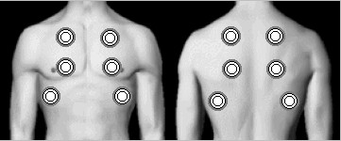

PATIENT REPORT AND DOCUMENTATION
Skill Component | Key Concepts
§ Give patient report to equal or higher level of care provider  Exception: Report may be given to a lower level of care provider when an ALS to BLS downgrade has occurred | Report should consist of all pertinent information regarding the assessment findings, treatment rendered and patients response to care provided.
§ Verbalize/Document:  Respiratory assessment:  - rate (respirations/minute)  - effort/quality  - tidal volume  - rhythm/pattern (regular or irregular)  - SpO2  Breath sounds  Oxygen administration:  - airway adjunct/ventilatory devices used  - oxygen liter flow  - ventilation rate | Respiratory rate, tidal volume, rhythm/pattern and breath sounds should be reported and documented.  Airway adjuncts and ventilatory devices are mechanical aids that assist in maintaining a patent airway, ventilating or delivering oxygen. These adjuncts/devices include: oxygen mask, nasal cannula, oropharyngeal and nasopharyngeal airway, bag-valve-mask-ventilation device, a tracheostomy, endotracheal or esophageal combitube, etc.  Documentation must be on either the Los Angeles County EMS Report, ePCR, or departmental Patient Care Record form.

Developed 3/02, Revised 10/2018

PATIENT ASSESSMENT / VITAL SIGNS
RESPIRATIONS / BREATHING

Supplemental Information

DEFINITIONS:

• Accessory muscles – Are the muscles used when a patient has difficulty breathing. They include the shoulder muscle (trapezius), neck muscles (sternocleidomastoid and scalenus), chest muscles (pectoralis and intercostals), and abdominal muscles.

• Dyspnea – Is the subjective feeling of shortness of breath. It is usually associated with heart or lung disease, but also occurs normally with intense physical activity or at high altitudes.

• Inspiratory-Expiratory ratio (I.E. ratio) - This ratio is the time of inspiration to the time of expiration. The active inhalation phase lasts 1/3 the time of the passive exhalation phase. It takes longer to exhale than to inhale. If the rate of breathing increases, the ratio may change to 1:2 or 1:1 depending on the rate. In patients with COPD and asthma, air trapping occurs and to exhale completely the ratio may increase to 1:4.

• Respiration (ventilations) - In normal breathing each breath includes 2 phases; inspiration and expiration

• Respirator – N95 or higher filters protect the healthcare provider from breathing in small particles which may contain viruses. They must be fitted to the face so that most air is inhaled through the filter material. N95 are disposable and should only be used once.

• Tripod position – The patient is in a high-fowlers sitting position with the patient leaning forward on both arms allowing for accessory muscles (pectoralis minor and major) to elevate the rib cage resulting in maximum chest expansion and diaphragmatic function. In addition, a patient in respiratory distress places his head and neck in a natural sniffing position that aligns the larynx and trachea allowing for better air flow.

NOTES:

• The amount of air exchange is dependent on the rate and the tidal volume.

• An adult patient breathing slower than 10 breaths/minute or faster than 24 breaths/minute should be evaluated for inadequate breathing. The pulse oximetry reading is helpful in this situation.

• Signs of respiratory distress:

- Respiratory rate < 10 breaths/minute or > than 24 breaths/minute
- Accessory muscle use
- Intercostal and sternal retractions
- Pale, cyanotic, or cool (clammy) skin
- Abnormal I:E ratio
- Abnormal respiratory pattern
- Decreased, unequal or abnormal lung sounds
- Labored breathing
- Shallow or uneven chest rise and fall
- Unable to speak in complete sentences between breaths (only 2-3 words at a time)

Facemasks and N95 respirator are to be used in cases of suspected airborne diseases such as:

Pandemic Flu season
Plague
Severe Acute Respiratory Syndrome (SARS-CoV)
Tuberculosis (TB)
Pertussis (Whooping Cough)

PATIENT ASSESSMENT / VITAL SIGNS
RESPIRATIONS / BREATHING
Supplemental Information (Continued)
Tidal Volume |  | Normal Respiratory Rates |  | Accessory Muscles
Normal/Adequate  Increased  Shallow (decreased) |  | Adults 12-20  Child 15-30  Infants 25-50  Newborn 30-60 |  | Adults  • Trapezius (shoulder) [assist with inspiration]  • Sternocleidomastoid (neck) [assist with inspiration]  • Scalenus (neck) [assist with inspiration]  • Abdominal [assist with expiration]  Pediatric  • Intercostal retractions  • Sternal retractions  “Children retract in severity from the bottom up”
Type of Respirations |  | Characteristics |  | Possible Cause
Normal/Adequate |  | Breathing is ordinary - neither deep or shallow |  | Normal respirations
Shallow |  | Slight movement of the chest or abdomen |  | Respiratory depression, chest wall injury, pleuritic pain
Labored |  | Increased effort of breathing, use of accessory muscles, *nasal flaring, *intercostal retractions, sternal retractions*  * mostly seen in infants and children |  | Respiratory insufficiency and failure  (In infants and children, cardiac arrest is most commonly caused by respiratory arrest)
Noisy |  | Snoring, wheezing, gurgling, crowing and stridor |  | Partial airway obstruction from a foreign object, swelling, neck position, fluid in the lungs, or constriction of the airways
 | Respiratory Patterns  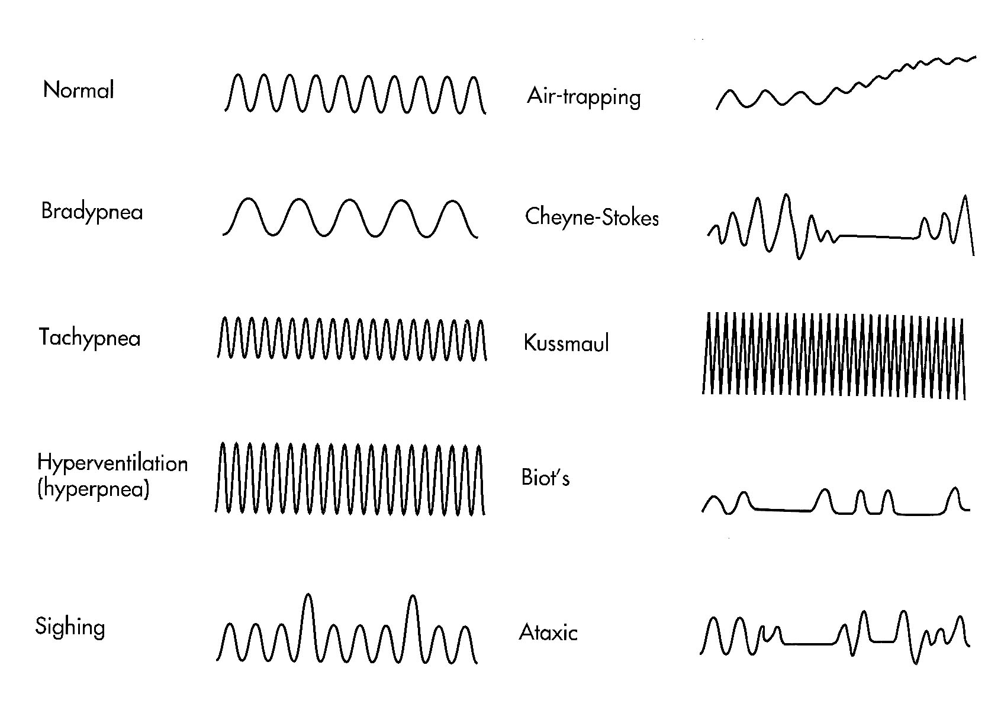  Graph obtained from Saunders, Paramedic Textbook 2nd ed. Fig. 11-13 |  | Respirations |  | Definition
 |  |  | Eupnea |  | Normal breathing
 |  |  | Bradypnea |  | Slower than normal rate
 |  |  | Apnea |  | No breathing
 |  |  | Tachypnea |  | Faster than normal rate
 |  |  | Hyperventilation  (hyperpnea) |  | Increased rate and/or depth  (faster and/or deeper than normal respirations)
 |  |  | Ataxic |  | Irregularly - irregular
 |  |  | Biot’s |  | Irregular with periods of apnea  (similar to but not as regular as Cheyne Stokes)
 |  |  | Cheyne-Stokes |  | Regular increase and decrease in depth followed by a period of apnea
 |  |  | Kussmaul |  | Rapid, regular deep respirations caused by diabetic ketoacidosis or other metabolic acidosis
 |  |  | Central Neurogenic Hyperventilation |  | Pattern similar to Kussmaul but caused by increased intracranial pressure (head injury)
 |  |  | Air trapping |  | Prolonged but inefficient expiratory effort, commonly seen in COPD or asthma
 |  |  | Sighing |  | An occasional deep, audible inspiration that is insignificant

