Los Angeles County EMS Agency  MICN RECERTIFICATION FIELD OBSERVATION CE DOCUMENTATION |  |  |  |  |  | 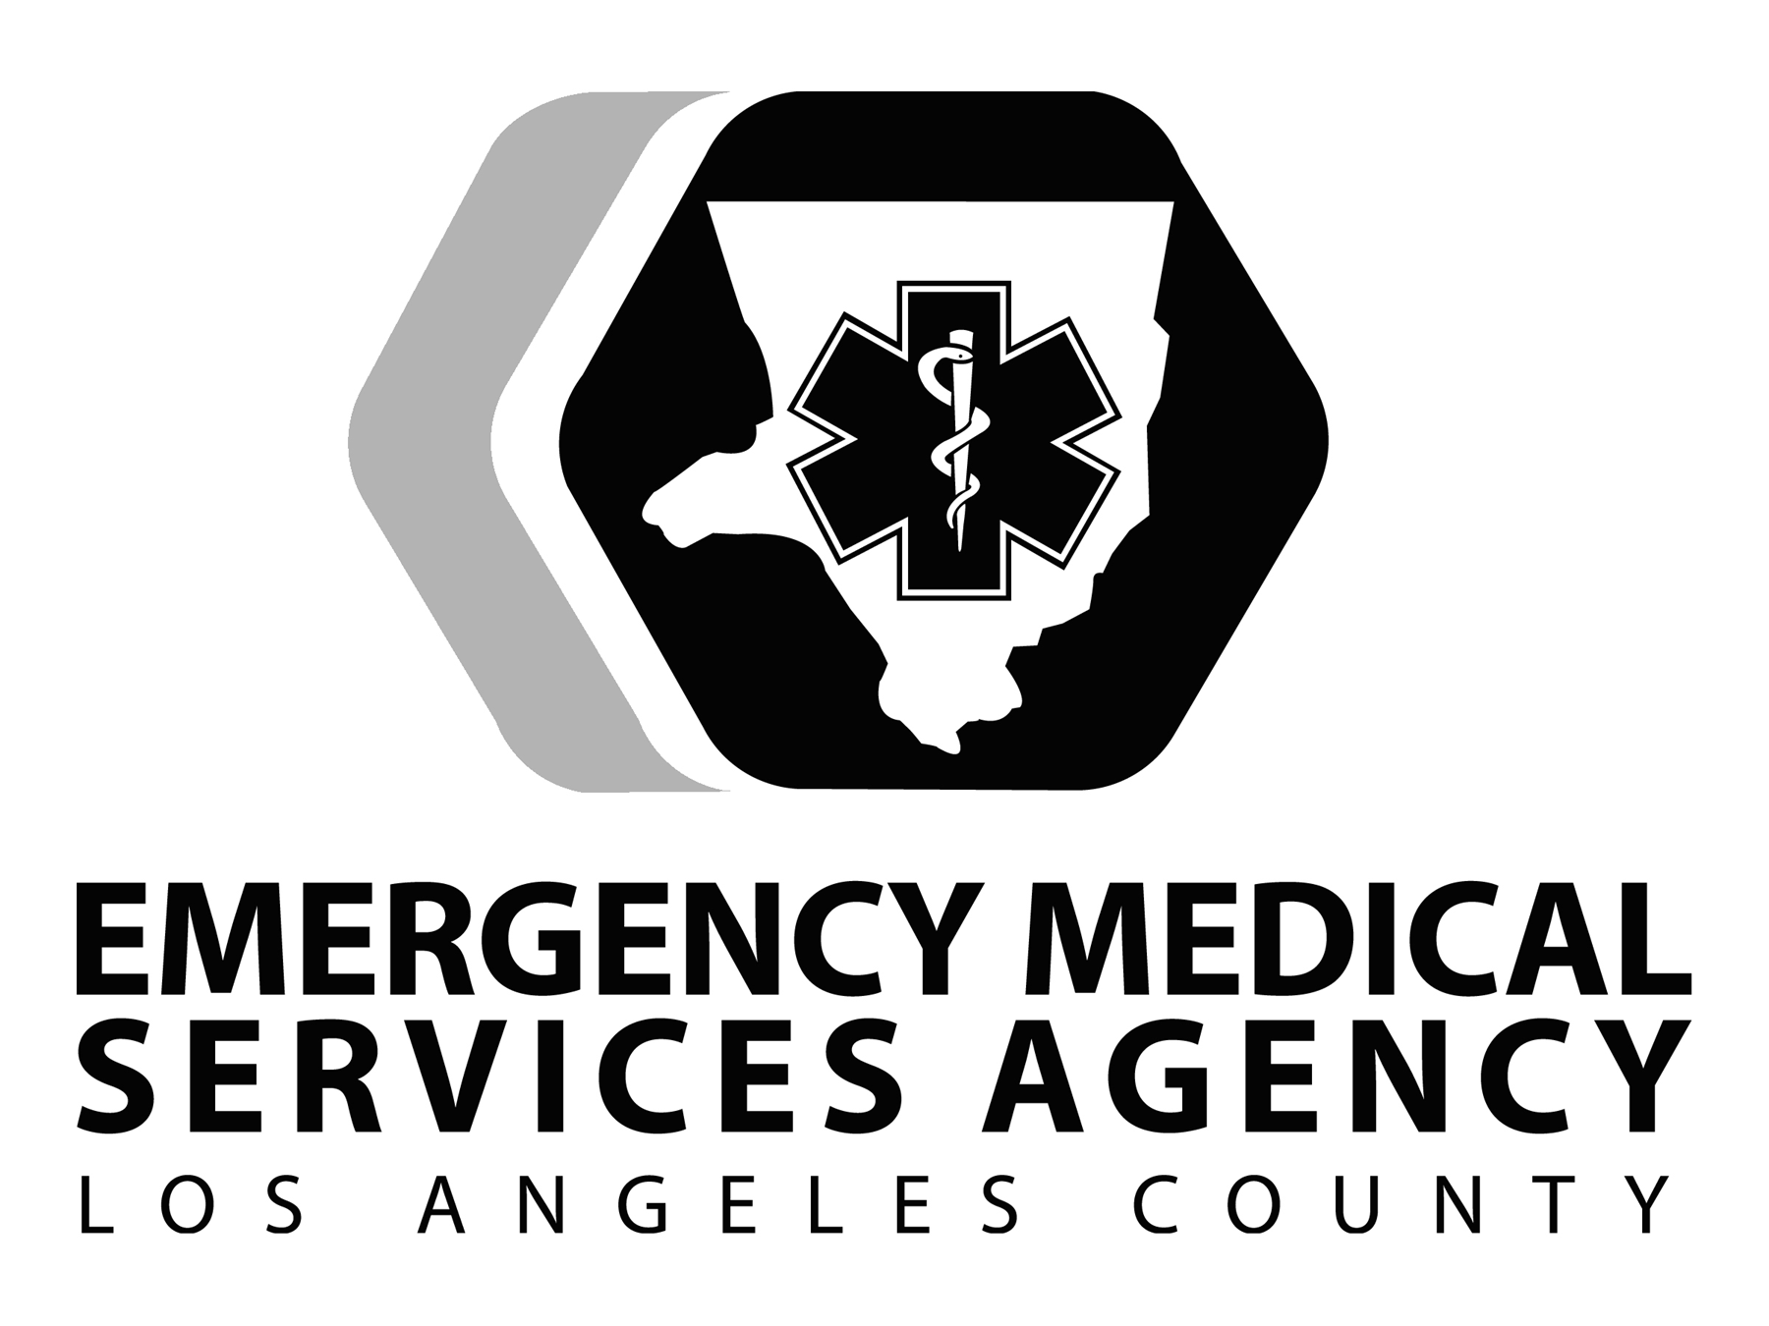
NAME: |  | CERTIFICATION #: N |  | SPONSORING AGENCY:
Prediscussion Date: |  | Discussed with EMS CE Program Director or Clinical Director Signature:
Date of Experience: | Time In: | Time Out: | Total Hours: |  | Location of Experience:  Provider Agency and ALS Unit #:

*maximum of eight (8) hours credit per certification cycle.

Learning Objectives – check (√ ) three or more | Plan to Meet Objectives | Results of Experience  (Completed by MICN)
- Enhance communication between prehospital care team members | - Communication  - Establish rapport and networking relationships with prehospital personnel
- Identify organizational and procedural differences/similarities among EMS provider agencies | - Organizational/Procedural differences/similarities  - Discuss the differences/similarities among EMS provider agencies
- Identify the importance of and the techniques for ensuring a safe prehospital environment | - Safe Environment  - Discuss what is required to ensure a safe environment such as crowd control, traffic control  - Observe techniques employed
- Identify the differences/similarities in the performance of patient assessment and treatment in the prehospital and emergency department setting | - Differences/similarities of patient assessment and treatment  - Observe how the prehospital setting affects assessment and the delivery of patient care
- Identify the communication patterns and roles/responsibilities of prehospital care personnel | - Communication Patterns and Roles/Responsibilities  - Observe communication patterns between EMTs, firefighters, paramedics, captains, field supervisors, etc.  - Observe roles/responsibilities of prehospital personnel
Learning Objectives | Plan to Meet Objectives | Results of Experience  (Completed by MICN)
- Identify the ways in which paramedic and base hospital communication and treatment protocols (TPs) impact patient care | - Base Communication and TPs  - Observe communication between paramedics and base hospital personnel  - Observe the utilization of TPs
- Other (specify) | - Specify
- Other (specify) | - Specify

General Instructions
- Prediscussion is mandatory to define objectives and ensure a structured field observation.
- Prediscussion must be conducted by the EMS CE program director or clinical director from the sponsoring agency.
- Minimum of three objectives must be completed. New or additional objectives can be written specific to the needs of the MICN at the discretion of the program director.
- Field Observation time less than one (1) hour will not be approved.
- Field Observation time greater than one (1) hour will be granted in no less than half-hour increments.
- The MICN must complete the “Results of Experience” section to demonstrate successful achievement of the objectives. This section must be filled out in order to receive CE credit.
- Signature of field paramedic must be obtained at the time of the experience.
- Field Observation Preceptor Evaluation form and a course roster must be completed to receive CE credit.

MICN Signature:  ____________________________________________ | Date: | Paramedic LA County  Print Name: _________________________ Accreditation #: P_________  Signature: __________________________ | Date:
Field Observation results reviewed and approved by EMS CE Program Director or Clinical Director:  Print Name: _________________________________  Signature: _________________________________ | Date: | - This document must be retained for a period of four (4) years  - Credit will be denied if signatures or “Results of Experience” omitted

