LASC JUSTICE PARTNER PORTAL

The Justice Partner Portal (JPP) provides authorized agencies access to restricted case information and documents. This guide provides instructions on how to use the different features of the portal.

SIGN IN
Agencies using Microsoft O365 can sign in to the portal using their O365 credentials. For those not on O365, access would only be granted via an invite from the Court, at which point the credentials are created upon acceptance of the invite.
- To sign in to the portal, click on the Sign In link located at the top right corner of the JPP home page.
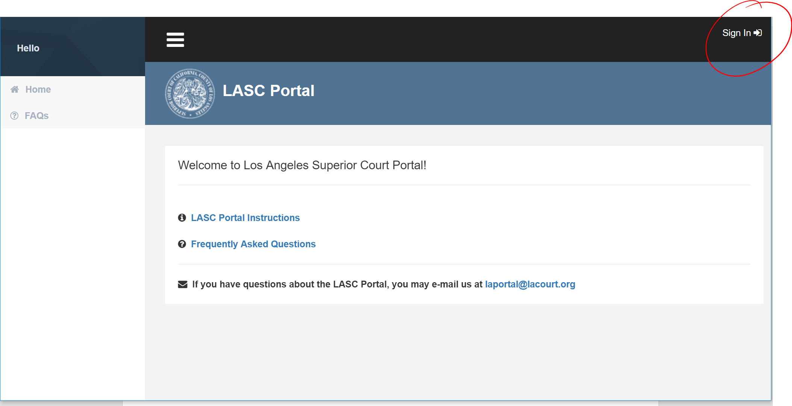
- Enter your O365 credentials.

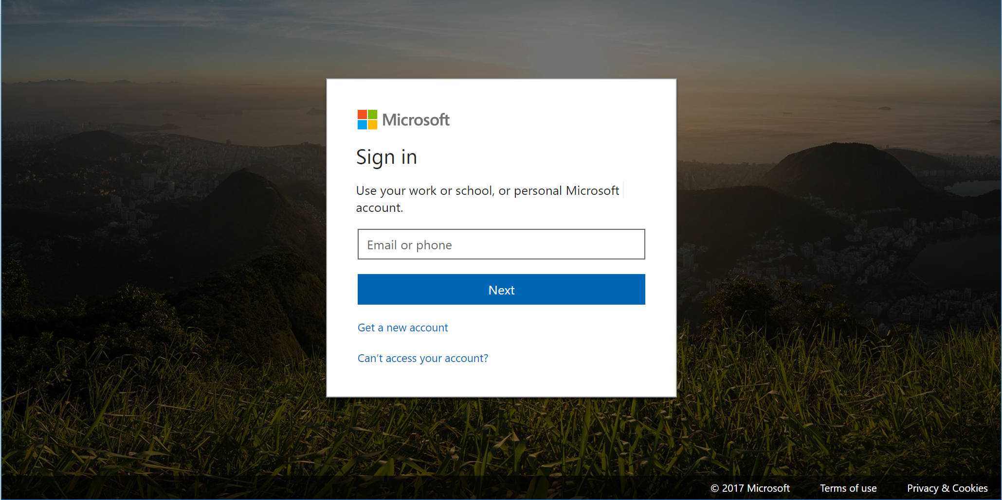

- Enter your password and click sign in.

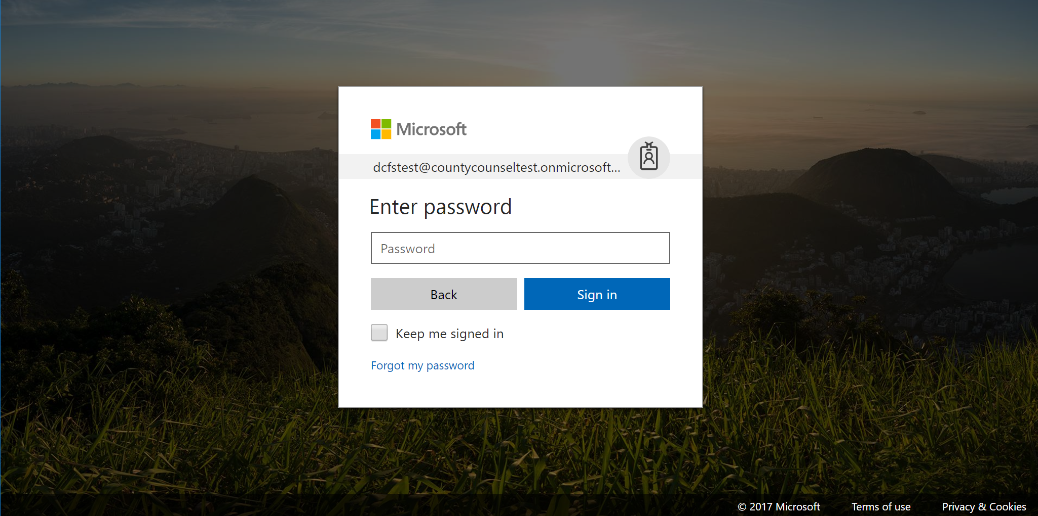

JPP FEATURES

The portal offers the following features, depending on the type of access that has been granted to the user.

- CASE ACCESS – allows the user to view case information / documents by case number.
- CASE CALENDAR – allow the user to view calendar information for a given courthouse / department.
- CASE SEARCH – allows the user to search for a case by name or case number. In some litigation types, such as Juvenile Dependency, the user may use other data elements such as JAI number to search for a case.

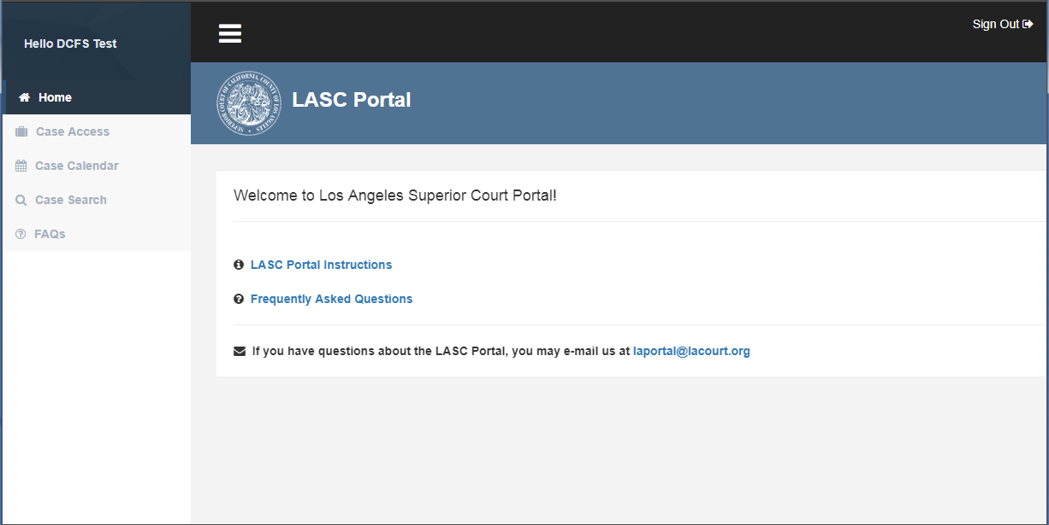
CASE ACCESS

- Enter the case number and click Search to view a case.
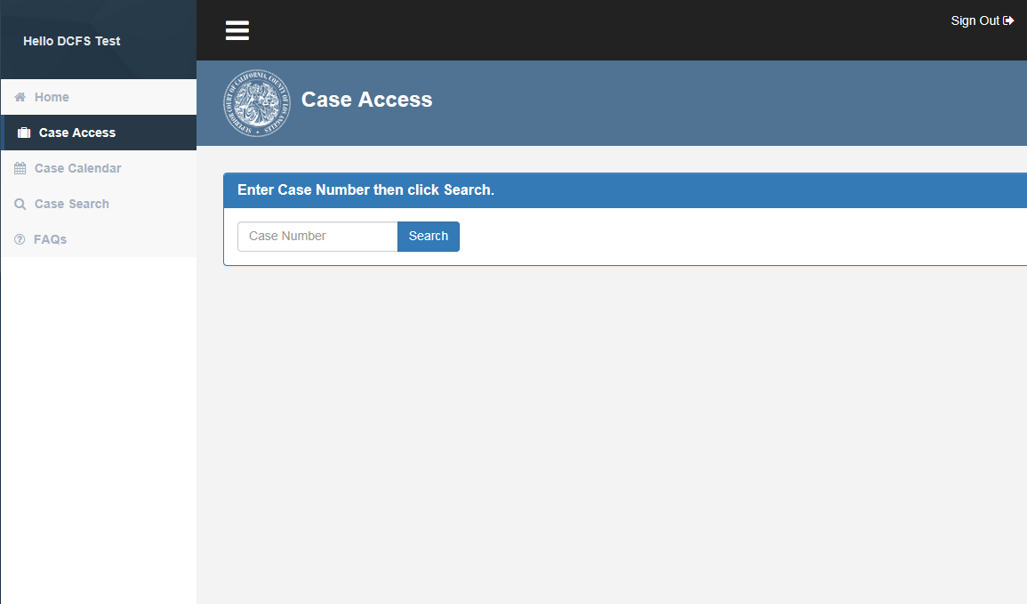

- If the case is available, the portal will display the case and party information. The user may view case Proceedings, Events and Register of Actions by clicking on the corresponding tabs.

Case Information
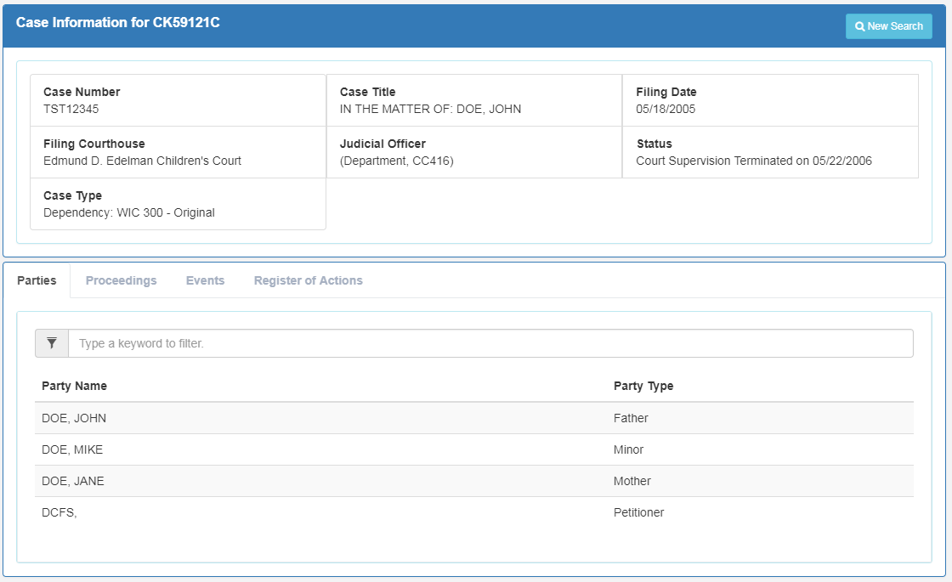

- The Proceedings tab contains future and past hearings for the case.

Proceedings Information
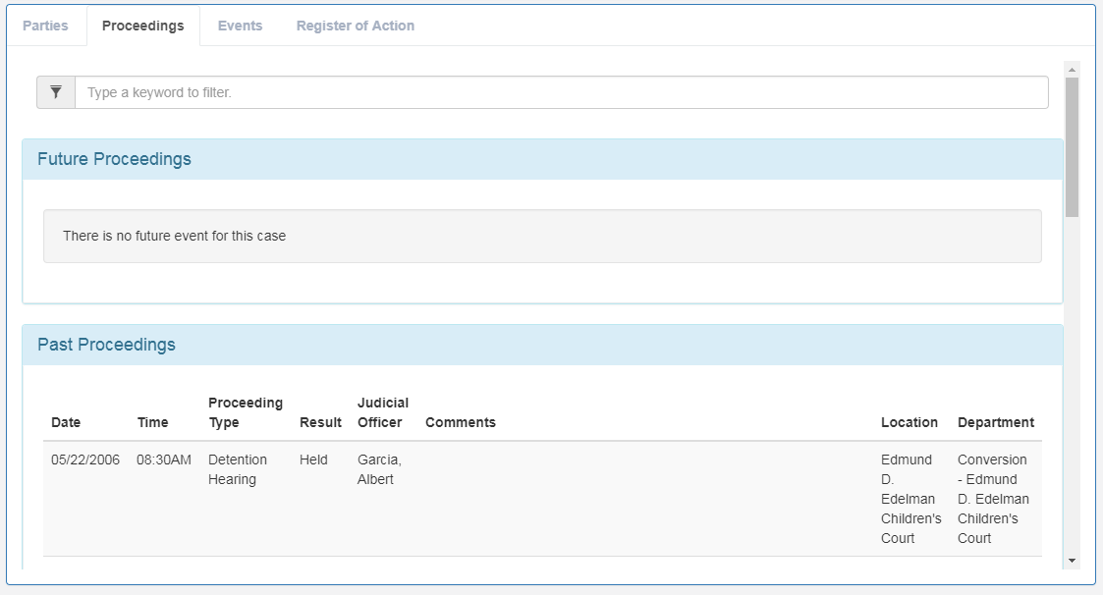
- The Events tab displays all events for the case. Documents associated with an event are viewable by clicking on the corresponding icon displayed after the description of the event.

Events
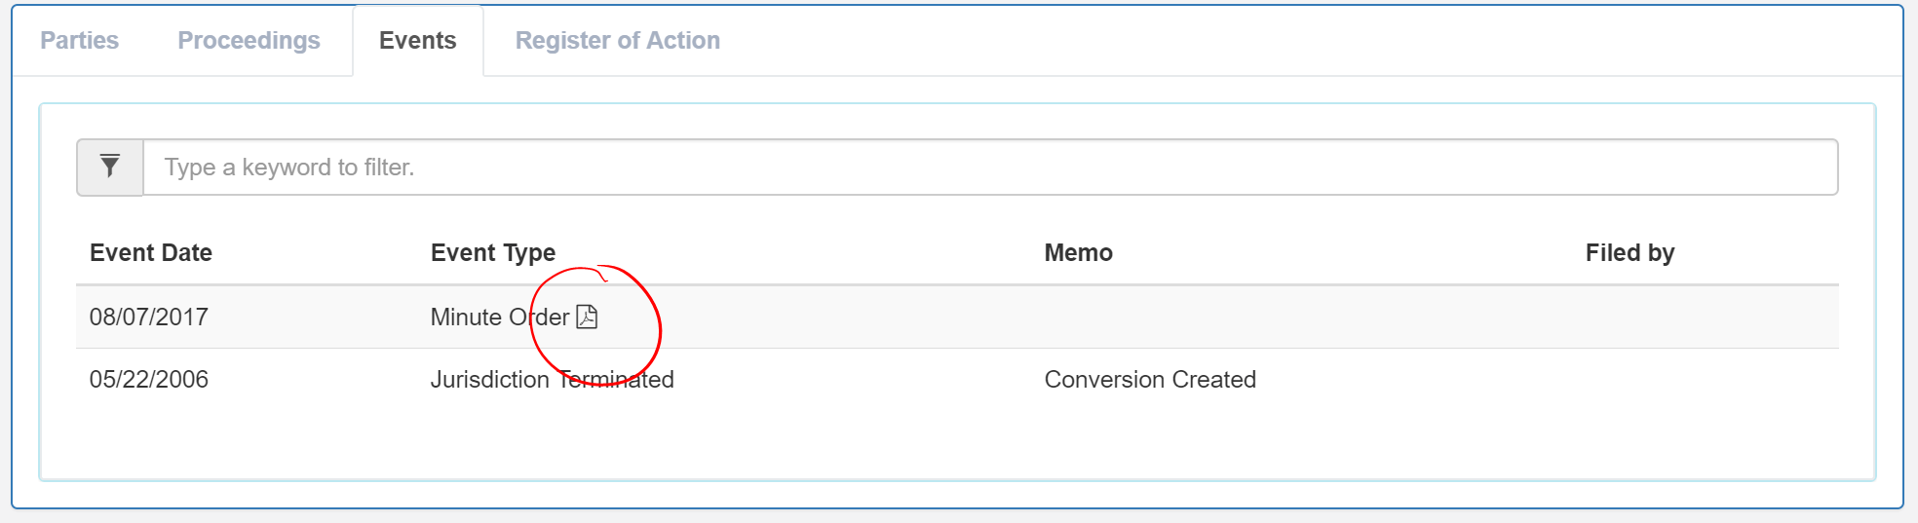

- The Register of Actions tab displays everything that has happened to the case in chronological order.

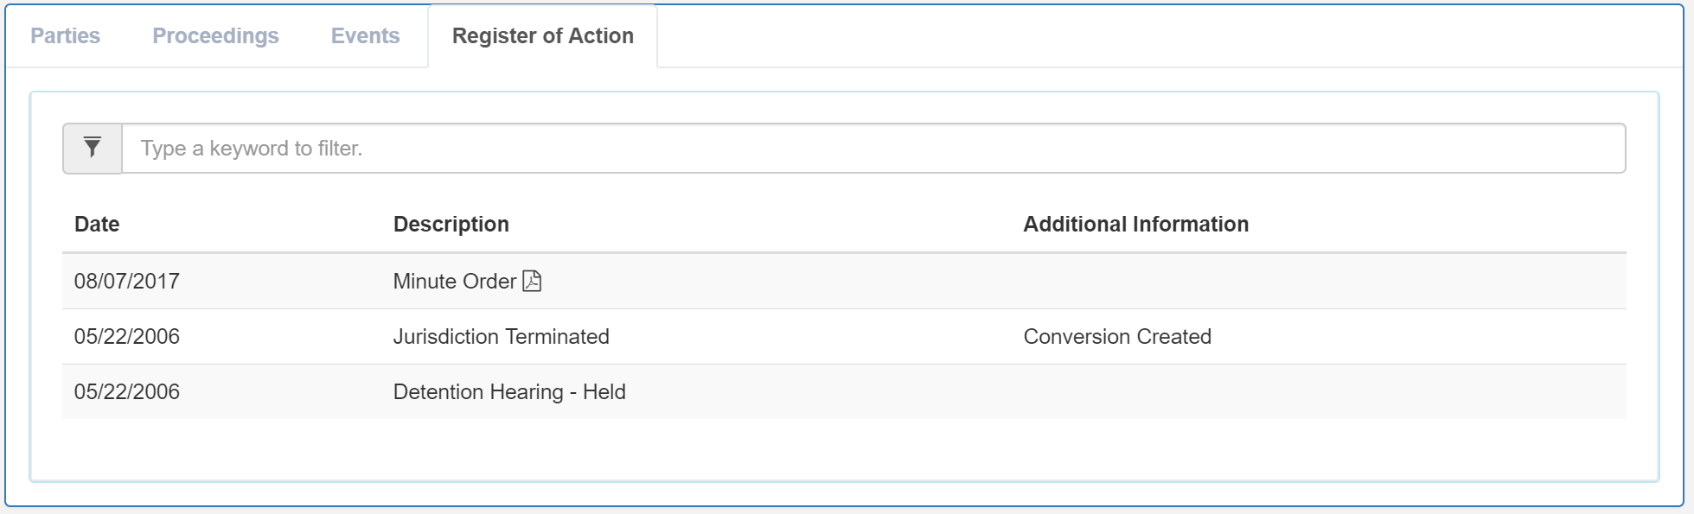

CALENDAR

- To view a calendar for a department, select the date range and courthouse.

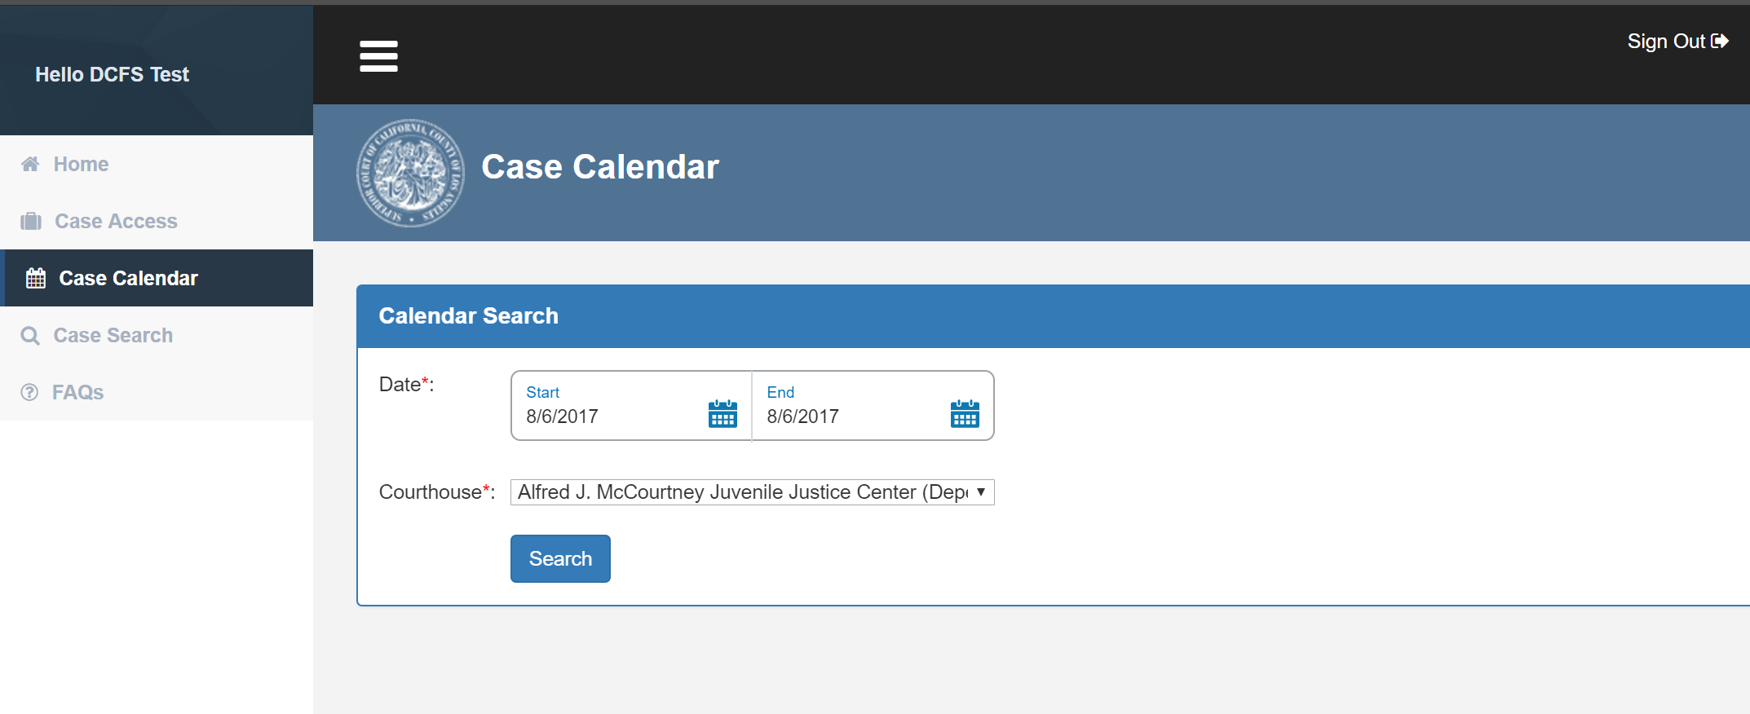

- The portal will display the calendar for the given courthouse. Enter the department on the field above the calendar to filter the list. Click on the “Export to Excel” button to export the calendar to an Excel spreadsheet.

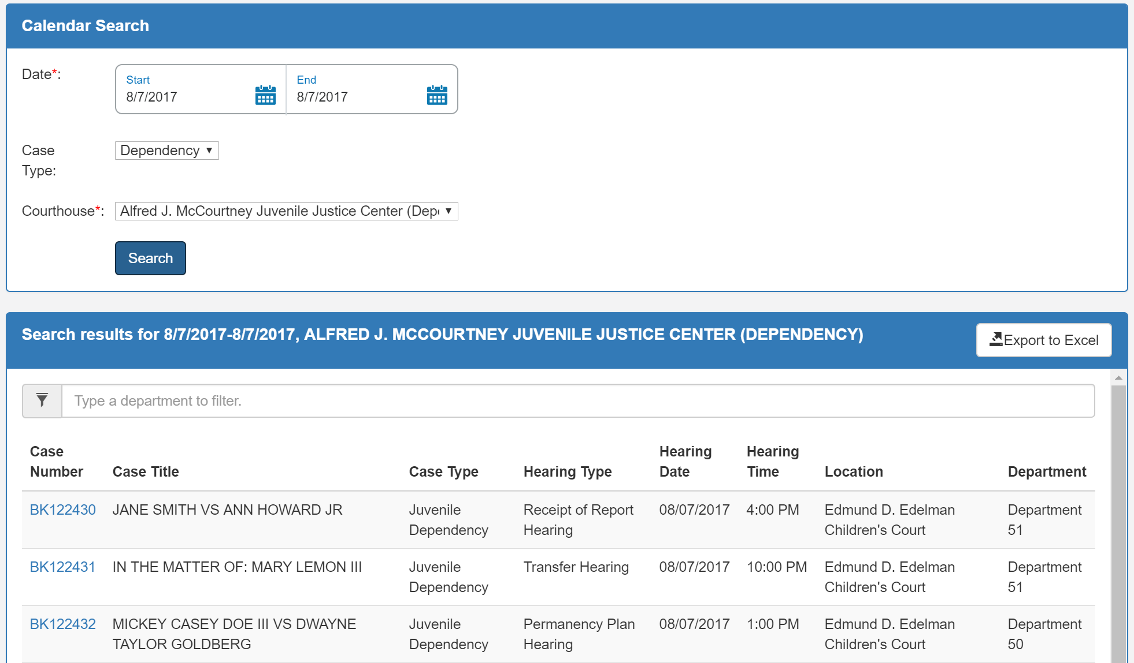

CASE SEARCH

Name Search – the portal allows the user to search for cases given the following criteria:

  - Exact Match - will only search for parties whose first or last name exactly matches the name you enter. For example, if you enter the last name ‘Miyamoto,’ the site will only search for the parties whose last name is ‘Miyamoto’.
  - Sounds Like - will search for parties whose first or last name is phonetically similar to the name that you enter. For example, if you enter ‘Miyamoto’ the site will return parties whose last names are ‘Montoya’, ‘Minatoyo’, and ‘Monette’
  - Starts With - will search for parties whose first or last name matches at least the characters that you enter. For example, if you enter the last name ‘Miya,’ the site will return parties whose last name is ‘Miya’, ‘Miyamoto’ and ‘Miyata’. The more characters you add to the search, the more manageable the results.
Helpful hint: Apply the ‘Exact Match’ search method on the first name if you wish to narrow the results of your search to a more manageable size.

JAI Number Search – for Juvenile Dependency, the portal allows the user to search for a case using the JAI number.

Case Number Search – for Juvenile Dependency, the portal allows the user to search using the beginning part of a case number to display a list of matching cases.

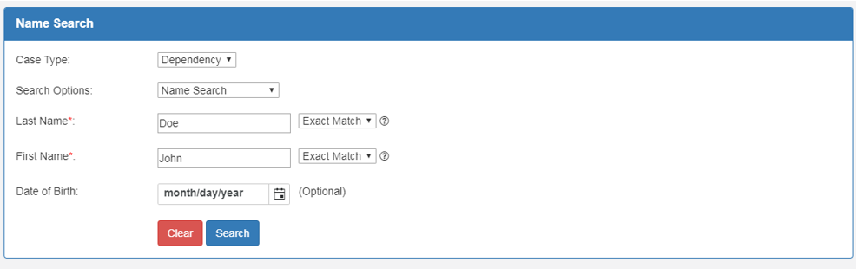

The portal will display all cases that matches criteria provided. Click on the corresponding case number to view the case in more detail.

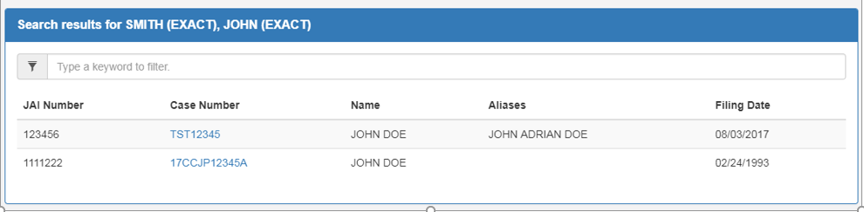

Questions about LASC Portal

If you have any questions about the LASC Portal, you may email us at: laportal@lacourt.org
